**OFFICIAL INTERNATIONAL PUBLICATION!**

**ASSOCIATED LOCKSMITHS OF AMERICA!**

**March** 1997

***PRP Prep* • *Master Keying Mag*** *18**8* ***Qifkslfb,***

: •

'/is ***To AskAbout Owning Your4)wn***

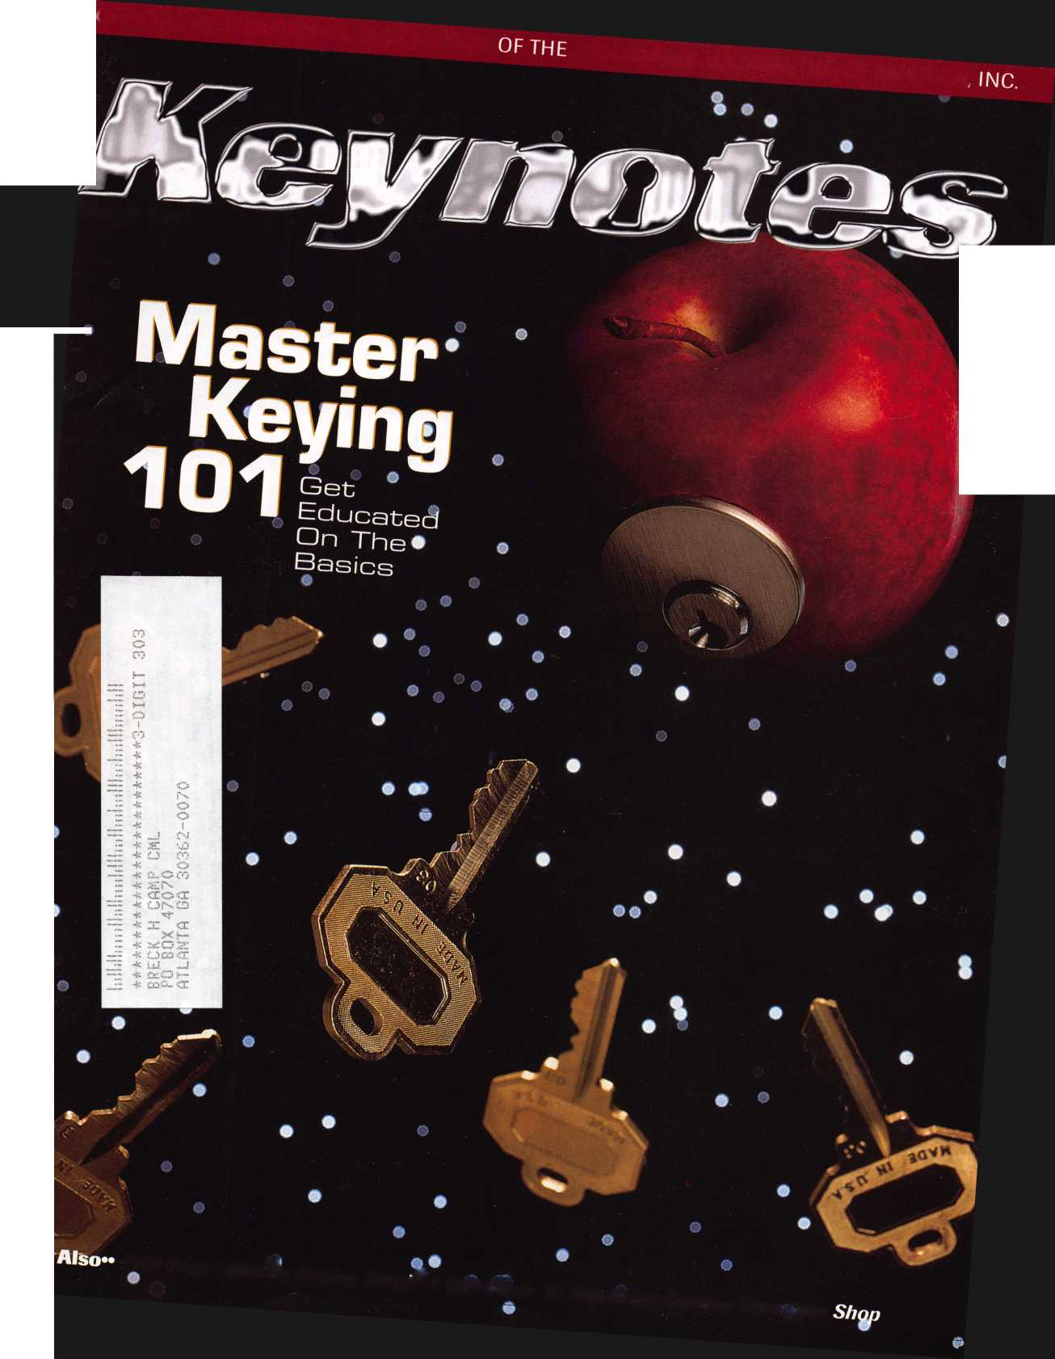

.

To order, write or FAX; Associated Locksmiths of America, Inc.

3003 Live Oak Street Dallas TX 75204 FAX [214] 827-1810

Credit card orders: Phone [214] 827-1701

| Get the best master keying textbook

**Jerome V. Andrews, CML**

around, written by one of the mosl

well- known locksmith instructors

in the profession. Just $44.00

[including shipping and handling)

Fundamentals of Master Keying

covers system structure and recon

keeping; basic mechanical and

arithmetic concepts; and how to

write a system

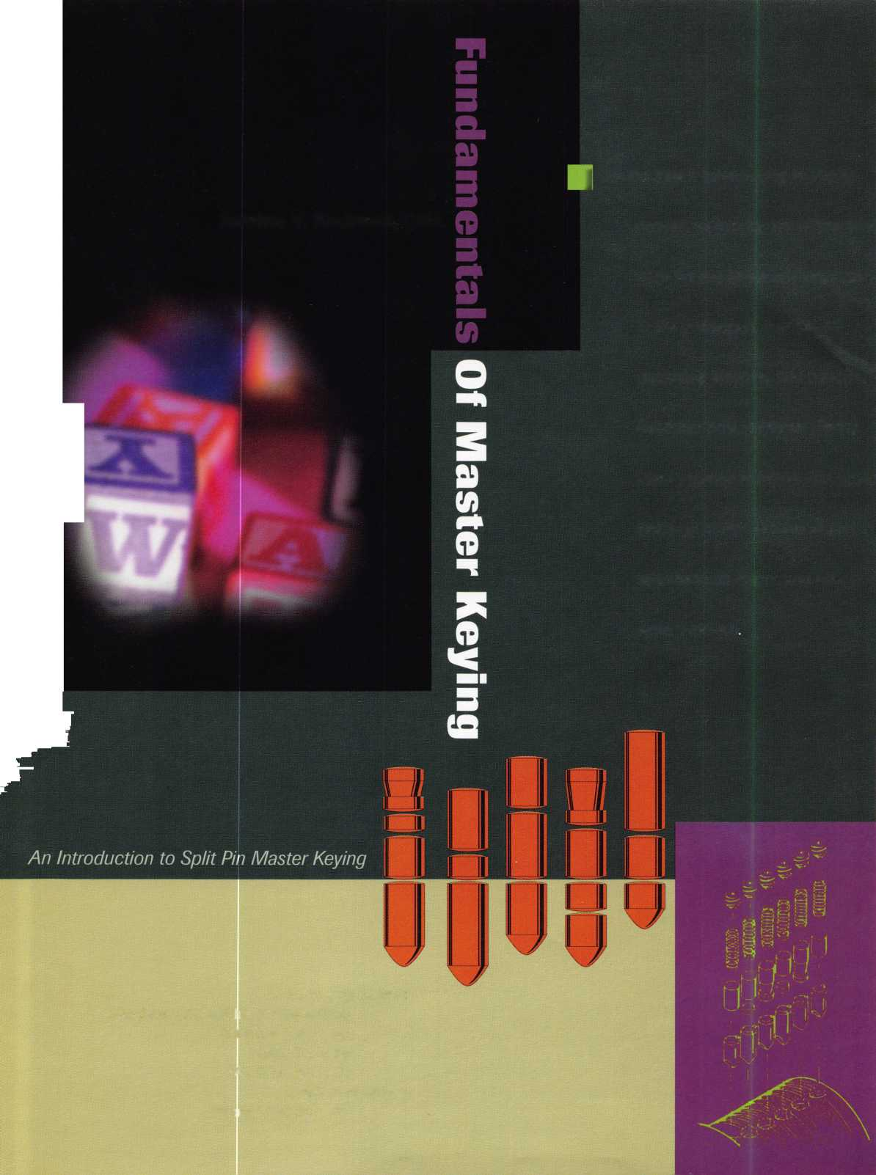

**OTEL**

**RENO, NEVADA**

**UGUST 2,1997  
ONVENTION CENTER**

TS CONTACT:

ASSOCIATED LOCKSMITHS OF AMERICA, INC

3003 LIVE OAK ST.

DALLAS, TEXAS 75204

214-827-1701

800-532-2562



A Word With

David Lowell

iat’s the use of running if you’re not on the right road?

y the time this issue of Keynotes is at the printer, I will be meeting with the Strategic  
lanning and Legislative committees of ALOA in Chicago, IL. And, in just a few more

eeks, the entire association board will convene for its spring meeting.

There are a great many challenges for your association at this point in time—challenges  
hat ALOA leadership is committed to meeting. This year, we have embarked on more com-

rehensive approaches to membership benefits, growth and support than ever before. For

ne, we are in the process of setting up a professional marketing survey of membership to  
letermine where we are and also some idea of where we should be headed, in your opinions,

'here’s an old German proverb that says, ‘What’s the use of running if you’re not on the

ight road?’ Accordingly, the insights we hope to obtain from this survey will be invaluable

:o the effective administration and leadership of ALOA, and of inestimable worth to our new

trategic planning effort.

We also are gearing up for the establishment of major legislative initiatives and capabili-

ties to serve you on both a national and state-level basis. This month, there is a list of pro-  
posed regional legislation beginning on page 9- Please take time to review this information  
ind to become an active part of the grassroots operations in your area. I trust you will agree  
with me that the area of legislation is one that requires we put aside our individual agendas  
ind work together to preserve the profession of locksmithing. I also am confident that you  
will be responsive when we contact you regarding this program in the near future.

Before I leave the subject of association involvement, I want to begin now to encourage  
you to attend the annual membership meeting, which will be held on Saturday morning,  
Aug. 2, in conjunction with ALOA ’97 in Reno, NV. We will be electing an extensive slate  
of association officers, including your president for 1997—99 term. Additionally, this is a rare  
opportunity for a large group of us to interact in person, and conduct open discussions on  
ALOA business and management.

We’ll bring you the news from all the spring meetings in the May issue along with a  
number of excellent articles on access control. This month, we’re sharing different perspec-  
tives on master keying—an essential base of knowledge for the serious professional. And next  
month, the April issue, we’ll be focusing on door hardware.

Keep in touch with your association. We need your input.

-David Lowell, CML, CMS

Keynotes

March 1997

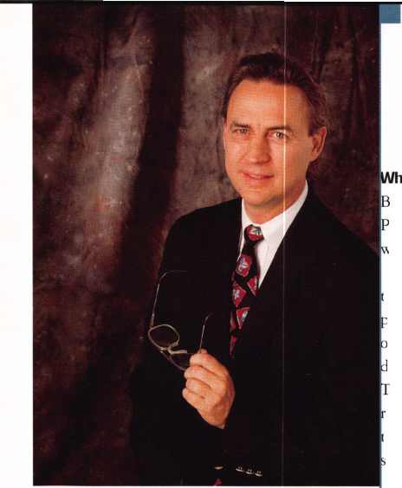

Art Director/Designer Advertising Sales

Contributing Authors

Publications Committee

ALOA Professional Staff

Staff Administrator Office Manager Receptionist Comptroller Financial Assistant Associate Executive Director Meetings & Education Coordinator Administrative Assistant Membership Coordinator Mailroom Assistant

Derek Holiman

Mary Sadler

Anelia M. Banda

Jerome V. Andrews, CML

Charles Cameron,CML

Paul Chandler, CRL

Claire Cohen, CML

Don Coleman, CPL, CPP

Bob De Weese, CPL

Ray D’Adamo, CML

Sal Dulcamaro, CML

Joe Esposito, CML

James Glazier, CML

Jon Griswold, CML

A.J. Hoffman, CML

Ken Holmlund, CRL

Tom Hood, CML

Richard A. Lacy, CPL

Barry Leas, CRL

Ray Lusk, CML

Mark Ohno

David Parrott

Henry H. Printz,CML

Randy Simpson, CML

Robert Stafford, CPL

Dave Thielen

James Watt, CML, CPS

John D. Cannon, CML, Chairman

Jerome Andrews, CML

AJ. Hoffman, CML

Tony Ramunno, CML, CPS

Donald E. Rule", CML

James Watt, CML, CPS

Evelyn Wersonick, CML, CPS (Trustee)

Charles W. Gibson, Jr.

Mary May

Margo E. Vela

Kathy J. Romo

Debra Bradshaw

Carmen D. Murphey, CMP

Jessica Vasquez

Janelle Vergara

Brandon Durrett

Jesse Morales Jr.

Complete address and phone number listings for the ALOA Board and Keynotes authors are available in your membership directory or by contacting the ALOA office at (214]827-1701.



ission Statement: The Associated Locksmiths of America, Inc. is dedicated to enhancing the professionalism, education and ethics among locksmiths and ose in related sectors of the physical security industry. With approximately 10,000 members in the United States. Canada and the freeworld, ALOA is poised to :lp members obtain the knowledge, the strength, and the confidence to perform their role in the physical security field with pride and dignity. But it is only rough active involvement and participation that ALOA can fully achieve its potential-and can help members to achieve theirs.

olicies: Keynotes® is the official publication of the Associated Locksmiths of America, Inc. [ALOA). Keynotes® acts as a moderator without approving, disap- oving, or guaranteeing the validity or accuracy of any data, claim, or opinion appearing under a byline or obtained or quoted from an acknowledged source, e opinions expressed by the authors do not necessarily reflect the official views of ALOA. Also, appearance of advertisements and new products or service donation does not constitute an endorsement of products or services featured by the Association. The Association does not accept responsibility for the inac- racy of any data, claim, or opinion appearing in this publication, due to typographical errors on the part of the authors. Association staff or its agents, iitor’s Note: This publication is designed to provide accurate and authoritative information in regard to the subject matter covered. It is provided and do­minated with the understanding that the publisher is not engaged in rendering legal or other professional services. If legal advice and other expert assistance required, the services of a competent professional should be sought.

uthors’ Payment: Effective Nov. 1, 1995, payment will be made for original articles submitted exclusively to Keynotes® magazine at a rate of: technical arti- 3S—$75 per page, double-spaced with standard one-inch margins; and business/human interest articles-$50 per page, double-spaced with standard one- ;h margins. [If only a portion of an eligible article is published, payment will be made for that portion only.) Authors will be paid $10 for each photograph, tart, exhibit or illustration that is utilized for their article. Maximum payment for both copy and photos is $350 for technical articles and $150 for isiness/human interest articles.

yment will not be offered for articles submitted by ALOA employees or members of the ALOA Board of Directors [unless material is of a technical nature), nor ■ articles submitted by a company that promote that company’s products or services. ALOA reserves the right not to pay for articles submitted by an individ- il[s) that promote a particular company’s products or services.

isclaimer: The Associated Locksmiths of America, Inc., [ALOA), reserves the right to refuse any article for any reason. Additionally, ALOA reserves the right edit, amend or modify any article submitted for publication in order to preserve technical accuracy, clarity, fairness or grammatical correctness. ALOA will ake the best efforts to notify the author of any changes. The extent of ALOA’s liability for any article or information contained therein will be a notice of correc- m or retraction in the next possible issue.

jynotes® [ISSN 0277 0792) is published monthly except for the combined July/August issue by The Associated Locksmiths of America, Inc., 3003 Live Oak St., alias, TX 75204-6186. Telephone: [214) 827-1701; FAX [214) 827-1810; e-mail [aloa@anet-dfw.com](mailto:aloa@anet-dfw.com). Subscription rates for members-$15.00 per year. Second ass postage paid at Dallas, Texas. POSTMASTER: Send address changes to: Keynotes, 3003 Live Oak St., Dallas, TX 75204-6186. © Copyright 1997, All rights served. No part of the contents may be reproduced or reprinted in any form without prior written permission of the publisher.

President

David M. Lowell, CML, CMS [602) 263-7716

Regional Vice Presidents Southeast

Dallas C. Brooks

Chairman: Finance Committee

[334) 826-8990

North Central

David A. Paulsrud, Sr., CML

Chairman: ALOA Scholarship Foundation, Inc.

[612) 533-6164

South Central

Carl King, CML

Chairman: Bylaws Committee

Curator: ALOA Museum

[713) 465-2500

Southwest

John I. Shandy, CML

Chairman: Membership Committee

[303) 443-9740

Northeast

John D. Cannon, CML

Chairman: Publications Committee

[703) 960-6413

Northwest

James M. Watt, CML, CPS Chairman: PRP Committee [406) 549-7667

Secretary

Ricardo Ohmit, CML [217) 384-6006

Trustees:

Breck H. Camp, CML, Chairman

[770) 455-6244

Henry H. Printz, CML

[201) 538-2737

Evelyn V. Wersonick, CML, CPS

[505) 247-9413

Leonard J. Passarello, CPL

[416) 752-7210

Edwin Toepfer, RL

[416) 225-5589

Directors

Dana L. Barnum, CML Chairman: Chapters Committee [610) 565-9900 Mark E. Blum, CML, CPS [517) 482-5809 James H. Glazier, CML Chairman: Education Committee [301) 831-5454 John J. Greenan

Chairman: Legislative Committee [773) 486-2030 Barry K. Leas, CRL [610) 272-9292 Raymond C. Lusk, CML Chairman: Convention Committee [509) 624-3152 Jeffrey S. Nunberg, CML [305) 324-8800

Anthony J. Ramunno, CML, CPS Chairman: Library/Museum Committee [330) 782-6204 Randy L. Simpson, CML Chairman: Public Relations Committee

1. 780-7026 Robert H. Stafford, CPL Chairman: Grievance Committee [860) 768-7917

William T. Straub, CML

1. 779-0383 Bruce J. Tarbet, CML [601) 924-4184

Chairmen of International Affairs

Laurence P. Mills Australia [129) 958-0445 Hans Mejlshede, CML Europe

Members-at-Large

Jerome V. Andrews, CM L

[860) 621-3601

Steven G. Engel, CML, CPP

Chairman: Strategic Planning Committee

[414) 731-5400

Thomas Freehling, CML

[320) 629-6538

AJ. Hoffman, CML

[714) 474-8877

J. Thomas Hood, CML

(610) 539-9555

Donald E. Rule', CML

(601) 324-2658

March 1997

Keynotes

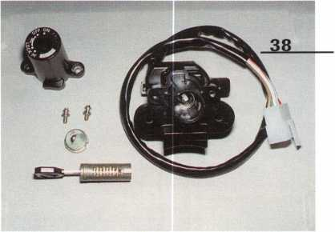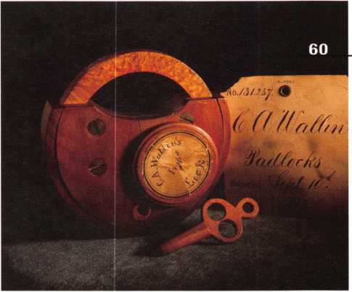

2

A Word with David Lowell

9

Legislative Comment

An overview of legislation across the country By John Greenan



42

Under Construction

A few months left until ALOA ’97 By Carmen D. Murphey, CMP.

52

PRP Report

Exam change reminder By James Watt, CML, CPS

53

Trade Tips

Brass plugs and figuring out the auto year By Tony Rammuno, CML, CPS

56

Focus on Education

Trade show learning bonuses By James Glazier, CML

59

Chapter News

Pulling off great meetings By Dana Barnum, CML

6D

Mail Box **Q**

Questions about the new industry classification*$* Q

12S

Upcoming Events **3**

Top of the third column 3

Applicants for Membership**. .**

Scheduled for clearance by April 1 ^

15

Industry News

Big llco/Silca news?



16

Security Marketplace

Something new every day

54

ALOA Extra

Updates on scholarships and museum donations

60

Back Page

44

Associate Members

49

Classifieds

54

Ad Index

55

Buyers Guide

Keynotes

March 1997

**Advertising**

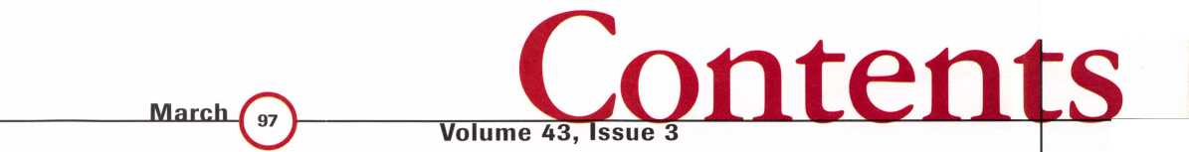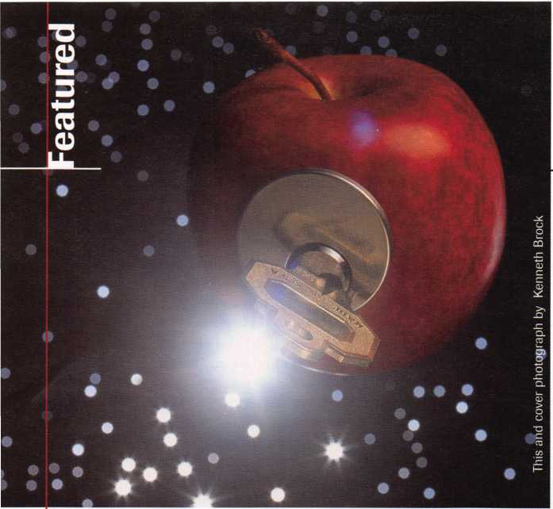

Cover

Knowledge of master keying and related topics is one way to separate the top-of-the-line professionals from the wannabes. So, if this subject isn’t one of your locksmithing mainstays, it’s back to school for you.

{Note: Master keying guru Jerome Andrews, CML, will be teaching a two-part class in July at ALOA ’97 in Reno. Herds your chance to learn from one of the best. Look for details in your convention brochure, coming in March. Or, for information on ordering Andrews' textbook, Fundamentals of Master Keying, see the ad on this issue’s inside front cover.}

Featured:also

24

**So You Want Your Own Locksmith  
Business?**

Being your own boss looks pretty attractive sometimes and  
it does have rewards. Just make sure you’ve thought it out  
first—then good luck!

By Ken Holmlund, CRL

28

**APPRENTICE CORNER  
Disclaimer: Not an Article on  
Master Keying**

You don’t need to take a course in real master keying, do  
you, huh? You’ll just cheat a little and that’ll work. Wrong!  
But until you make it to class, let’s cover a few pitfalls of  
faking it.

By Bob De Weese, CPL

38

**Motorcycle Locksmithing: Kawasaki**

The latest in our two-wheeler series.

By Ray DAdamo, CML, and Tina DAdamo, CRL

20

**Handling Routine Cylinder Changes Securely**

Now, if it’s non-master keyed hardware, we don’t need a sys­tem or anything, do we? Don’t make my head hurt. Put your reading glasses on. We need to discuss key records pro­cedures for routine cylinder changes.

By Jerome Andrews, CML

26

**Mastering Master Keying on the PRP**

It’s one of the 10 mandatory categories—it’s not going away. So stop worrying and learn what you need to know to pass this section, and improve your professional abilities too.

By Claire Cohen, CML

30

**Master Keying 101: Part 1**

Let’s start at the very beginning. This series will lead you through what master keying is, and some of the risks and benefits.

By Sal Dulcamara, CML

33

**Master Keying Magic**

OK, if you insist on a crash course, here’s a bag of tricks in one article. And whatever mystique you’ve assigned to the topic of master keying, we can make some of those delusions disappear.

By Randy Simpson, CML

March 1997

Keynotes

**Keynotes**

Mail Box



Dept!

**If you have an opinion to offer on the letter(s) printed in Keynotes each month, let us know! Submissions to the “Keynotes Mail Box” department are printed on a space-available basis. Write to: Keynotes Mail Box;**

**Associated Locksmiths of America, Inc.; 3003 Live Oak Street; Dallas TX 75204; or FAX (214) 827-1810.**

SIC Code Query

Dear Editor:

(Reference to the Jan. ’97 issue and item in Chapter News concerning “One Big Step for Locksmith-Kind” as reported by the Smoky Mountain Chapter concerning the hard work of ALOA legislative committee and lobbyist John Chwat) Locksmiths now have a new Security Industrial Classification (SIC) Code 571522—well, La-Ti-Da! So what? Seems to me an Internal Revenue Principle Business or Professional Activity Code is needed in the listing of trade codes so we can be classified as a professional trade when filing our annual income taxes and Schedule C.

How about it ALOA? What’s being done about that?

I also would like to comment on the Jan. ’97 PRP Report concerning the state of Illi­nois’ decision to use the ALOA Basic CRL mandatory examination and the Basic Elec­tricity and Life Safety Code elective exams as the main vehicle for testing Illinois lock­smiths to determine their competence and skill levels.

I don’t really think Mr. Watts and Mr. Greenan realize what a boon this is for ALOA and for locksmiths residing in states that are also thinking of licensing and writ­ten examinations. It appears to me that this is a very good opportunity to get some type of ALOA-sponsored national examination going for any state that chooses to partici­pate at a price for the use of the exam.

It appears to me that both the Legislative Chairman and the PRP Chairman would both be all over this new and positive devel­opment, and I further firmly believe that each member of ALOA is in the debt of Richard Ohmit, CML and Stan Haney, CPL for having the foresight to see this one com­ing—especially the state of Illinois—while still having the fortitude to do something about it while the iron was still hot.

I hate to see ALOA lose out on this one because no one claims to have the magic ball to see what is in store for us all.

Joe Stevens, CML, CJS

**Response from Charles Gibson, ALOA**

Dear Joe:

The importance of the Standard Industri­al Code (SIC) is much greater than may be understood. The SIC is established by the Office of Management and Budget (OMB). This code is then used by the Bureau of Labor Statistics (BLS) and the Census Bureau (CB) when they gather information. The IRS did not use the SIC code system to gather its data. However, the IRS will begin using the SIC code system for tax year 1997. The entire listing of SICs is far too long to be included on the tax forms. Because of this condensation of the list, it is possible that even though locksmiths have a separate SIC, it will not appear on the tax forms. It would certainly not be possible without the establishment of the number by the OMB.

The “SIC” will soon be replaced. New codes are being developed as a result of the North American Free Trade Agreement (NAFTA). These new codes will be under The North American Industry Classification System (NAICS). All of the functions of the SIC will go to the new code. The latest draft of the new code list published in the Federal Register—dated November 5, 1996—lists locksmiths with their own code of 561622. (This is a change from what was published in the January Keynotes). This places lock­smiths under the more general classification, 56162, Security Systems Services. It may be this, or an even more general classification, that will be used by some agencies when gathering data.

There is now a contractual arrangement between the state of Illinois and ALOA for ALOA to provide the examination Illinois will use under its locksmith licensing law. This test will be based on, but not identical to, the ALOA PRP Mandatory evaluation plus the Life Safety and Basic Electricity electives. Illinois locksmiths who worked on the establishment of a licensing law in Illi­nois envisioned this arrangement from the very beginning of their efforts several years ago. Kathy Zaniolo and John Greenan were two of the locksmiths who worked hard not

only for the legislation, but for the recogni­tion of ALOA as the appropriate organiza­tion to provide the test. ALOA has sent, and continues to send, copies of the Illinois and Model laws to locksmiths who are pro­moting locksmith legislation in other states. ALOA is currently bidding on conducting locksmith testing in Dade County, Florida. The ALOA PRP and Legislative commit­tees are working hard to build on the suc­cess of Illinois.

Second That Emotion

Dear Editor:

I second Lt. Col. Gibson’s sentiments (January Keynotes) Attending the annual business meeting is one the most significant contributions a member can make toward bettering our association. I hope that all of the members at the convention in Reno will make the effort to attend the meeting.

Paul Mannen, CML

Keynotes

March 1997

fim/u Horten!//

What have you been doing?

There's almost no time left!!!

Do you want to be left behind???

Bring the family ....A trip to the Liberty Science Center

Bring the employees Classes that will help them to help you

Bring the inventory list Manufacturers and Distributors from all over the country

Bring your brain The PRP, become a CML

Most important

Bring Yourself

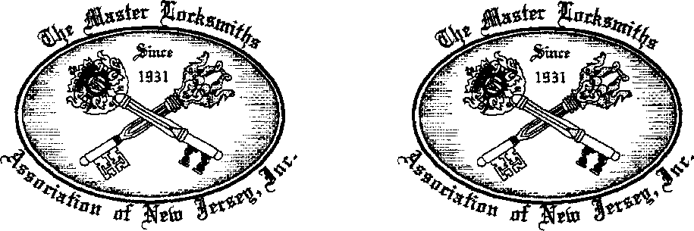

The iltatter HotfcSmttftf &**0Ctatt0n of Jieto JTttOep's convention  
Only ALOA's national convention is bigger

Remember the Date.............................................................April 17th until the 20th

Remember the Place...........................................Garden State Convention Center

next to Doubletree Hotel in Somerset, NJ Remember for more information..............................................................................

itetcr Hocfcsmittjs Association of M3

P.O. Box 2441  
Morristown, NJ 07962-2441  
Phone (201) 267-8884  
Fax (201) 538-2248  
E-mail: [btimmann@early.com](mailto:btimmann@early.com)

Free Information - Reader Service Card #1

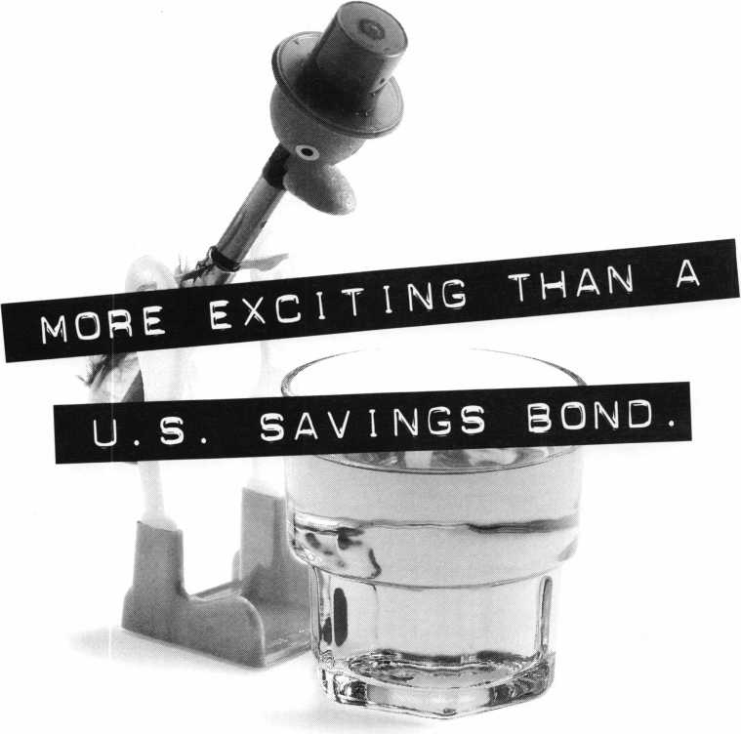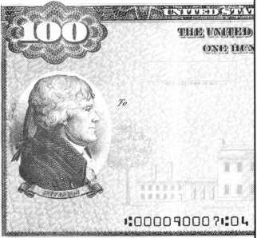

**ALL RIGHT ALREADY,** so a U.S. Savings Bond isn’t the most exciting thing in the  
world. **GOOD FOR YOU!** After all, this is your hard-earned money we’re talking about. Do  
you really want your investments to be thrilling? Breathtaking? **NO WAY.** Wouldn’t you rather

have an investment that’s guaranteed to grow, one that’s backed  
by the full faith and credit of the United States government?

Sure you would. U.S. Savings Bonds.

Yawn all the way to the bank!

Take Stock **in America**

S.

SAVINGS

BONDS

si*

A public service of this magazine

|  |  |
| --- | --- |
|  | Comment |
| Legislative |  |
|  | J John J.dreenan  Committee Chairman |

It would be very important for locksmiths in every state to seriously  
consider retaining a lobbyist.

I am pleased to say that our new monitoring service seems to be doing a good job. Since the beginning of the year they have reported on more than 30 state bills that may affect locksmiths in 17 states. These bills will have identifying numbers. Bill numbers that are preceded by A.B. are Assembly Bills, H.B. are House Bills and S.B. are Senate Bills.

You can contact your local state legislature for copies of these bills using the identifying numbers, or you can contact the ALOA office at 214-827-1701.

Some of these bills are tax credits to con­sumers for installing security systems in their homes or businesses. We have reviewed these bills to see if they include closed cir­cuit television as part of a security system. Since many of our members are providing CCTV to their customers, we will continue to address these bills. The following is a list of bills that provide for tax credits. We will keep you informed of their progress as we receive the information: Hawaii S.B. 1700, New York A.B. 489, New York A.B. 972, New York A.B. 2581, New York S.B. 1107 and New York S.B. 1746.

Ten of these proposed bills are for the licensure of the alarm or security systems companies. Almost all of these bills contain definitions that would include products and services currently provided by the lock­smiths in these states. It is extremely impor­tant that you monitor these bills at the state level. Once these bills are introduced, they can be changed and amended long before we

could ever report it to you. I strongly urge you to hire a lobbyist to represent you in your state legislature to address these bills: Georgia H.B. 191, Kansas S.B. 78, Indiana S.B. 73, Maryland S.B. 614, Mississippi H.B. 1163, Mississippi S.B. 2613, Montana S.B. 105, New Jersey A.B. 2629, New Mexico H.B. 331, North Dakota H.B.

1439.

Two of these bills are for the licensing of locksmiths. I strongly urge you to become involved in the legislative process with these bills: Pennsylvania S.B. 286 and Rhode Island H.B. 5695. If you are unfamiliar with the framework of these bills, I suggest you obtain a copy and evaluate it. You should also contact the association sponsoring the bill to gain an understanding of their posi­tion and what you can do to help.

It would be very important for locksmiths in every state to seriously consider retaining a lobbyist to monitor your state legislature for bills and regulations that may effect the locksmiths of your state. It can take a long time to organize this type of program. But if you start now, you will be better prepared when legislation does come to your state.

The ALOA legislative committee will be happy to help you and your association in any way we possibly can.

Legislative Comment is written by John Greenan on behalf of ALOA’s Legislative Committee. Comments or questions can be directed to him at: Fink Safe & Lock; 2307 N. Western Ave.; Chicago, IL 60647; (773) 486- 2030; FAX (773) 486-4268.

Assembly BillsA.B.

House BillsH.B. Senate BillsS.B.

Connecticut S.B. 549

Establishes procedures to reduce false alarms.

Georgia H.B. 191

Licensure of alarm systems monitoring con­tractors.

Hawaii S.B. 722

Relates to income tax credit for installation of an alarm system.

Hawaii S.B. 1700

Relates to income tax credit for home securi­ty systems.

Kansas S.B. 78

Licensure of alarm systems companies and their employees.

Illinois H.B. 72

Exempts journalists who obtain information from public records.

**Legislative Action Contact Network**

Date

Name

Company Address

I am interested in:

* Working on Legislative Issues
* Fundraising
* Gathering/Giving Information

Home Address

Telephone

FAX

e-mail

March 1997

Keynotes



OF WAY

MDA won't yield in  
its quest to defeat  
40 neuromuscular  
diseases.



Muscular

Dystrophy

Association

(800) 572-1717

People help MDA...  
because MDA helps people.



Keynotes

March 1997

Legislative

omment

Illinois S.B. 108

Amends act to require licenses to include their license number in any advertising.

Indiana S.B. 73

Licensure of alarm systems companies and their employees.

Indiana S.B. 150

Adopts a statewide examination to be given to applicants for licensure as electrical con­tractors.

Maryland S.B. 614

Licensure of security systems companies.

Mississippi H.B. 1163

Creates the Mississippi Alarm Contractors Licensing Act.

New York A.B. 2581

Grants a 10 percent tax credit to businesses in King county that install security systems.

New York S.B. 1107

same as A.B. 972

New York S.B. 1746

same as A.B. 2581

North Dakota H.B. 1439

Licensing of electronic security systems.

Pennsylvania S.B. 286

Licensure of locksmiths.

Rhode Island H.B. 5695

An act relating to the licensing of lock­smiths.

Mississippi S.B. 2613

Creates the Mississippi Alarm Contractors Licensing Act.

Montana S.B. 105

Requires a low voltage electricians license for persons wiring life and property protection equipment.

New Jersey A.B. 2629

Provides for regulation of alarm businesses by the Board of Examiners.

New Mexico H.B. 331

Licensure of burglar alarm businesses.

New York A.B. 328

Requires the installation of carbon monoxide detectors in various rental premises.

New York A.B. 489

Grants income tax credit for certain private security devices in a dwelling.

New York A.B. 972

Provides a tax credit against the corporate franchise tax for the expense of installing a security device for the purpose of protecting a taxpayer’s small business from unlawful entry, theft or burglary.

Virginia H.B. 2190

Excludes devices attached to wearing apparel used for theft deterrent from licensure as a private security service business.

Regulations

Iowa

Updates the state of Iowa building code to include the latest conditions of the national­ly recognized model codes.

Maryland

Proposes new regulations to establish a regu­latory framework to enforce Chapter 226, which requires persons who sell security sys­tems in the state to be registered, and per­sons who install them to be licensed.

wAbout the Chairman: John J.

Greenan represents the fifth generation of lock-  
smiths and is vice president of Fink Safe & Lock  
in Chicago, IL. A locksmith since 1985, John  
also serves on ALOA’s Convention and Strategic  
Planning committees. He is also chairman of the  
Allied Locksmiths of Illinois

Goodbye, tax forms  
Hello,TeleFile!

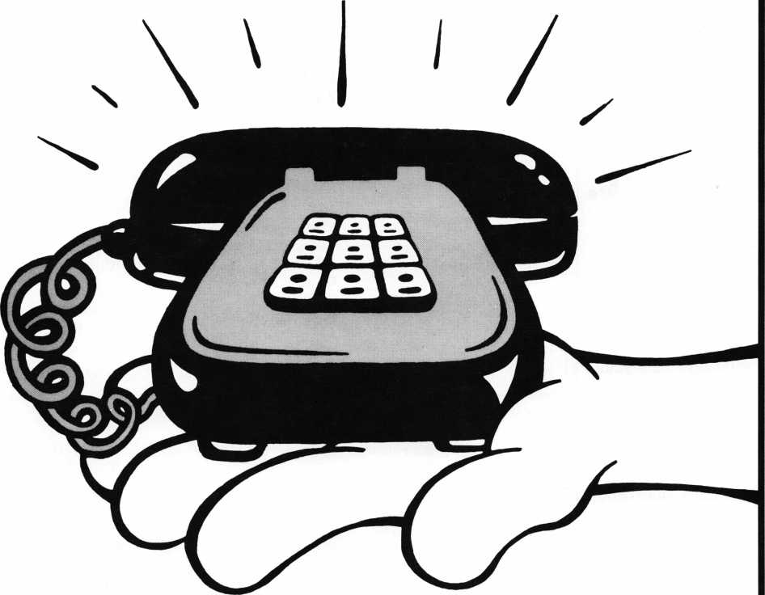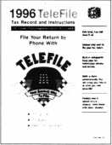

This year, join the millions who will use TeleFile to file their taxes by phone.  
With TeleFile from the IRS, you file your tax return with one quick, easy call from  
a Touch-Tone™ phone. TeleFile service is completely free. And since there are no  
forms, the IRS can get your refund to you within three weeks. Check your mail  
for a TeleFile booklet. If you qualify, take advantage of this convenient service.  
Filing doesn't get any easier than TeleFile.

&

Department of the Treasury

Internal Revenue Service

<http://www>. irs.ustreas.90v

III TeleFile

It's free. It's fast. It works.

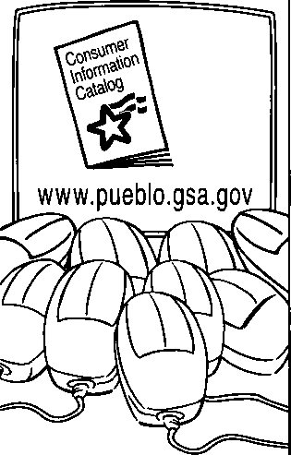

1. out of
2. mice prefer it.

If there’s a mouse in your house, catch the free Consumer Information Catalog online. There you’ll find the latest info from more than 40 government agencies.

Just point and click your way to [www.pueblo.gsa.gov](http://www.pueblo.gsa.gov) to nibble on hunks of useful information on saving money, staying healthy, even educating your children. There are more than 250 free publications ready for you to read or download.

Or you can order the Catalog by mailing your name and address to Free Catalog, Pueblo, CO 81009. But for the fastest info running, scurry to the Consumer Information Catalog online.

[www.pueblo.gsa.gov](http://www.pueblo.gsa.gov)

(It’s the cat’s meow.)

U.S. General Services  
Administration

12| Keynotes March 1997

**Upcoming**

Events

Date

March ’97

8 & 9

Ozark Professional Locksmith Association

Annual Retreat and Classes Inn of the Ozarks Eureka Springs, AR Contact Betty Gray at (501) 524-3660 or Janis Reves (evenings) at (501)631-6406

11-14

ISC Expo 1997 Conference and Exposition

Las Vegas Convention Center Las Vegas, NV Customer Service (203) 840-5602

15

Vindicator Corporation • Training Classes for Vindica­tor Lock II

Contact: Tamara Martell

(512)314-1200

[lock@vind.com](mailto:lock@vind.com)

15-16

Southern Lock

Annual Southern Lock Buyers Trade Show

St. Petersburg Bayfront Hilton St. Petersburg, Florida Contact: Bill Underwood (813) 541-5536

April ’97

7-11

mark bates Associates 5 Day D.O.D./D.O.E. Combination Lock Training (888) 622-5495

17-21

Master Locksmith Assoc, of New Jersey Somerset, NJ Contact: (201) 267-8884

19

Vindicator Corporation Training Classes for Microlock Contact: Tamara Martell (512)314-1200 [lock@vind.com](mailto:lock@vind.com)

24-27

Professional Locksmith Associa­tion of Alberta 1997 Convention and Trade Show

Red Deer Lodge Red Deer, Alberta Contact: Dave Kennedy (403) 948-9997 (FAX)

May ’97

16

Vindicator Corporation • Training Classes for Vindica­tor Lock II

Contact: Tamara Martell

(512)314-1200

[lock@vind.com](mailto:lock@vind.com)

19-23

mark Bates Associates 5 Day D.O.D./D.O.E. Combination Lock Training (888) 622-5495

June ’97

i

California Locksmiths’ Associa­tion

Sacramento Valley Chapter SWAP Meet, Trade Show, Lock­smith classes SES Hall

10427 Stockton Blvd.

Elk Grove, CA Contact: Joe Longoria (916) 391-1744

S' Future Conventions

1997

ALOA ’97 July 28-Aug. 2 Reno, NV

SAFETECH ’97 May 5-10 Louisville, KY

SERLAC Sept. 24-28 Grenelefe, FL

24th Annual Tri-Regional Security Conference Oct. 21-26 Bellevue, WA

1. ALOA ’98 June 15-20 Nashville, TN

SAFETECH ’98 May 4—9 Valley Forge, PA

1. ALOA ’99 July 25-31 Cincinnati, OH

SAFETECH ’99 May 3—8 Las Vegas, NV

2000

ALOA 2000 Date TBA Las Vegas, NV

SAFETECH 2000 May 8-13 Lexington, KY

2001

ALOA 2001 July 15-21 Baltimore, MD

For PRP dates, see p. 52. For ACE dates, see p. 56. Send in the dates of your organization’s activi­ties today!



Got your membership or class certificate thumb-tacked on the wall? Short of renting a spotlight and a billboard, a wooden pocket plaque is the coolest way to bring attention to your ALOA accomplishments.

Get a pocket plaque and show off a little. Because ALOA firmly believes suc­cesses should be proudly displayed. But renting a skywriter might be a little much.

Pocket plaques are on sale for 12 bucks. Get 'em while they're cheap.* After all, those thumb-tack holes start off small, but they always get bigger.



Associated Locksmiths of America, Inc. 3003 Live Oak Street Dallas, TX 75204 (214) 824-1701

While Supplies Last

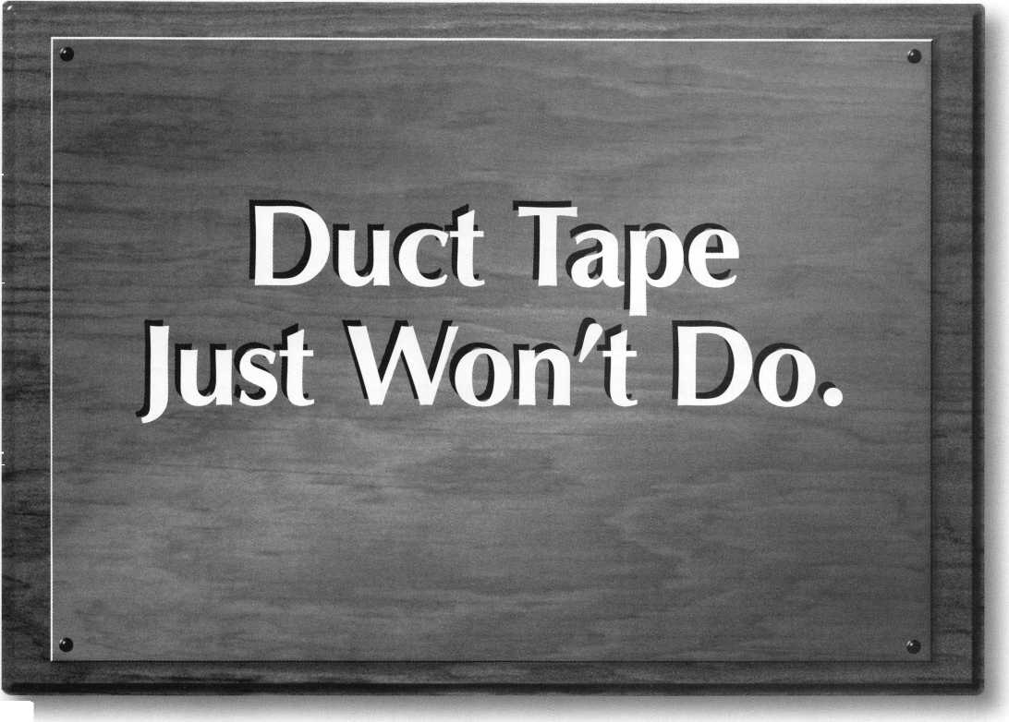

Applicants

For Membership



Dept

***The following applicants are scheduled for clearance***

***as members of ALOA The names are published for  
member review and comment prior to April 1, 1997, to  
ensure applicants meet standards of ALOA’s Code of  
Ethics. Protests, if any, should be addressed to the Mem-  
bership Department and must be signedActive Mem-  
bership applicants (A) have worked in the industry two  
or more years. Allied Membership (AL) applicants are***

***not locksmiths, but work in a security-related field.***

ALABAMA

Eight Mile

026590, David J Reynolds, AP SPONSOR: John Robinson

ARIZONA

Phoenix

026596, John R Alexander, A SPONSOR: James Hawley 026613, Paul Bilant, A SPONSOR: James Hawley 026605, Guy M Bryan, A SPONSOR: James Hawley

CALIFORNIA

Hayward

026621, Elton Fanter, A SPONSOR: Blaine Lucas 026618, Leonard Fross, A SPONSOR: Blaine Lucas 026620, Dorothy Jutras, A SPONSOR: Blaine Lucas 026622, Norman Jutras, A SPONSOR: Blaine Lucas 026619, Tracy Knight, A SPONSOR: Blaine Lucas Napa

026599, Michael A Creason, A SPONSOR: Chris Cunningham

San Clemente

026615, Sandi L Buskirk, A

Santa Rosa

026616, Don M Thomas, A SPONSOR: Larry Wirth

COLORADO

Thornton

026589, David J Baldwin, A

DISTRICT OF COLUM­BIA

Washington

026593, Dennis A Price, A SPONSOR: Philip Rovenolt

FLORIDA

Bradenton

026598, Shane L Youdal, A SPONSOR: Kent McFarland

Marco Island

026608, Mark W McCauley, A SPONSOR: Louis Woessner

Melbourne

026634, Loren W Hausman, A SPONSOR: Charles Granda

GEORGIA

Norcross

026601, Laura A Miles, A SPONSOR: Breck Camp

HAWAII

Kapolei

026611, Richard R Garcia, A SPONSOR: Barbara Watt

IOWA

Spencer

026632, Rodney R Coffman, AP SPONSOR: Maurice Kruckenberg

ILLINOIS

Chicago

026635, Mary J Nosek, A

Rock Island

026624, Timothy Meegan, A SPONSOR: Robert Furlow

LOUISIANA

Chalmette

026592, Richard M Gutierrez, A

MASSACHUSETTS

Sharon

026627, Gerald H Boyle, A SPONSOR: Jack Hobin

MARYLAND

Millersville

026594, J Black, A

MICHIGAN

Dearborn Heights

026609, Collis H Adkins, A SPONSOR: James Belcher

Grand Rapids

026617, Bradley J Polega, A SPONSOR: Robbin Potyraj

Pontiac

026633, William G Little, AP SPONSOR: Salvatore Dulcamaro

MINNESOTA

Minneapolis

026588, Steven D White, A SPONSOR: Douglas Wilson

Prior Lake

026591, Rod J Sawatzke, A SPONSOR: Richard Sievers

MISSOURI

Cape Girardeau

026614, Howard S Sander, A SPONSOR: John Lashley

Odessa

026606, James W Hankins Sr , A SPONSOR: Lawrence Taylor

MISSISSIPPI

Tupelo

026597, Sam Carter, A

MONTANA

Missoula

026628, Jim T Happe, A SPONSOR: Barbara Watt

NEW JERSEY

Rochelle Park

026630, Robert J Rutherford, A SPONSOR: Walter Lascar

NEW YORK

East Moriches

026636, Steven G O’Laughlin, AP SPONSOR: Robert DeWeese

OHIO

Cincinnati

026587, Jeffrey T Brickler, AP SPONSOR: James Brickler

Cleveland

026623, Glenn Mason, A SPONSOR: Sandor Davis

SOUTH CAROLINA

Beaufort

026631, Keith P Mayo, A

Columbia

026626, Ryan L Badeaux, AP SPONSOR: Daniel Landry

TEXAS

La Marque

026600, Rod C Starnes, AL SPONSOR: Donald Cooper

VIRGINIA

Arlington

026595, James S McAlpine, AP SPONSOR: John Cannon

WISCONSIN

Milwaukee

026602, Fred A Kosloske, AP

BAHAMAS

Nassau

026625, Desmond O Fox, AP SPONSOR: Desmond Fox

FRANCE

Sarcelles

026612, Michael A Farouze, A SPONSOR: Paul Kulauzor

JAPAN

Kanaga, Wa-Ken

026604, Kuroki Yoshito, A SPONSOR: Takashi Kuwana

Nagareyama City

026629, Shinichi Koyama, A SPONSOR: Toshihiro Asano

NEW ZEALAND

Auckland

026607, Kenneth R Lees, A SPONSOR: Ross Galt

TRINIDAD

Port of Spain

026603, Laurence P Pouchet, A SPONSOR: William Neff

14 | ***Keynotes***

March 1997

Industry

News



Dept

Big News

Keynotes has received an unconfirmed report  
stating that Ilco may have entered into an  
agreement to buy out Silca. Ilco and Silca  
are two of the largest manufacturers of after-  
market key blanks. Readers will be made  
aware of developments as they become avail-  
able.

New Guy in Town

Matthew Taylor  
has been named  
Applications  
Technologist for  
Philips CSS Inc.  
Taylor’s responsi-  
bilities include:  
assisting cus-  
tomers in product  
selection, provid-  
ing technical sup-  
port to sales and

marketing and responding to customer  
inquiries on Philips security products.

Before working at Philips, Taylor was a pro­ject engineer for a meteorological measure­ment company. He holds a bachelor’s degree in electrical engineering from DeVry Tech­nical Institute.

Joining the Sales Force

Craig Summers has been named the West Coast Regional Sales Manager for Silent Knight. Summers’ expensive experience in designing and selling fire alarm and inte­grated systems that specifically use Silent Knight equipment. He is NICET certified for fire alarms systems engineering. Feel free to contact Summers at 1800-328-0103, extension 39-

New Certification

Sargent & Greenleaf has received ISO 9000 certification. Internal Organization for Stan­dardization (ISO) certification is a global guideline for quality management systems. Over 90 countries accept ISO 9000 in their industries.

This certification allows Sargent & Greenleaf to remain competitive in the U.S.

and highly regulated markets.

Honk, Honk

Volvo Car Corporation has chosen SPX Cor­poration to be the exclusive supplier of dealer essential service tools. SPX will design, produce and distribute all essential speciality service tools for Volvo’s new model components and vehicles.

The Volvo Dealer Service Equipment Program in North America, which provides service solutions and equipment to the deal­er network of Volvo Cars of North America, will also be administered by SPX.

Olympus Web Site

Olympus Locks is now on line with a new web site: <http://www.olympus-lock.com>. Olympus Lock manufactures and distributes a variety of patented rekeyable small/large pin cabinet locks, interchangeable core cabi­net locks and solid brass padlocks. For more information, contact Olympus at:

2720 NE 15th Street Seattle, WA 98125 (206) 362-3290 (800) 525-0954 (206) 362-3569 (FAX)

[info@olympus-lock.com](mailto:info@olympus-lock.com) (e-mail)

Partners

Silent Knight and Northern Computers,

Inc. (NCI) have come together for a two- year, multi-million dollar agreement to jointly manufacture and market security systems hardware.

The alliance is beneficial because of Silent Knight’s engineering and manufacturing strength and NCI’s reputation as a sales and marketing leader.

This agreement enables NCI to market the Silent Knight Census 4821 Security and Access Control System as the N-750 direct to installing dealers. The Census N-750 is used for educational and health care facili­ties, as well as financial services. The system allows for up to 1800 users at up to 24 doors. For more information, contact:

Silent Knight 7550 Meridian Circle

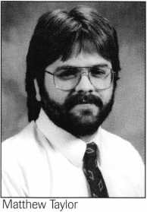

Maple Grove, MN 55369-4927 (612) 493-6400

More Involvement

The American Society for Industrial Securi­ty's Certified Protection Professional (CPP) Program has seen a 243 percent increase in participation. The CPP program requires new certification every three years to encourage continuing education. The recer­tification also allows professionals to be updated on current trends and develop­ments in the security industry.

ISC EXPOs

The ISC EXPO/Las Vegas takes place March 12-14 at the Las Vegas Convention Center. Attendees will see more than 500 companies, as well as state-of-the-art securi­ty equipment and services for access control and security hardware, integrated systems and home automation.

The conference offers 75 sessions, tours and special events.

The ISC EXPO/New York is scheduled for August 26-28, 1997 at the Jacob K. Javits Center in New York, NY. ISC EXPO/New York will showcase 450 exhibitors and 90,000 square feet of dis­plays.

For additional information, contact:

ISC EXPO Customer Service (203) 840-5602

http:! / isc. reedexpo. com

March 1997

Keynotes



Security

Marketplace

High Tech Connection

Samsung Opto-Electronics America intro­duces the SVC-10, a compact, high resolu­tion, color CCD camera. The camera is designed to connect to a personal computer via video capture board (not included) for multi-media communications. Through sin­gle cable, the camera can also be connected to a television, monitor or video recorder. The field of view is 57 degrees. For more information, contact:

(201) 902-0347 (201) 902-9342 (fax)

Reader Service #2

**Mew** Lock

Vindicator has just released the MicroLock 40, a combo-key elctronic safe lock. This product allows for multi-door control for multiple users, while maintaining a com­plete audit trail of all safe activity.

Simple to retrofit, the MircroLock 40 has programmable time locks and time delays.

A complete audit trail is a standard feature, which may be printed to a printer, down­loaded to a computer or viewed on the MicroLock 40’s display. The MicroLock’s memory records the most recent 2,000 events. For more information, contact: **Vindicator Corporation Howard Dame, General Manager (512) 314-1200 [lock@vind.com](mailto:lock@vind.com) Reader Service #3**

Super Surveillance

Philips Communication & Security Systems, Inc. has added the LDH 2550/60 Series Color VidQuad Video Processors. The processors digitally capture full video from four-color and monochrome source, reduces images to quarter-screen size and combines them to provide a quad display on a single monitor. The video seen on the monitor is displayed in real time update for optimum surveillance of detection areas.

Easy to install, the units do not require external synchronization, and will automati­cally accept inputs from any El A, RS-170 525 line, 2:1 interlaced source or input



from any PAL, CCIR 625 line, 2:1 inter­laced source. Four discrete digitizers provide a true real time update. Rack mounting hardware included.

For more information, contact:

Philips Comm. & Security Systems, Inc.

1004 New Holland Ave.

Lancaster, PA 17601-5606

(717)295-2900

Reader Service #4

You Can Run, But You Can’t Hide

Police now have a flexible, fiberoptic instur- ment to help locate illicit drugs in suspi­cious vehicles. Once attached to its portable light source, the Olympic fiberscope allows officers to see inside a gas tank, behind a dashboard or inside panels without having to disassemble the parts of the vehicle.

The scope has a diameter of six millime­ters and a working length of approximately six feet. The probe is easily inserted any­where in the vehicle that is difficult to see into. The units also have cameras with adapters so photos may be taken for future reference. For more information on visual inspection instruments, contact:

Olympus America, Inc.

Industrial Products Group Two Corporate Center Drive Melville, NY 11747 (800) 446-5260 ***Reader Service #5***

No Exit

Security Door Controls (SDC) 101 AR EXIT CHECK delays unauthorized egress for 15 to 30 seconds.

The EXIT CHECK complies with NFPA 101 Life Safety Code and helps to deter shoplifting, employee theft, patient wandering and infant abduction. This unit is designed for hospitals, retail stores, uni­versities, airports and commercial and indusrial facilities. For detailed data sheets, contact:

(805) 494-0622 (800) 959-4732 (FAX)

Reader Service #6

***Keynotes***

March 1997

What a Release!

The PEGASYS 1000 Release 4 from Card- key Systems, Inc. is a security management system that allows for full integration of video imaging and alarm receivers. The sys­tem also offers two elevator control options, dial-up operation and host redundancy fea­tures. Eight workstations on a local network can control and monitor a range of security management functions, and PEGAvision allows users to control cameras and moni­tors.

The new S320 Field Panel is available for Release 4.0 A fully configured PEGASYS 1000 Release 4 system supports up to 2,048 field devices consisting of card readers, alarm terminals and output control termi­nals. For more information, contact:

Cardkey Systems, Inc.

1757 Tapo Canyon Road Simi Valley, CA 93063 (805) 522-5555 (805) 582-7888

Reader Service #7

New NAVCO

NAVCO introduces the new NAVNET P.O.S. Exception Monitoring System, which enables retailers to identify, monitor and record suspicious cash register activity. The system is capable of generating exceptional reports at the host site, making it easier for loss prevention managers to identify prob­lems.

Options include: remote access for laptop access to the PC; tape managment for track­ing time and date usuage of individual videotape using barcodes; fax-back alarm reponse and automatic service dispatch. For more information, contact:

Jill Dunn (714) 779-7499

Reader Service #8

Now It’s Security 600

Security Lock now maintains total inventory of all Folger Adam strikes, replacement components and accessories, including the new 600 series strikes.

The 600 series offers heavy duty cast con-

|  |  |
| --- | --- |
|  | Security |
|  | Marketplace |

struction, fits ANSI A115.1 prep with sim­ple frame face modification, is non-handed and can be used in narrow jambs.

Security Lock is open late with guaran­teed overnight delivery. A 525-page catalog is available upon request. Contact Security Lock Distributors at:

(800) 847-5625

(800) 878-6400 (FAX)

e-mail: [SECLOCK@NETCOM.COM](mailto:SECLOCK@NETCOM.COM)

www. seclock. com

Reader Service #9

New Technology from NAPCO

NAPCO Secuirity Systems, Inc. now offers the version 3.25 of PCD3000 software. This version includes many new features for Gemini Keyfob users, more wireless features and new Veri-Phone capabilites. With the “automatic interior bypass,” the system is automatically in the “home” or “away” mode. The new version provides more options and system flexibility, and is user- friendly. For ordering or more information, call:

NAPCO Customer Service (800) 645-9445

Reader Service #10

Two New Ways to Lock

American Lock Company introduces two new styles of four-dial resetable combination padlocks. The additions are available in 20 mm and 40 mm, and both sizes have cut- resistent shackels and a four-dial “set your own combination” feature for private, key­less security. Both are sold on retail cards that are color-coded to match American Lock’s other brass padlocks. The 1 1/2-inch (40 mm) padlock is suitable for any indoor or outdoor security application, and the 3/4- inch (20 mm) padlock is suitable for lug­gage, sports bags, golf bags, or other per­sonal security uses. For more information, call: (800) PADLOCK Reader Service #11

Smart Looks

CCTV Corp. introduces the GBC Colorsen- try “Smart Value” Color BC-865C, an

indoor/outdoor, weatherproof ball camera.

Its decorative design blends into any envi­ronment and the weatherproof housing allows for worry-free installation.

The BC-865C has more than 325 lines of resolution and a sensitivity of only .4 Lux. True color rendition in all lighting condi­tions is possible due to its built-in electronic shutter and through-the-lens automatic white balance. The camera comes standard with a 6mm lens and a 12VDC power module. Other len options are available.

For more information, contact:

CCTV Corp.

280 Huyler Street

South Hackensack, NJ 07606

(201) 489-9595

(800) 221-2240

FAX: (201) 489-0111

Reader Service #12

Good Dogging

Architectural Control Systems, Inc. (ACSI) Series 1500 Electric Dogging allows contin­uous electric latch retraction and dogging of fire-rated exit devices simultaneously. Once the ACSI 1540 is energized, first time mechanical activation of the push bar will hold the push bar down and keep the latch bar retracted in the unlocked position.

When power is remove the latch bolt extends and the push bar is released.

The ACSI 1540 is UL listed for fire-rated exit devices. It is available in rim, mortise and vertical rod exit device and requires standard 24 VDC operation. For additional infomation, contact:

Mark LeGrand ACSI

10666 Gateway Blvd.

St. Louis, MO 63132 (800) 753-5558 (314) 432-2090

Reader Service #13

Night Time

ITT Night Vision introduces the new Night Cam 300/310 for use with 35mm cameras and camcorders. Used for outdoor recreation, wildlife observation, security,

surveillance and crime-fighting, this camera benefits photographers, security profession­als, home owners and night vision con­sumers. For more information, call:

*(800) 448-8678* Reader Service #14

■Reference Material **Smart Stuff**

McGunn Safe Company is offering a 17 minute videotape entitled “Smart Safe & Smart Cashier: Where the Smart Money Goes.” The video examines the benefits of the Smart Cashier, a new cash-dispensing safe. The Smart Cashier has a high speed bill validator, a self-sealed removeable inner canister and an exterior receipt printer.

The Smart Cashier is accessed by an employee’s personal combination so owners can track cash shortages via the safe’s audit capability. For more information, or to receive a free video, call: (800) 621-2816 Reader Service #15

**New Catalog**

MBA (mark bates associates) is pleased to offer Catalog No. 3, 1996/97. Many new products are offered in addition to the return of popular products offered in the past two catalogs. MBA is a factory autho­rized distributor of Mas-Hamilton Safe Locks, and the new catalog also features products from Framon, Pro-Lok, Industries CL, Strong Arm and a variety of small man­ufacturers making fine tools for the security industry. For a free copy, contact:

(888) 622-5495 FAX: (606) 887-9491 e-mail: MBA [Tools@aol.com](mailto:Tools@aol.com) or write:

MBA

101 Edgewood Plaza Dr.

Nicholasville, KY 40356-1850 *Reader Service #16*

March 1997

Keynotes



*Do you belong in the*

ALOA

President’s

Club?

How can I join (he President’s Club?

You can earn membership in this  
prestigious club by recruiting just  
10 new members for ALOA.

Any ALOA member may participate.*

What do I get?

When you recruit 10 members, you receive a handsome blue blazer with  
a President’s Club crest. For each additional five members you recruit,  
you receive a lapel pin with gold-filled numbers, indicating your  
recruiting successes.

You also get the satisfaction of knowing that

you are helping your association, helping your industry grow, and you  
are helping fellow locksmiths achieve success.

How do I get started?

Contact the ALOA office for a supply of applications. One President’s  
Club credit is awarded for each new applicant. Credit is awarded only  
after the membership application is approved. However, the credit will  
apply for the period in which the application is received. Failure to  
identify yourself as the sponsor on

the application form at the time it is submitted to ALOA for processing  
will forfeit any credit.

*ALOA Board of Directors not eligible for membership in the  
President's Club.

PRESIDENT'S CLUB ROSTER

131 Members 013186 Kwok-kei Leung

73 Members 019882 Henry Raymond

67 Members 005354 Stewart Levine, CML

58 Members 012566 Mary Ohmit, CPL

50 Members 022598 Allen Konrath

41 Members 012103 Jack Hobin, CPL

37 Members 022907 Toshihiro Asano

36 Members 021172 Myeong-Rae Cho

32 Members 011133 Salvatore Dulcamaro, CML

29 Members 006072 Charles Robertson, CML

27 Members 008951 William Neff, CML

27 Members 010464 Jeanne Lodge, CML

26 Members 016675 Roy Renderer, CML

23 Members 018521 David Federico

22 Members 003296 Danny Rudd, CPL

22 Members 014474 Robert Carroll, CPL

21 Members 004371 John Elliott, CML

21 Members 007215 Jerome Cohen, CML

20 Members 004475 Larry Warnick, CML

20 Members 019244 Eugene Altobella

19 Members 019138 Robert DeWeese, CPL

18 Members 007051 D Lee, CPL

18 Members 009049 John Heckman, CML

18 Members 014144 James Fowler, CML

18 Members 014996 David Harris, CML

17 Members 002501 John Kerr, RL

17 Members 015283 Ronald Heidzig

16 Members 007012 Joseph Ferrero, CML

16 Members 008154 Diana Bamum, CRL

16 Members 008617 William Grant, CRL

16 Members 015696 Barbara Watt

16 Members 018691 Brian Reetz

16 Members 023788 Jim Williams

14 Members 001657 Rex Parmelee, RL

14 Members 001825 Walter Lascar, RL

14 Members 005329 Marian Swann, CRL

14 Members 007129 Thomas Vandersteen, CML

14 Members 008168 Charles Cole, CML

14 Members 008361 James Cawby, CML

14 Members 016056 Elvis Hammerschmidt, CPL

13 Members 007009 John Dorsey, CPL

13 Members 008916 James Gruber

13 Members 009172 Peter Gauthier, CPL

13 Members 022358 Russell Fuller, CRL

12 Members 000712 Edwin Scott

12 Members 004361 Robert Rodocker, CRL

12 Members 015305 Lonnie McKinney, CML

11 Members 003430 Lawrence Smith, CML

11 Members 009546 Gary Teams, CPL

11 Members 010266 William McElheney CML

11 Members 010909 Rolando Bouza

11 Members 016525 Philip Rovenolt, CPL

11 Members 018034 Michael Robinson, CRL

11 Members 018805 Robin Horsley

10 Members 004993 Ernest Wright

10 Members 009305 Frank Hartung, CML

10 Members 009482 Lester Brodsky

10 Members 010602 Herbert Dusenberry CML

10 Members 011316 Robert Duman, CML

10 Members 016726 Dale Knowles, CPL

Yes! I want to join the ALOA President’s Club.

Please rush meapplications so I can start now to earn credit toward membership in the ALOA President’s club!

Name:

Company:

Address:

City: State: Zip:

TIjs ’f^smjjscjj J\l3W5 JVkjgsj^j/Js

Sssumy Pro125510mil

**

«*?

**YES!** Please □ start □ extend my subscription to

3 YEARS (includes 36 issues, 3 FREE Annual Directory* issues)

USA $90.00

□ 2 YEARS (includes 24 issues, 2 FREE Annual Directory* issues)

Ledger International

USA $64.00 Canada $91.00 International (air) $179.00 International (surface) $119.00

□

1 YEAR (includes 12 issues, 1 FREE Annual Directory* issue)

USA $38.00 Canada $52.00 International (air) $95.00 International (surface) $65.00 * Comprehensive guide to industry manufacturers, distributors, products and services.

CARD INVALID UNLESS COMPLETE DATA IS GIVEN

You must indicate your locksmithing affiliation below

1. Are you a locksmith or individual involved in locksmithing? Q YES [] NO
2. My position is: Ql Owner/Pres. Q3 Employee Q6 Student Q9 Other
3. Business classification (check one only): AG Locksmith shop B □Hardware

CQ Wholesaler/Distributor D □ Manufacturer

E □Security or Maintenance

1. □ Consultant 3 □ Industrial 5 □ Government
2. □ Commercial 4 □ Institutional 6 □ Police

GQ Architect/Specifier ZQ Other (specify)

1. Are you involved in purchasing or influencing the purchase of locksmith products?

**Qyes Qno**

Name .

Company . Address _ City

Phone .

State . _ Fax _

Zip

Payment: (us funds only) Money Order Charge Card _Check # _

Complete for Charge Orders Only: VISA Master Card

Account #Exp. Date

Signature

IM7

Send payment to: Locksmith Publishing Corp. • 850 Busse Highway • Park Ridge, IL 60068  
Phone: 847-692-5940 • Fax: 847-692-4604 • Website: [www.lpc.simon-net.com](http://www.lpc.simon-net.com)

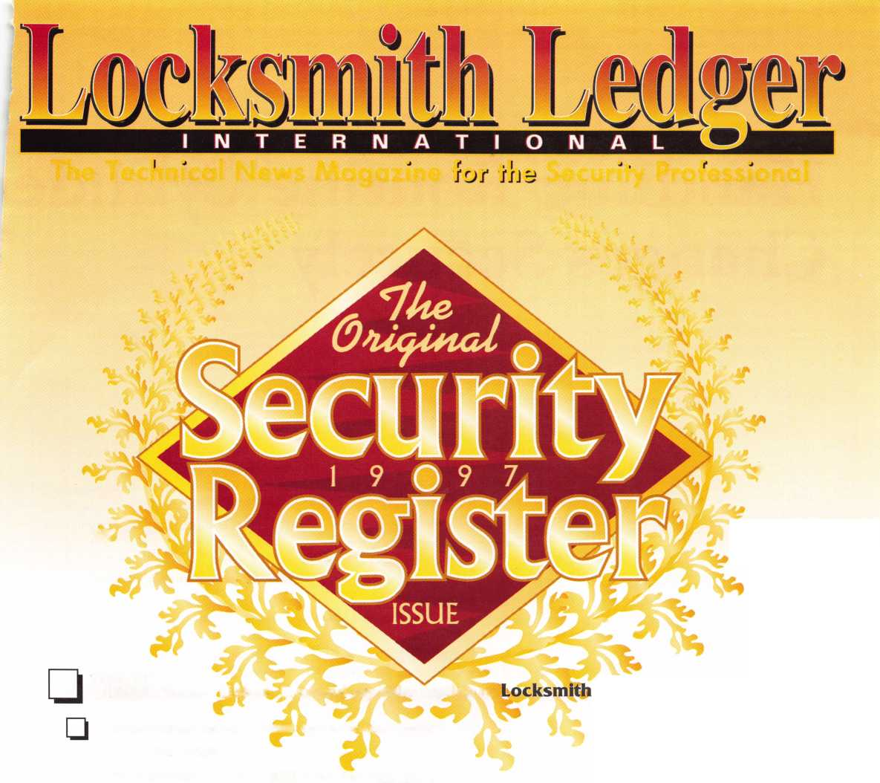

Handling Routine Cylindei Changes Securely

By Jerome V. Andrews, CML



Keynotes

March 1997

Rekeying is a basic service. The home cen­ters of the world notwithstanding, lock­smiths will continue to do lots of cylinder changes for the foreseeable future.

Proper records for master keying are a must. The state-of-the-art technique is to maintain a top master key register (TMK register) listing the masters and controls for all the systems you sell or maintain. The purpose is to prevent duplication of TMKs and controls, and to provide geographic sep­aration of identical parity patterns.

Most of us are aware of such procedures for master keying. However, little has been written about non-master keyed hardware. This article will discuss key records proce­dures for routine cylinder changes.

Always room for improvement

Historically, locksmiths have chosen bit- tings, even for master keying, by using cut keys saved from previously rekeyed locks, and by picking bittings off the top of their heads.

For many years, a major lock manufactur­er maintained a set of bins with a limited number of changes used for locks “keyed random.” As I recall there were about 250 combinations in all, and these same 250 were continually repeated. Padlock manufac­turers have done similar things.

Last year, a question and answer column posed the alleged question, “What are some good master keys?” The answer that fol­lowed was a short list of bittings. Lets all use the same top master keys. At this point in our history, it is difficult to justify such advice in a trade journal.

Enough complaining about the spec in our neighbor’s eye. If we kept track of the so-called random numbers we pick, we might be surprised that they aren’t as ran­dom as we assume. We all have certain men­tal habits.

Increasing randomness increases security

What does state-of-the-art mean for a pin tumbler cylinder? It means achieving the greatest degree of security the cylinder can support. That means using all the practical combinations, not just a portion of them.

There are a limited number of combina­tions for any brand. We tend to repeat the same few. For master key systems, I urge you to maintain a TMK register and use all the parity patterns available for two-step pro­gression.

Avoid single step progression. For any given manufacturer and keyway, there is only one keying system.

SKDs shouldn’t be orphans

For SKDs (non-master keyed combinations), we need a method that will exploit the key­ing capacity of the various brands of cylin­ders. If we all do things a bit differently, and select SKD combinations so as to maximize randomness, our customers will be better served.

SKD1, SKD2, SKD3, et cetera, are Standard Key Coding System key symbols for non-master keyed combinations. An SKD combination is never intended to be operated by any master key, at any time. Behind the symbol SKD1 (say “es-kay-dee

wun”) is a particular bitting on a particular key section.

Incidentally, SKD is pronounced “single keyed” rather than “single keyed different.” If you have two locks keyed to SKD45, you have a keyed alike group. It would be clum­sy to refer to locks keyed alike as “single keyed different.”

One practical method

State-of-the-art work for SKDs demands that we derive them from a properly constructed progression list. Let us consider typical 6-pin two-step systems such as Arrow, Best A2, Pre-System 70 Corbin, Sargent and Schlage. Similar thinking can be applied to 5-pin and

7-pin hardware.

The first step is to set aside one or two parity patterns for the progression of SKD combinations. In the case of 6-pin cylinders, that leaves 60-odd patterns for generating master key systems. Log the chosen pattern in the TMK register as reserved for SKDs.

The second step is to construct a progres­sion list from which SKD combinations can be drawn.

Matrix format is handy for random com­binations. Figure one shows such a progres­sion list based on the parity pattern EOOOEO.

In this first example, the page has been designated for Schlage six-pin E. The appeal­

ing thing about matrix format is that it can be photocopied to provide combinations for many manufacturers and key sections.

Copies of this same matrix can be used to pick changes for any similar two step specifi­cation. However, there are several observa­tions that must be made.

First, MACS and shallow-to-deep require­ments apply. A matrix like the one in figure one may be copied and repeated for any Schlage section. However, in Sargent, 2 is shallow and 0 is deep. For Sargent, write a different matrix. Matrices for different key sections can all use the same parity pattern without risk, but every matrix must be policed for MACS violations before use.

Second, we observed a modified ’’Schlage Rule” in selecting progressives. There are no Os or Is in the bittings. If you dedicate a parity pattern for SKDs, this rule is probably not necessary. Apply it to any Schlage work, however. In fact, Schlage omits 2s as well.

Stock Schlage keys don’t have 1, 2 or 3 cuts. Those cuts are used only in master key sys­tems.

Third, our example progresses positions two through five. The first and last cuts are constant cuts, 4 and 5, respectively, for the entire page. Other matrices can and should be written with different cuts in the first and last positions. Use all the practical combina­tions!

In practical terms, you would create a sep­arate matrix for each brand and key section in your service area. When a cylinder is changed, pick a bitting from the appropriate matrix and cross it off.

Additional matrices can be written as you encounter different brands and key sections.

If you are more comfortable with list format or standard progression format progression lists, they can be used instead of matrix for­mat.

SKDs for Best style interchangeable cores and liability

Discussion of SKDs for Best style inter­changeable cores raises a serious liability issue. Some locksmiths have issued SKDs for different customers under a single control key.

This may be convenient for service per­sonnel. They only have to carry one control

***Keynotes \*** 21

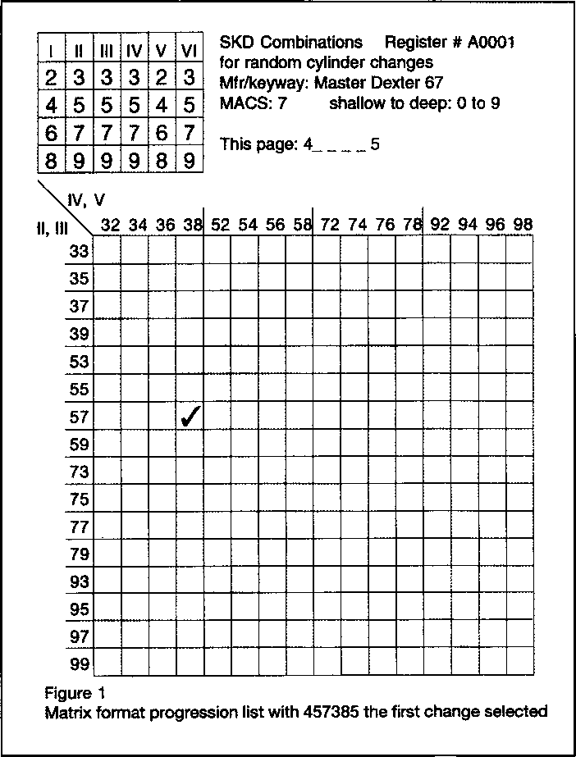

March 1997

Register # A002

|  |  |  |  |  |  |
| --- | --- | --- | --- | --- | --- |
| 4 | 9 | 3 | 0 | 7 | 2 |
| 6 | 1 | 5 | 2 | 9 | 4 |
| 0 | 5 | 7 | 6 | 1 | 0 |
| 2 | 7 | 9 | 8 | 3 | 8 |
| 8 | 3 | 1 | 4 | 5 | 6 |

A keyway page 1 Arrow/Best/Falcon SKD's with unique controls

|  |  |  |  |  |
| --- | --- | --- | --- | --- |
| C5 | 6,1,5 | 2,9,4 1 | 6,1,7 | Ml |
|  | 0,1,5 | i i | 0,1,7 | 1 1 |
|  | 2,1,5 | , , C2 | 2,1,7 | 1 I |
|  | 8,1,5 | l l | M7 |  |
|  | 4 1,5 , , | | 417;,. | |
|  | 6 5,5 | II | 6,5,7 | 1 1 |
| Cl | 0,5,5 | i i | 0,5,7 | I 1 |
|  | 2,5,5 | l 1 | 2,5,7 | 1 1 . |
|  | 8,5,5 | 1 1 | 85 7 | 11 |
|  | 4,5,5. , | | 4,5,7, , , | |
| 3 | 67 5 | 1 1 | 6,7,7 | 1 1 |
|  | 0,7,5 | i i | 0,7,7 |  |
|  | 2,7,5 |  | 2,7,7 | 1 1 |
|  | 875 | 11 | 877 | 1 1 |
|  | 4,7,51 , , | | | |4,7,7| , , | |
|  | 6,3,5 | 1 1 | 6,3,7 | 1 1 |
| 4 | 0,3,5 | i l | 0,3,7 |  |
|  | 2,3,5 | l 1 | 2,37 | 1 1 |
|  | 8,3,5 | 11. | MI | I1 |
|  | 4i3,5| i i | | 4,3,7) , , | |
|  |  | |  | |

Figure 2 - SPF Progression list; five sets

|  |  |  |  |  |
| --- | --- | --- | --- | --- |
|  | 6,1,9 | 29,4 C4 | 6,1,1 | 2,9,4 |
|  | 0,1,9 | i i | 0,1,1 | i l |
|  | 2,1,9 | | | | 2,1,1 | 1 1 |
|  | 8,1,9 | C3 | ML | 11 |
|  | 41,9l , , | | 4,1,11 , ■ | |
|  | 6,5,9 | 1 1 | 65 1  w |W 11 | 1 1 . |
|  | 0,5,9 | i l | 05,1 | I l |
| 5 | 2,5,9 |  | 2,5,1 |  |
|  | 8,5,9 | 2 | 851 | 11 |
|  | 4,5,9, , | | |451; ^ _ | |
|  | 6,7,9 | l 1 | 6,7,1 | 1 1 |
|  | 0,7,9 | i i | 0,7,1 |  |
|  | 2,79 | l 1 | 2,7,1 | 1 1 |
|  | 87,9 | i l | Ml | 11 |
|  | 4,7,91,i | | 4,7,11 , , | |
|  | 6,3,9 | I 1 | 6,3,1 | 1 1 |
|  | 0,3,9 | , i | 0,3,1 |  |
|  | 2,3,9 | l 1 | 2,3,1 | l 1 |
|  | 8,3,9 | 1 1 | Ml | 1 1 |
|  | 4,3,9| i , | | [4,3,11 i i | |

been chosen so far.

control key 0 5 5 2 9 4

operating key 6 1 7 2 9 4

|  |  |  |  |  |  |  |
| --- | --- | --- | --- | --- | --- | --- |
| 13 | £ | i | 8 | 11 | 4 | 9 |
| 4 | 1 | 4 | 8 | 10 | 10 | 10 |
| 6 | 1 |  | 7 | 2 | 9 | 4 |

top pin buildup pin bottom pin

Figure 3

ICore pinning for SKD set #1 from Figure 2.

key to make lock changes in various loca­tions. Unfortunately, another locksmith can unwittingly make and issue a control for one customer, without even realizing that the same key fits another property down the street.

SKDs for any given end  
user need to have a unique  
control key. If a customer  
wants two or more differ-  
ent SKDs under a single  
control, that can be done.  
But two customers should  
never share the same con-  
trol key.

Figure two is a page of  
standard progression for-  
mat with some combina-

tions chosen for SKDs with unique controls.  
SKDs for ICores are actually pairs of combi-  
nations—an operating key and its associated  
control.

My criteria for these combinations, the “Andrews Rule” if you will, are as follow. 1)

For 6-pin cores, the control and operating keys have identical bittings in three posi­tions, and different elsewhere. 2) The partic­ular positions in which the bittings are iden­tical may be randomly selected. 3) The con­trol key should be shallower than the operat­ing key in one position, and deeper than the operating key in another.

This method is not the only way. There is much to be said for all of us doing it differ­ently. I am asking that we all adopt a sys­tematic approach. You will have to decide how “far apart” the control and operating keys are on the progression list. That is, you must decide how many cuts they will have in common and which cuts those will be.

The bittings in figure two are marked to indicate how they are used. For example, the bittings marked “1” and “Cl” go together. Bittings “2”and “C2” go together, and so on. The “C” indicates the control bitting. Thus, “Cl” is the control bitting associated with the # 1 operating key. Figure three shows the pin stacks for a Best style ICore pinned to operating key #1 and its associated control.

In practice, one would select bittings required for a job, and mark the progression list to show that they have been used. Then the bittings would be entered into the records for that customer, where key quanti­ties, authorizations and other pertinent data are kept.

The illustrations shown are examples only! Be creative! There are a million theo- reticals in a typical 6-pin, two-step cylinder. Let’s increase security by using all the practi­cal ones.



About the Author: Jerome V.

Andrews, CML, has been a locksmith since 1967, and is currently the Manager of Dealer Sales and Director of Training for KABA High Security Locks in Southington, CT, where he also provides system design services for both KABA and PEAKS and technical support for KABA engi­neering. Known as one of our industry's finest teachers, Jerome is a Member-at-Large of the ALOA Board of Directors and a Keynotes Contributing Author.

Keynotes

March 1997

**ALOA ’97 AND SECURITY EXPO**

**AUGUST 2,1997 CONVENTION CENTER HOTEL**

**RENO, NEVADA**

**f JULY 28- IENO-SPARKS RENO HILTON**

WITH QUESTIONS OR COMMENTS

CONTACT:

ASSOCIATED LOCKSMITHS OF AMERICA, INC 3003 LIVE OAK ST.

DALLAS, TEXAS 75204

214-827-1701

800-532-2562



**SO YOU WANT  
YOUR OWN  
LOCKSMITH  
SHOP?**

The time has come to make a decision about your future. You have been working for someone else for a long time and you want to try it on your own. You feel you have the technical knowledge to do the job, but is that enough? Are you aware that upwards of 70% of all new businesses fail within the first three years?

There is a lot more to consider when beginning on your own other than having the technical knowledge of the job. I believe most locksmiths with a few years under their belt can do the work, but can they handle running a business? More than luck is needed to make a business successful in the long run. A good solid plan, taking into account as many of the pitfalls as you can think of, will help considerably.

Don't let this article dissuade you from going into business for yourself. That is not the intention at all. In fact, I had worked in business for 10

years with a major retailer before deciding to make the move. After 13  
years on my own, I would have trouble working for a corporation again.  
If you have the background in the locksmith industry, you have an  
advantage I did not have. I apprenticed with a good locksmith, but

years are needed to learn enough to be reasonably good at our  
profession.

I believe that if you approach this as a profession and are willing to

work hard at overcoming your weaknesses, both technical and business

[wise, you can succeed. Make a plan and work it.

oin ALOA and your local association. The networking and knowledge

you gain will be invaluable to you as you begin the exciting path of  
owning your own business.

Now, let’s take a look at some of the things you may not have thought  
about before you make this big leap. I will break this down into several  
considerations and present it in the form of questions that only you can  
answer for yourself. Good luck, and I would enjoy getting some  
feedback from readers on my articles. Write me at 1612 Tompy St.,

Miles City, Montana, 59301.

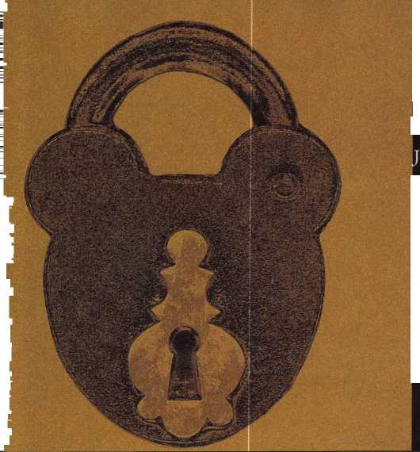

CONSIDER THIS

PHYSICAL CONSIDERATIONS

1. Am I in good enough physical condi­tion to handle the starting of a new business?
2. Heart condition
3. Leg and arm condition
4. General physical health
5. Doctor checkup advised.
6. Is my appearance business-like?
7. Will I dress professionally (clean uniforms or “regular” clean clothes)?
8. Will I keep my hair neat and clean?
9. Will my general appearance instill confidence in the customer?
10. Is my personal hygiene good?
11. Do I bathe daily?
12. Do I brush my teeth at least once a day?
13. Are my fingernails and hands as clean as possible?
14. Other physical considerations
15. Can I handle working a 12-hour day under pressure?
16. Are my communication skills aver­age or above?

PSYCHOLOGICAL CONSIDERATIONS

1. How do I handle stress?
2. Does meeting new people make me nervous?
3. Do I require a set schedule to func­tion?
4. Does a lack of cash flow cause me to loose sleep?
5. Does it irritate me if the phone rings when I am busy?
6. Can I work well with people?
7. Do I easily meet new people?
8. Am I confident around people?
9. If I smoke, can I work without smoking?
10. Am I willing to go out and meet people to expand my business?
11. Can I take criticism and rejection?
12. When someone is critical of some­thing I do, do I get angry?
13. How can I handle someone making a comment such as:

* “It doesn’t take that long on t.v.!”
* “I knm' kids who open cars faster than you. ”
* “My uncle has a ring of keys that can open any car made. ”
* “1 called your competition, but he couldn’t come today. ”

• “You’re not going to break anything, are you?”

1. Can I look at a problem and reason out a cause?
2. Can I work at a jigsaw puzzle until it is done?
3. Do I enjoy figuring out how things work in relation to each other?
4. Do I quickly resort to force if things don’t fit together?
5. Do I enjoy challenges?
6. Does fear of failure prevent me from trying?
7. Do new thoughts, ideas or devices make me nervous?
8. How do I feel about being a “ser­vice man?”
9. Does someone else’s opinion keep me from trying something new?
10. What is my motivation for opening my own business?
11. Making a lot of money?
12. Helping people?
13. Enjoy working with tools and my hands?
14. Getting out of my present job?
15. Can I manage my time?
16. Am I self-starter?
17. Can I handle long periods of time with little or no work?
18. Do I feel I have to quit when my eight hours are up?
19. Will I get up to answer a call late at night?

FINANCIAL CONSIDERATIONS

1. Can I manage money?
2. If I have 20 dollars in my pocket, do I have to spend it?
3. Do I pay my bills on time?
4. Have I ever been able to save any money?
5. Can I budget to make a purchase down the road?
6. Can I set money aside to pay taxes quarterly?
7. Do I have a banker who will work with me?
8. Will my banker loan money on accounts receivable—if necessary?
9. Will my banker help with working capital?
10. Have I established a good credit history?
11. Do I even know a banker?
12. How will I fund the startup costs of my business?
13. Will my own funds be the only source?
14. Am I going to the bank for a loan?
15. Will my family be helping with the funds?
16. Will I cash in my invested funds?
17. Do I even have a plan?
18. How will I advertise my new busi­ness?
19. Yellow Pages?
20. Signing on a shop and my vehicle?
21. Will word of mouth be my best or worst advertising?
22. What will my client base be?
23. Commercial?
24. Financial?
25. Broad-based?
26. Where will I open my business?
27. What is the population pattern?
28. How many locksmiths now service the area?
29. Is the area security-conscious?
30. Am I known in the area?
31. How will I do my bookkeeping?
32. Do I have an accounting back­ground?
33. Can I balance a checkbook?
34. Can I figure a markup price?
35. Will someone else do my book work?

GENERAL CONSIDERATIONS

1. Will licensing or testing be required?
2. Is bonding necessary?
3. How do I get bonded and what kind will be needed?
4. What insurance will be necessary?
5. Business liability?
6. Inland marine?
7. Disability?
8. Business property?
9. Do I have a legal record?
10. Does my family support my decision?
11. How will I continue my learning and education process?
12. Take classes?
13. On the job?
14. Do I already know all I need to know?
15. How will I get to know the right peo­ple to make my business grow?
16. Am I willing to join and be active in a service club, i.e. Kiwanis?
17. Am I willing to attend local events and network?
18. Will I go to businesses and talk to the owners and managers?

BY KEN HOLMLUND, CRL

Mastering



Planning on taking the PRP soon? Intimidated by the section on master keying? One of the 10 mandatory cat­egories on the PRP is “Basic Master Keying.” The basics of this subject must be understood in order to pass this section. Take a deep breath and relax. The section on master keying, in reality, is information that you use in your everyday work! Becoming more proficient in the area of master keying will make you a more “profession­al” locksmith.

Please note: There is also an elective category on advanced master keying; however, this article is aimed solely at the mandatory portion of the PRP. Remember that once the basics of master keying are understood, it is much easier to move on to the advanced master key­ing elective category.

One of the first (and easiest) things to do when you start the subject of master keying, is to obtain a copy of the PRP Resource Guide (available from ALOA). The PRP Resource Guide gives the following description of the mandatory portion of master keying.

Master Keying, Basic

“You must thoroughly study the theory of progression, levels of keying, and the Standard Key Coding System. You must be prepared to calculate the number of key changes, given certain parameters. Be prepared to identi­fy mistakes in progression lists, and to determine expan­sion possibilities from a sample listing. You must under­stand proper terminology, symbols and levels of keying listed in the “Glossary.” Knowledge of basic single, and two-step progression will be necessary, as well as bitting and specifications of various manufacturers.”

Suggested Study Material

* Basic Master Keying (H.P.C., Inc.)
* Basic Master Keying Course (The National Publishing Co.)
* Fundamentals of Master Keying by Jerome Andrews, CML
* Manual of Master Keying by Gerry Finch, RL
* Mini Master Systems (Locksmith Publishing Corp.)
* Practical Master Keying (The National Publishing Co.)
* Trade Magazine articles
* ALOA Annual Convention and Trade Shows
* Association Classes

Don’t let the above description overwhelm you! You can conquer this subject by building on your present knowledge of master keying. And, as a bonus, you will be able to use this knowledge in your everyday work!

How To Begin

Order the PRP Resource Guide or borrow one from a fel­low locksmith. The “Professional Glossary of Terms Relating to Cylinders, Keys and Master Keying” is con­tained in this guide. Many of the terms in this glossary relate to master keying. Thoroughly review all of the ter­minology. Start using these definitions in your work. Remember that this terminology will be used on the PRP!

The Value of a Master Key System

A master key system can be very useful for operating convenience to control a building, a group of buildings, floors of a building, or even sections of a floor. A master key system can provide security, safety and convenience if it is properly planned, ordered, keyed, controlled and maintained. A master key system has mathematical limi­tations based on factors like the number of different mas-



BY CLAIRE COHEN, CML

ing for your everyday work as a professional locksmith, as well as for the PRP.

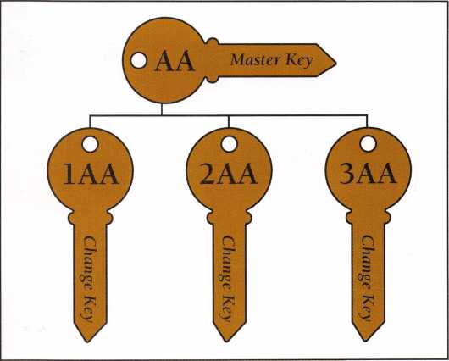

ter keys, the number of keyways and the number of pins used in the locks. The system should be designed to allow for adequate expansion. This can be accomplished by adequate site surveys and obtaining detailed present and anticipated future expansion information from prop­erty owner or management.

Creating a Master Key System

Steps required

1. Determine the number of keys required for your system (top master, masters and change keys)
2. Select your Top Master Key
3. Select Master Keys
4. Progress change keys
5. Study the Master Key System—cross out unusable combinations
6. Implement the system

Before physically implementing any master key sys­tem (before pinning any cylinders or cutting any keys), the entire system should be written. (There are now computer programs that will do this for you; however, in order to properly service your customers, you should be able to understand how the computer has created this system for you.) You will need to be able to create a sys­tem on paper for the purposes of the PRP. Only by understanding a master key system can you be certain that the system you have created is valid and will do the job it was designed to do.

Be sure to study the number of changes and masters, and how using different numbers of chambers alters them. Understand shear lines, and how they change the number of change keys and number of incidental mas­ters in a system. Understand both progression and rota­tion constant master key systems.

To pass the PRP evaluation, you will need to be able to fill out a standard master key sheet that contains the key bitting array for a master key system. You will need to know the rules for selecting a proper top master key, knowing the possibilities for that key, create other mas­ter keys, and create change keys. To practice doing this, use the standard form from the ALOA classes.

The Standard Key Coding System

The Standard Key Coding System is an industry stan­dard and uniform method of designating and ordering all keys and/or cylinders in a master key system. The designation (“keyset”) automatically indicates the keying level of each key and cylinders (usually without further explanation). Letters are used to designate master keys. Numbers are used to designate changes. The layout of the keying systems determines whether the change number comes before or after the master key letters. Learn the letter/ number sequences for all levels of key­

One of the benefits of using this system is that keying instructions can be understood quickly and easily at a later date. This system has been adopted by the Door and Hardware Institute, the Builders Hardware Manufactures Association and the American Society of Architectural Hardware Consultants. It is used by lock manufacturers in the United States and other countries. Material on the Standard Key Coding Systems will like­ly appear on the PRP!

Some Final Hints on Basic Master Keying

You may wish to form a study group with others in you association who are also planning to take the PRP You might invite a fellow association member to give a mini session to your group. Working together with terminol­ogy, key bitting arrays and standard key coding can be quite helpful.

The level of proficiency for master keying, like all skills, will depend entirely upon the amount of effort and time you are willing to invest. Skill and ability comes from a thorough study of master keying and long hours of practice. The material included on the Basic Master Keying section is, as it says, “basic,” and should be a part of every professional locksmith’s knowledge.

the Author: Claire L. Cohen, the second woman to become a CML, has been in locksmithing since 1911 and has been writing articles for Keynotes since 1981. She is an active member of the Locksmith Association of Washington,

1. C. where she has taught many classes.

March 1997

Keynotes

By Bob DeWeese, CPL

CLAIMER:

**This Is Not Intended To Be An Article On** Master Keying.

Please, no letters, phone calls, e-mails, etc. telling me that this is not how master key­ing should be taught. I agree. This is not how master keying really works; hence, the title of the article. When I started kicking around the idea of writing this, I made a point to contact several “industry notables.” Most thought it was okay, while a few dis­agreed adamantly. They felt that it shouldn’t be put into print because they thought some may take it as gospel. I respectfully disagree. I’m mainly writing this article because I know this is a common practice and I think that if it’s going to happen, (and it will) there should at least be some ground rules. I also think that it will arouse interest in tak­ing a real master keying class that some beginners would not otherwise feel the need to take.

Most of us, even those who won’t admit it, originally learned “master keying” the same way. No key bitting array. No charts. No keys cut on a code machine. Just seat-of- the-pants, trunk-slammin’, “make two keys work this cylinder” master keyin’!

While this practice is certainly frowned upon most of the time, I feel that it does have its justifiable uses—if some basic rules are followed.

Example one: Your customer has a house divided into three apartments. He wants a master key that will open all three apart­ments and the door to the laundry/storage are in the basement. Of course, all four areas also need an individual key.

Example two: Your customer owns a small business. He wants his master key to work the front and back doors, the doors to every­

body’s private office (three or four maybe), and the executive bathroom. Of course, all of them will also need individual keys. Example three: Your customer owns a bar. (Yeah, I know a bar is a small business.) He wants his master key to work the entrance, his office, the liquor room and the padlock on the walk-in box. And each of these will have individual keys.

In all three examples, as long as all of the locks use the same original keyway, you should have no problem creating an off-the- cuff system (and I use the term loosely) that will adequately accommodate your cus­tomer’s needs in a short time.

Okay, let’s say we have three Kwikset knob cylinders. Form your collection of change keys (Kwikset originals!), take out four different keys. Duplicate one key and set the duplicate aside. This will be your master. Next, duplicate (only) the first two cuts (of the same key) onto three more blanks. With the remaining three original change keys, duplicate the last three cuts of each original on the three partially cut keys. These will be your individual keys. Number them one through three. You now have four different keys, but the first two cuts will be the same for all four.

Holding the master key next to the change key number one, determine which of the last three cuts is higher on which of the two keys. These will be the depths that determine the size of the bottom pins.

Let’s say that the master key has higher cuts in the third and fifth positions, and the number one change key has a higher cut in the fourth position. (Still with me?) Place

28 | ***Keynotes***

March 1997



the master key in the plug and inset the appropriate pins into the first, second, third and fifth chambers. Remember the first two cuts will be the same on all keys. Next, remove the master key and place the number one change key into the plug. Insert the appropriate pin into the fourth chamber. With the change key still in the plug, you will notice that the pins in chambers three and five do not come all the way up to the shear line. This is where the master pins come in. Drop the appropriate master pin into the third and fifth chamber right on top of the bottom pin to bring the height of the pin stack up to the shear line.

At this point, all chambers should be up to the shear line. Carefully dump out just the master pins from chambers three and five, keeping track of which one came out of which chamber. Remove the change key and place the master key back into the plug. You will now notice that the only chamber that doesn’t come up to the shear line is chamber number four. Drop the appropriate master pin into that chamber on top of the bottom pin. Once again, the pins in all chambers will be at the shear line.

Carefully remove the master key from the plug, making sure not to lose the master pin in chamber four. Insert the respective master pins back into chambers three and five. Holding the plug at about two o’clock to the housing, insert the plug back into the housing without any key in it. Be very care­ful that the plug doesn’t get inserted straight up and down without a key in it, or the top pins will fall into the plug in the wrong positions and ... let’s just say this: you’ll have a mess on your hands.

After the plug is all the way back in the housing, rotate the plug so that the top pins now drop into their respective chambers in the plug. Insert the master key into the plug. Say a prayer. Turn the key. (If it didn’t turn, go back and re-read this article.) Next, insert the number one change key. Say another prayer. Turn the key.

Now, just repeat the process with the remaining cylinders and change keys.

There! You just did a master keying job....sort of.



Some Ground Rules

Even though this is not scientific master keying, there are still a couple of rules that you should be aware of in order to avoide potential problems downs the road.

1. Never, ever try to do this on a big job! I’d say four individual keys is tops. And that’s pushing it.
2. Try to use a high to medium cut in the first position. Keys with deep cuts in the first position sometimes have a tendency to break.
3. In real master keying, there is a term called MACS (maximum adjacent cut specification), which simple means the maximum allowable difference between two adjacent cut depths. In other words, if you try to put a really deep cut next to a really shallow (high) cut on the same key, the really deep cut may wipe out the shallower cut next to it.
4. Some manufacturers require something called a “two step program,” which means that you don’t put a three and a four, four and a five, a five and a six, etc., cut in the same position on two different keys intended to work the same lock because the master plan needed would be too thin and would create a problem. A good rule of thumb is to try not to use a master pin less that .045-inch thick, and never use a master pin that is less than .023-inch thick.
5. (And this is a biggie!) Be sure to try all of your change keys in all of the other locks to be certain that none of them open any of the locks that they were not intended to open. (This is called “phantom keying” or key interchange.) Also, remember to do this if you have to rekey one of the locks some time in the future.

I About the Author: Bob De Weese,

CPL, #19138, owns and operates Bear Lock and  
Security Service, Inc. in Baltimore. He has been a  
locksmith for 13 years and an ALOA member  
since 1990. He was awarded AlLA’s President's  
Awardfor his efforts on behalf of locksmith educa-  
tion and was named Keynotes’ 1994 author of  
the year.



When she designed a barrier-free playground, she didn’t let anything stand in her way.

Meet Allison Falleur. Allison got the idea for an accessible play­ground while she was an Easter Seal camper. From then on, nothing could stop her, including cerebral palsy. Your support of Easter Seals helps the one million people like Allison who come to us each year for physical, occupational and speech therapies and other programs.



I

Give ability a chance.

0 1995 National Easter Seal Society

March 1997 ***Keynotes \*** 29

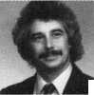

**\***

**GC**



**0)**

**<**



Keynotes

(/)

-S3

DC

*5

Q

■c

.CJ

33

rS

GO

QJ

:C

In this article, I will explain the  
basic principles of master key-  
ing—from why it is done to  
how it is accomplished. This will  
not (and is not intended to) pre-  
pare you to be able to design a  
large master key system for a  
major hotel or commercial  
building. This will tell you what  
master keying is, and some of  
the risks and benefits.

Sometimes a little bit of  
knowledge can be a dangerous  
thing. With the advent of master  
keying computer programs, it  
may seem deceptively simple to  
set up and design a master key  
system. You may think that the  
computer has done all the hard  
work and the rest is a piece of  
cake. A master key system done  
wrong can have serious conse-  
quences. Those consequences can  
include a major breach of securi-  
ty for your customer and (if the  
angry customer wishes to pursue  
it) a lawsuit that could wipe you  
out financially.

If master keying is a service

you’d like to provide for your customers, I’d suggest you  
take a comprehensive class on the subject. ALOA and  
other organizations sponsor one or two day classes that  
you can attend locally or at a convention or trade show.  
Comprehensive books or correspondence courses are also  
available from different sources within the industry.

**Master keying- What is it?**

The term “Master Key” is widely misunderstood by the general public. To many, keying alike and master keying are pretty much the same thing. There are customers who will say something like, “This master key works all the locks to my house, and I want you to match my new lock to work on my master key, too.” This kind of remark usually means that the customer has all his/her locks keyed alike and would like a new lock matched to all the others.

There is a common presumption that a key that oper­ates many different locks is a master key. Although a master key will often operate many different locks, that factor alone does not define a master key. A master key system is defined by having two or more locks with two or more levels of key access.

**Levels of Access**

If you’ve never done any master keying, it may not be clear to you exactly what I mean by levels of access. I will demonstrate, with illustrations, what that is. Figure one represents a four-story building. On each floor, there are four separate offices. Each office has its own door and key operated lock.

If I said that a key exists that will operate all 16 offices in a building, that information alone could not tell us whether or not the building was master keyed. We would need to know more information about the individual offices.

For our first example, we will indicate that the occu­pants (of all the different offices) have keys that will let them into their own offices. At the same time, the key that works their own office will also operate the locks on every other office in the building. Every person has equal and identical access to every part of the building. If they were to compare their keys with each other, they might find that they were cut exactly the same. Since everyone in the building (with a key) has the same access, this would be considered one level of access. One level access indicates keying alike, not master keying. Therefore, although all the keys can open every door in the build-

March 1997

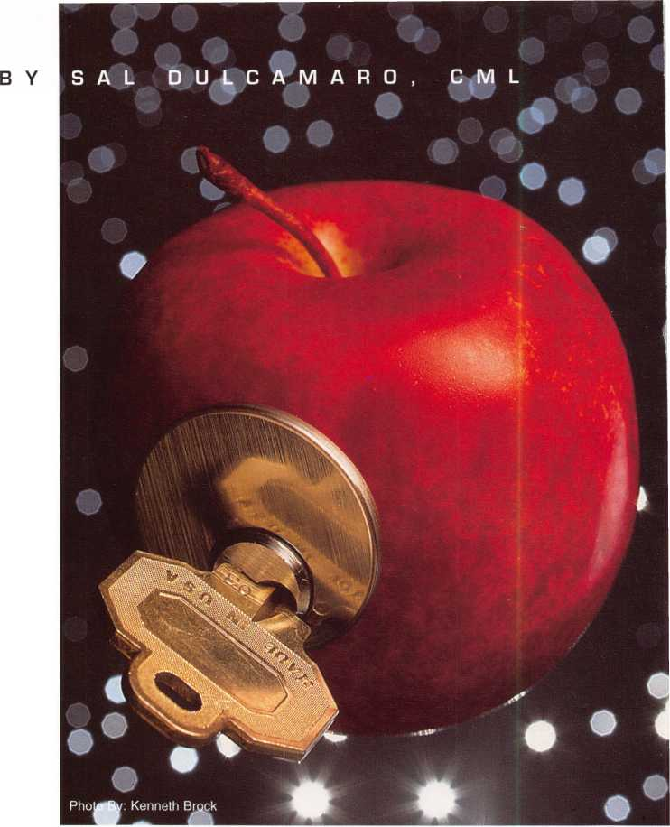

ing (and gives the key users complete access throughout the entire building), they are not “master” keys.

In our second example, the occupants (again) have keys that will let them into their own offices. In this instance, however, the key that works their own office only works their own office. If the key for one office was tried in the lock of any other office, it would enter the keyway but would not turn. We will further presume that the owner of the building has a special key that will operate all sixteen offices in the build­ing. Occupants of the offices have limited access to only their own office, while the owner has complete access throughout the building. There are no mid-level keys that have access to more than one office or less than the whole building. That is two levels of access, which is the smallest number of levels to be considered a master key system. The special key that the owner uses to oper­ate all the locks in the building is the “mas­ter” key.

The situation for the third example is similar to the second, but instead there will be mid-level keys. While each office has a unique key that will not operate the locks of any other offices, there is a key for each floor of the building that will operate the locks on all four offices for that floor. The mid-level

“master” key for each floor will not operate any locks on any other floor of the building. The first floor “master” key will only work on the first floor. The second floor “master” key will only work on the second floor, and so on for the other floors. In this situation, there are three levels of access. Individual office keys are one level, floor “master” keys are the next level and the owners “master” key is the top level.

I will not explain terminology, abbrevia­tions or coding for master keying in this article. Depending on the number of levels in a system, you may see mid-level master keys referred to as: sub-master, master, grand-master, great grand-master, great great grand-master, plus numerous more “greats” attached to the term. You will also see combinations of letters used as symbols to indicate master key levels. I will only explain this aspect of terminology: the high­est level master key in a system will be con­sidered the “Top Master Key” or abbreviated “TMK.” No key in a master key system will have higher access than that one. You can understand the levels of access without being fluent in the language of the standard indus­try terms, but you must speak the language at least a bit to communicate with other locksmiths or the factory when you order master keyed locks.

**Master Keying- Why is it done?**

Before I go into the aspects of how master keying is physically accomplished, I want to briefly go into the reasons for doing it in the first place. Master keying is most commonly done with lock hardware on commercial buildings, and consequently, most master key systems involve pin tumbler locks. In years past, when most master key systems were generated by hand, many locksmiths who were never good with numbers were often intimidated by the apparently compli­cated charts. With computer programs that can figure out all the numbers for you, there are fewer obvious reasons not to master key locks.

There is one major reason for master key­ing locks: convenience. Any level of access that can be accomplished by master keying can (technically) be accomplished with locks that have not been master keyed. The down side is that the alternate method is often inconvenient. In many cases the alternative is ridiculously impractical.

Let’s review one of my earlier examples of multi-level access by master keying. I have yet to explain how 16 different locks with unique operating keys can be made to oper­ate by one key, but (trust me) I will. If the 16 locks were just separately keyed, each lock would have its own unique key. Where a master key system would allow an individ­ual on each floor of the building to use just one “master” key to operate all four locks on that floor; a non-master keyed system would require the same individual to carry four dif­ferent keys to gain access to all the offices on that floor. Likewise, the owner of the build­ing would have to carry 16 keys to gain access to all the offices in the building. That can be a load of keys to carry in one’s pocket.

I think we can all agree that carrying 16 keys (in addition to all the other keys one would carry) could be somewhat inconve­nient. Imagine if the building had one thou­sand separately keyed locks. The owner, to have access everywhere, would have to carry one thousand keys. Now that would just be plain crazy. If you didn’t before, I’m sure you now understand why we master key locks. There is a price that we pay to gain the con­venience of master keying, but I will explain that later in this article.

**Master Keying- How is it done?**

The ultimate goal of master keying is creat­ing different levels of access, so that people of varying authority and responsibility can get where they should be, while keeping out

|  |  |  |  |  |
| --- | --- | --- | --- | --- |
| Floor 4 | Office  13 | Office  14 | Office  15 | Office  16 |
|  |  |  |  |  |
| Floor 3 | Office  9 | Office  10 | Office  11 | Office  12 |
|  |  | * | """ |  |
| Floor 2 | Office  5 | Office  6 | Office  7 | Office  8 |
|  |  | ' | ’ |  |
| Floor 1 | Office  1 | Office  2 | Office  3 | Office  4 |

Figure 1

March 1997

Keynotes

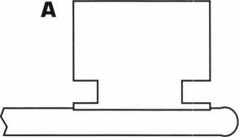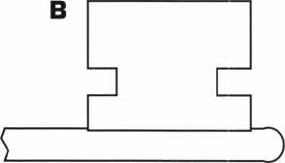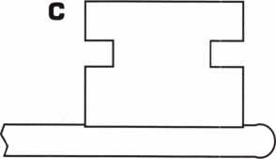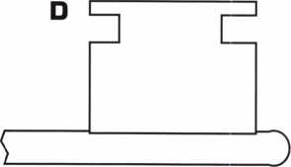

|  |  |  |
| --- | --- | --- |
| E |  |  |
| S |  |  |
|  | | |
| IT  IL |  |  |
|  |  |  |
|  | | |
| G 1—, |  |  |
| i |  | ) |

Figure 2

Keynotes March 1997

people who shouldn’t be there. That concept applies regardless of the type of locking device used to secure the property involved. There is a big difference, though, on how master keying is physically accomplished, depending on the locking devices involved.

From the end user’s standpoint, there is no significant difference whether the master keyed locks are disc tumbler, pin tumbler, lever tumbler or any other lock type. The holders of the master keys can use their keys to open all (or groups of) the locks, while others have keys that get them into more limited areas. The actual mechanical opera­tion of the lock and key is not their concern. The key either turns or it doesn’t.

For the locksmith, the mechanical opera­tion of the lock and key is very important. After all, he or she is going to have set it up initially and (probably) service it afterward. Because of service kits and specialized servic­ing techniques, the variation in cost and work involved (to master key locks) can be rather dramatic.

**Key-Based Master Keying**

If it hasn’t happened already, you will proba­bly (one day) be confronted by a customer with this inquiry, “Do you have one of those master keys that opens every lock?” If you know anything at all about master keying, this seems like an odd question. If you’ve watched a bit of television and the movies, however, the question shouldn’t be a total surprise. Characters in the movies are some­times able to get everywhere with just one key—hence, the magical master key.

As a general rule, master keying is no accident. In most cases, master keying is tumbler based. To make two or more locks (with different operating keys) work with one common key, the locks in question must be specially modified (i.e. tumblers changed). Warded locks, which don’t have tumblers, are an exception to the rule. Although they can be specifically assembled to be master keyed, they can also be master keyed as an afterthought. The locks would not have to be changed, only the keys would.

Figure two shows a variety of differently cut bit keys. The keys have cut patterns designed to let them open certain warded locks. The keys identified as “A”, “B”, “C” and “D” each operate a specific lock with a ward in a particular location. The only pur­pose of the ward cut is to allow the key to rotate past a ward (obstruction) in the path of the key.

Warded locks are normally simple in

design. The key acts as a tool to operate a locking mechanism. It could move a bolt or draw in a latch. If it wasn’t for the wards in the lock, nearly any piece of metal (small enough to fit into the lock) could be used to operate the lock.

“E” shows a bit key with ward cuts com­mon to both “A” and “C.” It would act as a low level master key that would work in any locks operated by the keys “A” and “C.” “F” would likewise act as a master key for locks operated by “B” and “D.”

“G” would be a higher level master key because it contains ward cuts common to “A,” “B,” “C” and “D.” It resembles what would be called a “skeleton” key. Skeleton keys are unintended master keys. They have cuts everywhere a ward might be presumed to be located, leaving only enough material to operate the lock mechanism without breaking. They can open locks that have absolutely no intended connection with each other.

The same principles apply to simple warded padlocks made by Master and other padlock manufacturers. By making ward cuts everywhere (other than the sections that operate the lock release mechanism), an unintended master key can be made to oper­ate a whole series of locks.

**Tumbler-Based Master Keying**

With the exception of warded locks, virtual­ly all master keying will be tumbler based.

If you want to make two or more locks work with separate operating keys, but still have them open with a common master key, you will need to alter the locks in some way. Locks with tumblers of one variety or anoth­er will usually have keys with patterns that match specific tumbler arrangements.

Special tumblers are usually required to allow locks to be master keyed. Some lock types will be similar to each other, while others will be completely different.

**Stay tuned for Master Keying, Part Two in an upcoming issue.

S3|

1POT* WF About the Author: Sal Dulcamaro, CML, has been in the locksmith business for over 21 years. He is the president of All Pro Security, Inc. in Michigan and has been an ALOA member for 13 years. A past president of the Locksmith Security Association of Michigan, Sal currently serves as editor of the association newsletter. He was named “Keynotes Author of the Year” for 1996.

Master

Keying  
Magic

The task of master keying locks has a magical mystique associated with it that most believe is reserved for people who own official titles—titles like Key Records Manager or Master Key Systems Engineer. While there are jobs that would require extensive knowledge and experience, it is possible to master key locks within a system of con­trol as long as you have a grasp of the basics.

A Bad Bag of Tricks

By pinning up a lock cylinder to accept more than one key, you have master keyed the lock. You could have randomly chosen numbers or pulled two keys from a shoe box. Adding in a master pin allows both keys to operate, but there is no system. Keys with constant bit- tings to the master could become incidental masters opening other locks in this chaotic system. This method is out of control from the beginning, and will assuredly end up being a disaster.

Have you ever seen a master key cut 898989 or 565656? It could be a Corbin or Falcon. This practice of deep cut master keys was actually begun by manufactur­ers. At Corbin, it was done for union pay scale reasons (the company abandoned this practice many years ago). The union workers had to be paid more to combinate cylinders with deep and shallow master key cuts. This convenience master made it much easier to set up and key systems.

While pinning up the cylinder you can insert the master key, drop in all the bottom pins that equal the change key bittings and then your master pins. This enables a visual check of the shear line to ensure that the master works. It also makes it convenient for the main­tenance person to rekey the lock.

They can remove the plug and all the pins with the master key, pick another key from their shoe box and change the change key. Since the master key bits are all deep, almost any key can be made to work with it. Although this practice could save some time, I do not consider it good practice to use it. We will have some further discussion later in this article about choosing a balanced master key.

Out Of Thin Air

Identifying the job by creating a door hardware sched­ule is the first and most important step of a project. The information gained by this schedule will be used as long as service is provided to the customer. This record needs to be legible and systematic.

The difficulty comes from the fact that most build­ings do not have detailed, if any, floor plans. The door has to be identified. Numbering the door itself is the easiest way to find it in the schedule. Identify the door by writing a number on the hinge with a permanent marker. Choose or create a form (Figure 1) to record

>

z

o

-<

GO

“U

GO

o

o

r-

March 1997

Keynotes

33



Glossary of

Professional

Terms

bitting

* The number(s) which represent(s) the dimensions of the key cut(s)
* The actual cut(s) or combination of a key

Bitting depth

* The depth of a cut which is made into the blade of a key

bitting list

* A listing of all the key combinations used within a system. The combinations are usually arranged in order of the blind code, direct code, and/or key symbol.

Bitting position

* The location of a key cut. See “spacing”

blind code

* A designation, unrelated to the bitting, assigned to a particular key combination for future reference when additional keys or cylinders may be needed

chamber

* Any cavity in a cylinder plug and/or shell which houses the tumbler(s)

change key

* A key which operates only one cylinder or one group of keyed alike cylinders in a keying system

constant cut

* Any bitting(s) which are identical in corresponding positions from one key to another in a keying system. They usually serve to group these keys together within a given level of keying, and/or link them with keys of other levels.

Cross keying

* The deliberate process of combinating a cylinder (usually in a master key system) to two or more different keys which would not normally be expected to operate it together.

Cutter

* The part of a key machine that makes the cuts into the key blank.

Floor master key

* A master key that operates all or most master keyed locks on a particular floor of a building

FM

* abb. floor master key

Grand master key

* m. The key that operates two or more separate groups of locks, which are each operated by a different key.

GM

* abb. Grand master key

Key bitting array

* A matrix (graphic) graphic display of all possible bittings for change keys and master keys as related to the top master key

Maximum adjacent cut specification

* n. The maximum allowable difference between adjacent cut depths

MACS

abb. Maximum adjacent cut specification

Progression

* A logical sequence of selecting possible key bittings, usually in numerical order from the key bitting array

Standard key coding system

* n. An industry standard and uniform method of designating all keys and/or cylinders in a master key system. The designation automatically indicates the exact function and keying level of each key and/or cylinder in the system, usually without further explanation.

D

0

***V)***

(ft

&)



*(f)*

your information.

With the doors numbered and a schedule of hardware, you have performed your first trick: transforming the rest of the job into a much easier one.

The Magnificent Karmac

Holding a key marked AA21 to his head he says, “The key to the gorilla banana stock room.” The key schedule (Figure 2) is a second document to help organize and identify keys and users in the system.

By stamping the key with a blind code it can be quickly located on the schedule. The Standard Key Coding System is the industry standard. A three-level system would use letters and numbers. Avoid the letters I, O and Q. It is hard to differentiate them from 1 and 0. If you have a three-story building you could have three floor masters under the grand master. First floor master stamped “AA”, second stamped “AB” and the third stamped “AC.” The grand master would be stamped “A.” A key stamped “AA1” would be identified as door #101. Stamp it “AA1-1.” And it is also identified as being issued to Anne Davis. The first “A” says the grand master fits the lock. The second “A” says the first floor master fits the lock. The first one says it fits door #101. The second one says it is issued to Anne Davis. Add a hook number from the key box to the schedule and you can issue new keys at will.

Select Volunteers From the Facility Audience

Interaction with the people who will be using the system is important. One bold face note to remember. Just because the cus­tomer said, it does not mean they understand what they have said.

Take notes of all of the details of how the system will work and write it out on paper for them. In order for you to perform the satis­faction trick, you must deliver the user a system they can use.

Ask questions. By gathering information you will enable the user to make decisions. Who are the users? What are they securing? Where does each user need access to? Why are you master keying this project? When would you like for me to start?

Bound Hand and Foot Inside a Vault

We both know it’s much easier to get out of a locked vault than it is to get into one. If you are going to bet your life on a situation, make sure it’s a sure thing.

When designing a master system, always follow the rules. After creating the system, deposit all available key bits into your key bank. When you remove a bitting from the bank, it is put into the system and is listed on the key schedule. Both should be stored securely with blind codes, not customer names or addresses for identification.

Determine how the system will work and section it off for intend­ed use. Know how many floor, section or building masters will work under the GM key, and know how many change keys you will need under each master key. Remember to ask questions. You do not want the user to unknowingly conjure up a new building for the project.

Take it to The MACS

Maximizing the system is achieved by manipu-

341 ***Keynotes***

March 1997

MT'Afflpttrtitafcift UK-

SITESURVEY «55333Sicn**** xnmma

Date: Contacts phone; Page of

&£ __ _

|  |  |  |  |  |  |  |  |  |
| --- | --- | --- | --- | --- | --- | --- | --- | --- |
|  |  |  | hardware msetefA function | flnlah | IKfettt | door & | hand&  *»««l |  |
|  |  |  |  |  |  |  |  |  |
|  |  |  |  |  |  |  |  |  |
| * |  |  |  |  |  |  |  |  |
|  |  |  |  |  |  |  |  |  |
|  |  |  |  |  |  |  |  |  |
|  |  |  |  |  |  |  |  |  |



Key Schedule

|  |  |  |  |  |  |
| --- | --- | --- | --- | --- | --- |
| Doors | Stamp | Cuts | Cores | Keys | Cab# |
| 101 | AA1 | 729260 | 1 | 2 | 1 |
| 102 | AA2 | 729268 | 1 | 2 | 2 |
| 103 | AA3 | 729250 | 1 | 2 | 3 |
| 104 | AA4 | 729262 | 1 | 2 | 4 |
| 105 | AA5 | 729220 | 1 | 2 | 5 |
| 106 | AA6 | 729230 | 1 | 2 | 6 |



lating numbers and staying away from MACS (maximum adjacent cut specification) violations. When choosing numbers for your GM key, consider how the permutations of the numbers will effect the MACS.

One method used to achieve this is to change between even and odd numbers between each position. Also choose to use the shallowest and deepest numbers in posi­tions to achieve either more useable MKs or CKs as needed. The progression sequence will also effect your outcome.

Another method is to change the manu­facturer s recommended MACS by changing the cutting wheels on your code machine. This will usually increase your number by one more depth. Remember the angles of the bits effect the way the key will work the lock. Tapered or crowned bottom pins may not work or cause the key to insert or pull out with difficulty.

The Balancing Act

A master key should be balanced. It should have at least one of the shallowest and one of the deepest cuts from its system. The bit closest to the bow should not be deep enough to cause key breakage.

If the system size allows for it, leave one or more constants in the system. If every key in the system has a four in the sixth cham­ber, the lock is more secure against picking and random key manipulation.

The key is always right! The key must be cut exactly to the manufacturer s specifica­tions. If the key is cut correctly and the proper pins are in the lock cylinder, the lock plug will rotate smoothly. Filing keys or plugs to compensate for improperly cut keys will quickly throw your system out of bal­ance. Most systems are designed to work within .015 tolerances. If you are certain your keys are cut correctly, any problems

will always be the fault of the  
hardware.

The Magic Square

Correctly called the Key  
Bitting Array, the Magic  
square will give us our matrix  
for systematically organizing  
our system.

For our example we will be  
using a Schlage system with a  
MACS of seven. This will be a  
three-level system. The GM  
key will be 505894 (Figure 3).

This number is on top of the square. Each  
position of the square is rotated with even or  
odd numbers matching the GM code verti-  
cally below that position. It is best to rotate  
these randomly instead of having each num-  
ber increase. This will mix up the shallowest  
and deepest cuts throughout the system. By  
rotating all six positions, we will end up  
with 64 pages, with 64 changes per page.  
This is calculated by four numbers in three  
positions or four to the third power (4x4x4).

Our sequence of progression is by num­bers (some people prefer using letters). The sixth position is indicated first. The first position progressed is progressed last. This sequence will move in the same way as an odometer does on an automobile. Positions four-six will give us our changes for individ­ual change keys on the first page (Figure 4). Positions one-three will give us our changes for additional pages in the system. Each of

March 1997

***Keynotes***

|  |  |  |  |  |  |  |
| --- | --- | --- | --- | --- | --- | --- |
| Magic Square \ | | | | | <ey Bitting Array | |
| 5 | 0 | 5 | 8 | 9 | 4 | TMK (A) |
| i | 2 | 9 | 2 | 5 | 0 |  |
| 9 | 8 | I | 0 | 3 | 8 |  |
| 1 | 4 | 3 | 4 | 1 | 6 |  |
| 3 | 6 | 7 | 6 | m"J | 2 | Sequence of Progression (SOP) |
| 6 |  | 4 | 3 | 2 | 1 |

Magic Square

LICENSEE - Bakers Safe And Lock * * SYSTEM Page l * *

TOP MASTER = 505894

-- PAGE MASTER = 729894

|  |  |  |  |
| --- | --- | --- | --- |
| 729250 | 729050* | 729450 | 729650 |
| 729258 | 729058* | 729458 | 729658 |
| 729256 | 729056* | 729456 | 729656 |
| 729252 | 729052* | 729452 | 729652 |

|  |  |  |  |
| --- | --- | --- | --- |
| 729230 | 729030* | 729430 | 729630 |
| 729238 | 729038* | 729438 | 729638 |
| 729236 | 729036* | 729436 | 729636 |
| 729232 | 729032* | 729432 | 729632 |

|  |  |  |  |
| --- | --- | --- | --- |
| 729210 | 729010* | 729410 | 729610 |
| 729218 | 729018* | 729418 | 729618 |
| 729216 | 729016* | 729416 | 729616 |
| 729212 | 729012* | 729412 | 729612 |

|  |  |  |  |
| --- | --- | --- | --- |
| 729270 | 729070* | 729470 | 729670 |
| 729278 | 729078* | 729478 | 729678 |
| 729276 | 729076* | 729476 | 729676 |
| 729272 | 729072* | 729472 | 729672 |

***Keynotes***

March 1997

|  |  |  |  |  |  |  |  |  |  |  |  |  |  |  |  |
| --- | --- | --- | --- | --- | --- | --- | --- | --- | --- | --- | --- | --- | --- | --- | --- |
|  |  |  |  |  |  | Magic | | Square | |  |  |  |  |  |  |
|  |  |  |  |  | LICENSEE | - | Bakers Safe And | | | | Lock |  |  |  |  |
| ====== | === = = | ===== | = = = | = = = = = | ========= | === | ==== | ==== | = = | = = = = = | ========= | ====== | _ _ _ _ _ | : = = | _______ |
| Level | | 5 MASTER System Pages | | | | | Covered. | | ( | 1024 | Changes | Under | Each | MK ) | |
| 705894 | Pages 1 | |  | 16 | 905894 | *Pages | | 17 |  | 32 | 105894 | Pages | 33 |  | 48 |
| 305894 |  | 49 | — | 64 |  |  |  |  |  |  |  |  |  |  |  |
|  | Level | 4 | MASTER | | System Pages | | Covered | | = = | ( 256 | Changes | Under | Each | MK ) | |
| 725894 | Pages 1 | |  | - 4 | 785894 | Pages | | 5 | -- | - 8 | 745894 | Pages | 9 |  | 12 |
| 765894 |  | 13 |  | 16 | 925894 |  |  | 17 |  | 20 | 985894 |  | 21 |  | 24 |
| 945894 |  | 25 | -- | 28 | 965894 |  |  | 29 |  | 32 | 125894 |  | 33 |  | 36 |
| 185894 |  | 37 | -- | 40 | 145894 |  |  | 41 |  | 44 | 165894 |  | 45 |  | 48 |
| 325894 |  | 49 |  | 52 | 385894 |  |  | 53 |  | 56 | 345894 |  | 57 |  | 60 |
| 365894 |  | 61 | — | 64 |  |  |  |  |  |  |  |  |  |  |  |
| ii  ii  ii  ii  ii  ii | Level | 3 | MASTER | | System Pages | | Covered | | = = | ( 64 | Changes Under Each | | | MK | ) |
| 729894 | Pages l | | -- | - 1 | 721894 | Pages | | 2 | -- | - 2 | 723894 | Pages | 3 |  | - 3 |
| 727894 |  | 4 | -- | - 4 | 789894 |  |  | 5 |  | - 5 | 781894 |  | 6 |  | - 6 |
| 783894 |  | 7 | -- | - 7 | 787894 |  |  | 8 | -- | - 8 | 749894 |  | 9 | -- | - 9 |
| 741894 |  | 10 | -- | 10 | 743894 |  |  | 11 |  | 11 | 747894 |  | 12 |  | 12 |
| 769894 |  | . 13 | -- | 13 | 761894 |  |  | 14 |  | 14 | 763894 |  | 15 |  | 15 |
| 767894 |  | 16 | -- | 16 | 929894 |  |  | 17 |  | 17 | 921894 |  | 18 |  | 18 |
| 923894 |  | 19 |  | 19 | 927894 |  |  | 20 |  | 20 | 989894 |  | 21 |  | 21 |
| 981894 |  | 22 |  | 22 | 983894 |  |  | 23 |  | 23 | 987894 |  | 24 |  | 24 |
| 949894 |  | . 25 | -- | 25 | 941894 |  |  | 26 |  | 26 | 943894 |  | 27 | -- | 27 |
| 947894 |  | . 28 | -- | 28 | 969894 |  |  | 29 |  | 29 | 961894 |  | 30 | -- | 30 |
| 963894 |  | . 31 | -- | 31 | 967894 |  |  | 32 |  | 32 | 129894 |  | 33 |  | 33 |
| 121894 |  | 34 | -- | 34 | 123894 |  |  | 35 |  | 35 | 127894 |  | 36 |  | 36 |
| 189894 |  | . 37 |  | 37 | 181894 |  |  | 38 |  | 38 | 183894 |  | 39 |  | 39 |
| 187894 |  | . 40 | -- | 40 | 149894 |  |  | 41 |  | 41 | 141894 |  | 42 | -- | 42 |
| 143894 |  | . 43 |  | 43 | 147894 |  |  | 44 |  | 44 | 169894 |  | 45 | -- | 45 |
| 161894 |  | . 46 | -- | 46 | 163894 |  |  | 47 |  | 47 | 167894 |  | 48 |  | 48 |
| 329894 |  | 49 |  | 49 | 321894 |  |  | 50 |  | 50 | 323894 |  | 51 |  | 51 |

these pages will have a Master for every change key on the page (Figure 5).

Starting in the upper right hand corner, we will begin our permutations. Zero will be the first number in this progression. The first change key will be 729750. The Master for this page will be 729894. The GM key is 505894. You will notice that the change key and Master key share positions one-three.

The Master and GM key share positions four-six. By completing the rotation of the first position we get our next three changes of 729258, 729256 and 729252.

Next we move to the second position and change the 7292(5)0 to a (3). Our next four changes are 729230, 729238, 729236 and 727232. You can see the pattern in the 6th chamber of 0,8,6 and 2 repeating its self throughout the page. The fifth chamber will use the cuts of 5,3,1 and 7. Chamber four will progress with 2,0,4 and 6. By progress­ing chambers four-six, you will end up with 64 changes.

When the numbers are organized on a page by columns you will see the progres­

sions repeat themselves. Positions one through three will use this same process to create 64 pages of 64 changes per page, each with a Master per page.

When pinning up a lock from this sys­tem, each chamber will have a bottom pin and only one master pin. More than one master pin in any chamber will cause the lock to be cross keyed. This process of selec­tively choosing and allowing more than one change key to operate a lock should be exer­cised with caution. Make sure you have a full understanding of this process before you try this trick.

Teaching an Old Dog New Tricks

Learning new skills is what keeps me inter­ested in my trade. I have enjoyed the experi­ence of many other talented locksmiths who have written books or articles, instructed classes or created computer programs. My hat is off to those who have contributed to our industry. I know that seeking out and applying new information will always reward me handsomely for any time or

money I’ve invested.

Please consult these references for more information.

* ALOA ACE classes
* Fundamentals of Master Keying by Jerome V. Andrews, CML
* David House Master Key on Computer

X

I About the Author: Randy Simpson,

CML, serves as a director for ALOA, and he is  
Chairman of the ALOA Public Relations  
Committee. He owns Baker Safe and Lock in  
Houston, TX.

March 1997

Keynotes

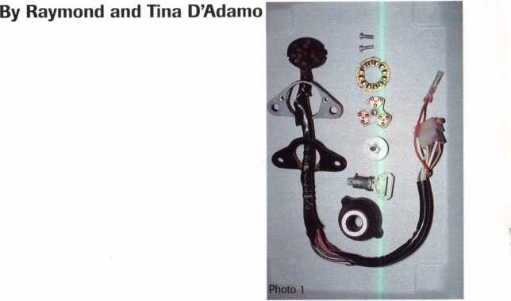

This article is written as documentation and chronology of the Kawasaki motorcycle in the United States, dating from the mid- 1970s. The dates specified are approximate, due to some overlap occurring during transi­tion zones, periods when Kawasaki switches to a new key system, or introduces and uti­lizes a new system concurrent with an exist­ing one.

Kawasaki lockwork is extremely similar to Yamaha lockwork, and is therefore simi­larly serviced. Kawasaki produces three types of motorcycles: on-road, on/off-road and off­road. Here, “motorcycle” applies to two-, three- and four-wheel, motorized, open-air vehicles, which do not possess an enclosed passenger compartment. The first two types usually sport a full complement of locks: ignition, helmet/seat and tank. Models like the Vulcan Classic sometimes sport addition­al compartments.

When determining whether an auxiliary compartment lock is keyed to a bike s sys­tem, we apply these rules. If the compart­ment is part of the stock vehicle, the lock in it is most likely keyed to the usual group— ignition, tank and seat locks. If it is not part of the vehicle (like an extra luggage com­partment on the back) when the piece is fit­

ted as a factory-installed addition, then the lock in it is most likely keyed to the rest of the vehicle. If the piece is purchased and installed afterwards, but is a piece of Kawasaki equipment, then it is only possible that the lock in it is keyed to the rest of the vehicle. If the piece is not original Kawasaki equipment, then it is very unlikely that the lock in it is keyed to the rest of the vehicle.

The off-road cycles do not use key locks, they use toggle switches and buttons to enable the lighting and ignition circuits.

The ATVs are usually fitted with an ignition switch only.

Code Series: 401-925 Keyblank: YH25, YH26, and Others

The earliest Kawasakis with which we have any service experience were manufactured in the mid 1970s. They utilize single throw disc locks, operated by single and double bitted, reversible keys. As with Yamahas of the period, the key code is stamped into the face of the lock plug—a very conspicuous location. All the locks on the bike are keyed alike. The Silca Automotive Keyblank Cross Reference has a section in the back that is totally devoted to motorcycles. It is set up chronologically and is very helpful when

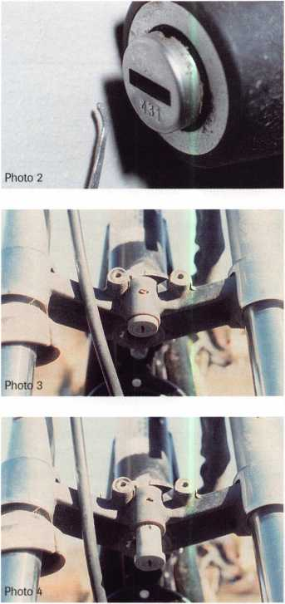

Keynotes

March 1997

MOTORCYCLE **LOCKSMITHING/^**

*D*

determining the appropriate keyblank for the key code you may be working with.

The ignition assembly is a keyed electric switch, mounted at the console with two screws. To remove it, remove the two screws securing it to the console, separate the two halves of the plastic connector between it and the rest of the bike’s wiring harness and remove the assembly from the bike.

To disassemble it, first remove the two screws securing the mounting bracket to the switch casing, and remove the mounting bracket. Remove the electrical terminal plate. This is the plate that is connected to the wiring. It is notched to fit the back of the switch casing—one way only—and it just lifts out. Next, remove the switch plate. Lift it out of the switch cavity. Since it can be installed 180 degrees out, take steps to reinstall it correctly. This switch plate is a complete assembly, so there will be no parts falling off or out of it while getting it to a safe place on your work bench. Next, lift out the switch plate locator. This metal disc is corrugated and interacts with the bottom of the switch plate to hold the switch plate firmly in each position of operation. This plate is also notched to fit inside the cas­ing—one way only—as long as you do not install it upside down. After the switch plate locator has been removed, lift out the plastic switch plate drive shaft, which is connected to the back of the cylinder plug and drives the switch plate through all operating func­tions. Lastly, remove the cylinder plug by depressing the spring-loaded plug retainer disc at the back of the plug, and push the plug out the top of the switch casing. Four- combination discs are contained. Photo one displays the entire unit disassembled with the terminal plate and wiring surrounding (from left to right): the switch housing, cylinder plug and key, drive shaft, switch plate, switch plate locator and mounting screws.

Of course, you can “pick and pull” the plug from the front of the housing, just like you would on a Yamaha of the same period. Insert a pick and put it to the back of the plug, depress the retainer disc and remove the plug from the housing (photo two).

Kawasaki Fork Locks

As an attempt to further deter theft, Kawasaki made its move to lock the fork to the steering head of the frame. At first, Kawasaki did not utilize a fork-locking igni­tion switch. Instead, a separate lock was used for this purpose.

A couple of designs were used. The fork lock in photo three is mounted inside a steel bracket on the fork. The key code is stamped into the face of the plug. When locked, its locking pin penetrates a strike in the steer­ing head of the frame. To lock the fork to the frame, turn the fork and align the lock­ing pin at the back of the cylinder with the strike in the frame, insert the key, turn it 180 degrees counterclockwise and remove the key. To unlock the fork, reverse the pro­cedure.

To remove this fork lock, first push back the crimped metal, which partially covers the top of the cylinder retainer; a set screw located in the top and center of the steel mounting bracket. With this metal cleared away, remove the set screw with a small blade screwdriver and push the cylinder out the front of the steel bracket (photo four). To disassemble this fork lock, uncrimp the col­lar at the back of the casing in four places and remove the plug and locking pin from the back of the casing.

Another fork lock design, mounted in a steering head of the frame, utilizes a dust shutter, which pivots from a drive pin locat­ed above the cylinder. This lock and shutter assembly is designed exactly the same as the assembly discussed in our Yamaha article in the January ’97 issue of Keynotes, and is simi­larly serviced.

Seat locks of this period are usually stamped with the key code on the face of the plug, and contain all system discs. They can be disassembled, or the plug can be removed with a pick, as described earlier in this arti­cle.

Tank locks of this period are also usually stamped with the key code on the face of the plug. If a problem occurs removing the plug with the “pick and pull” method, the cap can be disassembled, beginning with the removal of the bottom cover plate. Kawasaki tank lock disassembly procedures are the

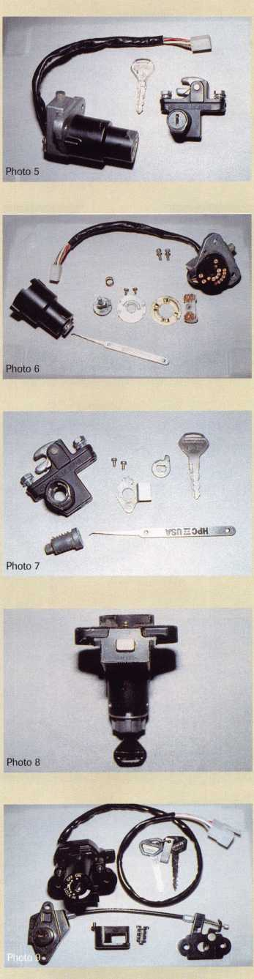

March 1997

Keynotes



3

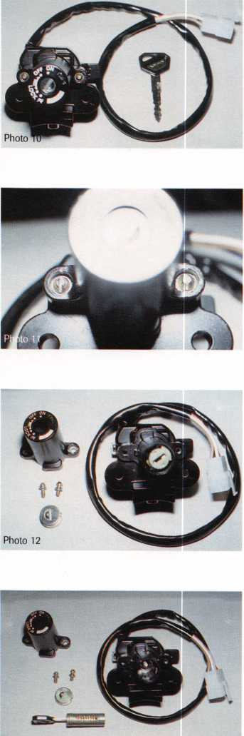

Photo 13

same as they were for the Yamahas of this period, and can be researched in our January ’97 article.

When servicing gas tank locks, remember that some of the parts contained in the cap, usually ball bearings, springs and O-rings, not only help prevent moisture contamina­tion and unwanted emissions, but effect fuel feed to the engine. Keep especially good track of these parts and make sure they are reinstalled correctly.

Code Series:

A/G/N 01-35 Z5000-Z6000

Keyblank: X90, X91 XI03

During the early ’80s, two new lock series were introduced: the A/G/N and Z. Also during this period, the ignition lock config­uration split into two models: fork-locking and non-fork-locking.

The A/G/N series cylinders utilize five positions and three depths. All the locks are keyed alike and stamped with the key code on the plug face. The ignition contains all system discs, while the others contain only the last five. All cylinder plugs can be removed by the “pick and pull” method described earlier. Assembled examples of these units can be seen in photo five.

The A/G/N series fork-locking ignition is a dead ringer for the Yamaha unit of the same period. To disassemble it, first remove the two crosshead screws securing the bolt housing. The black plastic terminal plate will come away from the assembly with the bolt housing. Lift out the switch plate. It is driven by the drive shaft attached to the back of the cylinder plug. Next, remove the two crosshead screws securing the drive shaft mounting plate, and remove the mounting plate and drive shaft. Lift out the “push to lock” return spring, located at the end of the cylinder plug. Lastly, depress the plug retainer and remove the plug from the top of

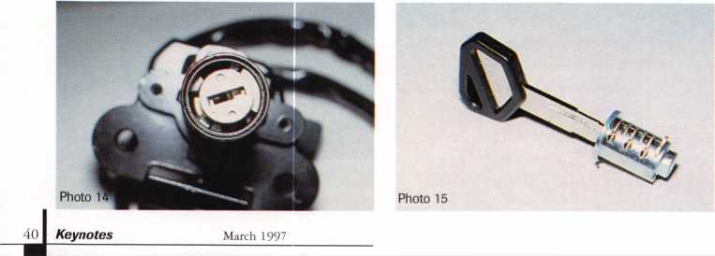

the assembly. A disassembled ignition assembly can be seen in photo six, but we left the cylinder plug in the upper housing to demonstrate how it can be removed with a pick. Photo seven displays a disassembled seat lock.

The Z series cylinders utilize six positions and four depths. Only the ignition contains all system discs. All the locks are keyed alike and stamped with the key code, but the code is no longer stamped on the plug face. The ignition is stamped near the locking bolt, as seen in photo eight. The helmet/seat lock is stamped in the cavity at the back of the unit, and the tank lock is stamped on the bottom of the cover plate. The cylinder plugs can no longer be removed by the “pick and pull” method because the bottom of the plug retainer disc has been removed.

The Z series fork-locking ignition is assembled differently than the A/G/N series unit. Three pins secure the cylinder to the bolt housing. To remove the cylinder from the bolt housing, drill and remove the three pins and remove the cylinder from the bolt housing. To remove the cylinder plug, depress the spring-loaded plug retainer disc at the back of the plug and remove the plug from the front of the casing.

Code Series: A/B Direct Digit Keyblank: XI05, XI06

During the mid ’80s, the A & B series were introduced and were in use concurrent with the Z series. Since they are very similar to the Z series, they are serviced in a similar way.

Code Series:

B/H Direct Digit B8000-B9000

Keyblank: KW14 (Silca) KW15BP (Silca)

In 1993, two new series were introduced. Let’s take a close look at the B8000 series.

An entire set of locks (photo nine) is com-

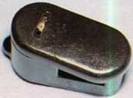

Photo 16

prised of a fork-locking ignition, a helmet, a Disassemble it from the rear as seen in photo

seat and a tank lock. They are accompanied 17, but do not lose track of the ball bearing

by two keys and a code tag. None of the (photo 18). The seat lock (photo 19) can be

locks are coded. This system is composed of disassembled from the rear. You can see the

seven combination discs and an eighth disc plug retainer disc under the white plastic

in the ignition that only sheers with the cut cable driver in photo 20, and an entirely dis-

at the very tip of the key. This eighth cut is assembled seat lock can be seen in photo 21.

pre-cut into each keyblank.

We have decoded the specifications for  
this series and have listed them from bow to  
tip. Disc placement is as follows: ignition 1-  
7, seat lock 1-3, helmet lock 3-6 and tank  
lock 3-7. Disc spacing and depth specifica-  
tions are as follows: first cut spacing is 320.

Cut to cut is 100. The depths are 1-4, 296,

276, 236, and 236.

The ignition lock (photo 10) is installed  
with a pair of sheerhead bolts. After remov-  
ing it from the bike, disassemble it by first  
removing the upper housing cover. Slot or  
drill out and remove another pair of sheer-  
head bolts, one bolt on either side of the  
upper housing cover (photo 11). Remove the  
cover and dust shuddle assembly. The  
removed housing cover and dust shutter can  
be seen in photo 12. To remove the plug,  
insert the key, push the plug down into he  
bolt housing, rotate the plug clockwise until  
it stops, and lift the plug from the assembly.

A completed disassembly of the ignition  
lock can be seen in photo 13.

To remove the plug when an operating  
key is not present, here is a method that  
works for us. Insert a blank into the plug.

This will allow the eighth disc at the back of  
the plug to sheer—a condition that must be  
met before the plug can be pushed down  
into the housing. A pick will accomplish the  
same thing. When the eighth disc sheers,  
push the plug down into the housing and  
hold it there. While keeping the plug  
depressed, remove the blank or pick and  
begin to apply slight clockwise rotational  
pressure to it. Next, with an appropriate  
tool, push the combination discus protrud-  
ing from the left side of the plug to the  
sheeriine (photo 14). When all the discs  
sheer, turn the plug clockwise until it can be  
lifted from the assembly.

The tank lock plug (photo 15) can be removed by disassembling the tank lock from the bottom cover plate. The helmet lock (photo 16) is secured with two bolts.

Photo 17

ATVs

The ATVs are usually fitted with a keyed ignition switch only. The original keys are most likely stamped with the key code, but whether or not a code will be found on the ignition switch itself will be determined mostly by the time period. Earlier ATVs will be stamped with the key code on the face of the plug. Later units will be stamped on the side of the casing. Todays switches will not be stamped with a key code, but all of these key switches can be disassembled to remove and decode the plug. Remove the switch by unscrewing the bezel nut near the face of the switch, drop the switch behind the panel it occupies, disconnect the wiring and remove the assembly from the bike. Begin disassem­bly by unsnapping the terminal plate from the back of the switch casing and follow this path to the spring-loaded plug retainer disc.

The more we dig into this field of motor­cycle lockwork, the more interesting it gets, and the more confident and better we feel about servicing them. See you next time when we look into another exciting facet of motorcycling locksmithing.

Photo 19

“v About the authors: Raymond UAdorno, CML, has been writing technical articles for Keynotes and teaching auto­motive locksmithing since 1982. He uwks at Fort Security Center in Ft. Collins, CO. with his wife Tina, CRT. Ray has been a member of ALDA since 1978 and Tina since 1988.

Tina DAdamo CRL, began locksmithing in 1983 and immediately showed a great interest in motor­cycle lockwork. She soon realized the lack of motor­cycle lock service information available to lock­smiths, and began compiling hr own. hoping to someday release it to locksmiths in the fonn of arti­cles like time in this series.

Photo 21

***Keynotes*** | 41

March 1997

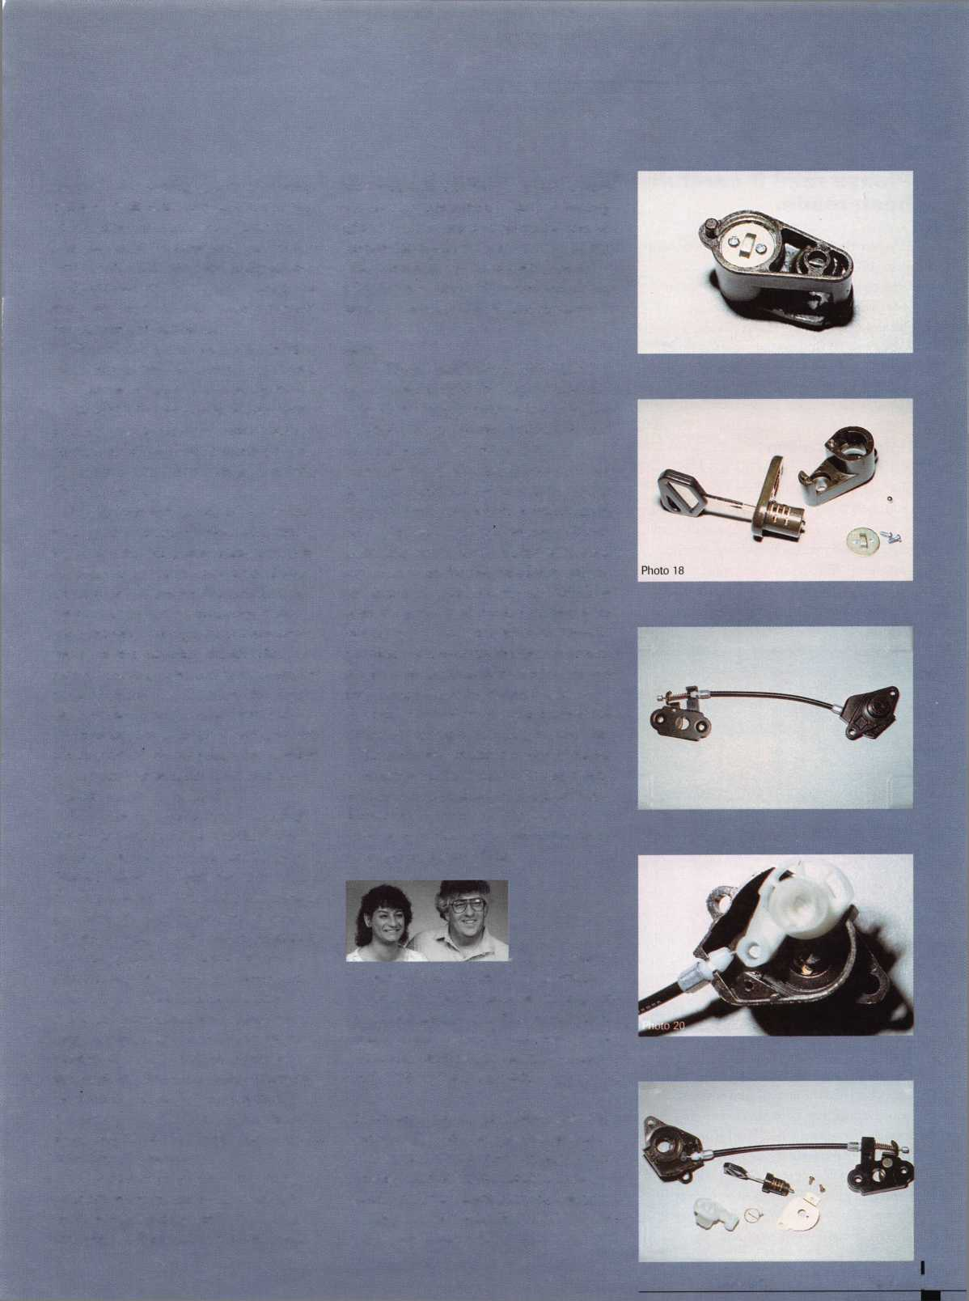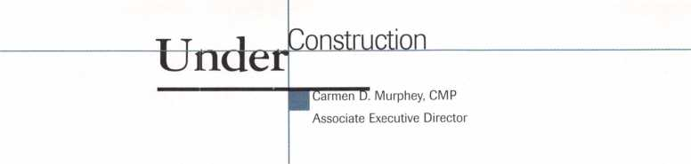

Please read it carefully—Changes in packages and pricing have been made.

This month you will be receiving your com­plete ALOA ’97 Convention and Security Expo registration brochure. Please read it very carefully—there have been some changes in the packages and pricing.

Now is the time to start making hotel and airline travel plans. As a reminder, make your hotel reservations before airline arrange­ments.

**Hotei-Reno Hilton**

A hotel form is located in the brochure; however, you can call the hotel directly at (800) 648-5080 or (702) 789-2000. In order to receive the rate of $99 single/double, ask for the Associated Locksmiths of America group rate. Also, reservations must be made by July 1, 1997. After this date, the rate will be based on availability and is subject to an increase.

**Transportation**

Runaway Travel has been selected as the offi­cial agency for the annual convention. Sever­al air carriers have been selected to offer you special, discounted fares. *Call Runaway Travel to make your travel plans at (800) 284-0001 (US only) or (972) 717-2949 (8-5 Central Standard Time) to find the best fare for you! If you prefer to call the airlines directly or have your agent make the

arrangements, here are the phone numbers and the file numbers. The file numbers help determine the discounts.

American Airlines: 1-800-433-1790

Index #S9832

Delta Airlines: 1-800-241-6760

Index #XW787 Southwest Airlines: 1-800-433-5368

Index #C3707

*Restrictions apply to all discounts.

**Security Expo**

With the change in the name of the show, comes some new and return exhibitors. Here is a sneak preview

* A & B Safe Corporation
* Adesco Safe Company
* AdvanSec—Adv. Sec. Concepts
* DRK Specialties
* Intermountain Lock & Supply
* Kwikset Corporation
* Labor Saving Devices
* Low Tech Products
* National Security Safe Co.
* Omaha Wholesale Hardware
* Papaiz USA Ltd
* R.Q. Associates
* Taymor Industries, Inc.
* TESA Access Control
* Weston Key Systems
* Wilco Supply

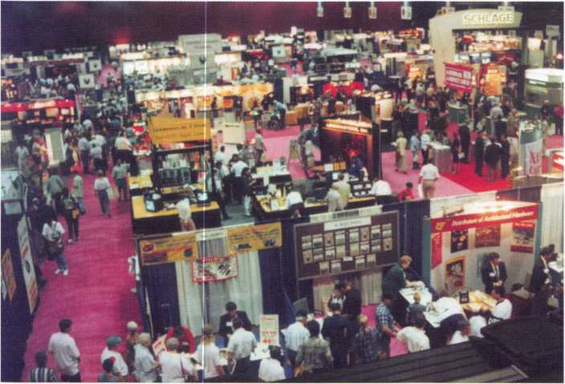

Keynotes

March 1997

**Classes**

As mentioned in an earlier article, we have made some changes to the class schedule and classes offered. Here is a list of new classes being offered. Check out the brochure for a full description.

* Basic Safe Deposit Lock Servicing
* Your Bottom Line
* Servicing Aluminum Storefront Doors
* Investigative Locksmithing
* Jail and Prison Locks
* Grow Your Business-Shark marketing ’97
* Basic Computing
* High Security Import Automotive
* Basic Safe Penetration
* Hands-On Access Control
* Electronic and Mechanical Access/Egress Control

If you have any questions, please give us a call at (800) 532-ALOA (2562).

About the Author: Carmen D. Murphey, CMP, is the Associate Executive Director for ALOA.

ALOA Video Library

Order Form

Policies of the ALOA Video Tape Library and procedure for ordering videos:

1.

**2**.

3.

4.

5.

Videos are loaned to ALOA members, chapters and local associations for a period of one (1) week. All tapes  
are VHS format. Notice: All video tapes are protected under the US copyright laws and may not be duplicated.

Only one tape per order is allowed unless prior arrangements have been made with the ALOA office; e.g., chapters  
holding educational events.

Charges: $5.00 per tape for shipping and handling.

$10.00 per day late charge. Late charges are assessed for tapes more than 2 days late.

$100.00 per tape for loss or damage.

Payment for shipping and handling must accompany the order, except for faxed orders. Any additional charges  
will be billed to the borrower.

A credit card account number must be included on the video order form as a deposit. If the video is not returned, your  
credit card will be billed for late charges or for loss/damages.

Credit card #

Expiration date

1. It is the responsibility of the borrower to insure each tape for the $100 against loss or damages when returning videos to the ALOA Library.
2. Failure to remit shipping and handling, late, or any other charges may result in suspension of borrowing privileges.
3. To order a video, indicate 1st, 2nd, and 3rd choices on this form, fill out the bottom portion completely, and

mail the entire form to: ALOA Video Department, 3003 Live Oak St., Dallas, Tx 75204

1. Orders may also be faxed to (214) 827-1810.

|  |  |  |
| --- | --- | --- |
| □ | 99 Rim Device Installation | □ |
| □ | Advanced Door Panel Servicing | □ |
|  | Volume 1 | □ |
| □ | Air Bag Steering Columns | □ |
|  | Volume 1 | □ |
| □ | Air Bag Steering Columns | O |
|  | Volume 2 | □ |
| □ | Auto Lock Servicing Update #1 | □ |
| □ | Automatic Dialer | □ |
| □ | Basic Car Opening, Vol. 1 | □ |
| □ | Basic Door Panel Servicing | □ |
| □ | Basic Locksmithing, Volume 1 | □ |
|  | Beretta & Corsica: Opening | □ |
| □ | and Fitting Keys | □ |
|  | Business Locks and | □ |
| □ | Locking Devices | □ |
| □ | Car Opening Update #1 | □ |
| □ | Car Opening Update #2 | □ |
| □ | Car Opening Update #3 | □ |
| □ | Car Opening Update #4 | □ |
| □ | Car Opening Update #5 | □ |
| □ | Car Opening Update #6 | □ |
| □ | Car Opening Update #7 | □ |
| □ | Car Opening Update #8 | n |
| □ | Chrysler Double-Bitted Locks | □ |
| □ | Chrysler Pin Tumbler Locks | LmJ |
| □ | Chrysler Steering Columns |  |

* except for faxed orders and orders from outside the US

Detention Locks

The Door to Business Security

The Door to Home Security

Filing for Dollars

Ford Locks

Ford Steering Columns GM Locks

GM Steering Columns

Home Security Alarms

Home Security Survey

Import Models, Volume 2

Impressioning GM/Ford Sidebar Locks

Labeled Fire Door

Lock Mortiser

Mastering the Art of Impressioning

On the Home Front

Padlocks

Pinning KABA

Plugging for Profit

Precision Key Machines

Residential Locks and Locking Devices

Residential Magnetic Contact Applications

Robbery Prevention Techniques

S&G 6120 Series

S&G Combination Lock Fundamentals for the R6730-TOR (5/90)

Q S&G Commercial Products (2/90)

Q S&G Government Products (8/89) **f~j** S&G Integrating High Security with Life Safety

* S&G Locking Mechanisms (6/89)

**| k** S&G R6730-TOR Combination Lock **p! (8/90)**

S&G Scrambler Servicing Q Safe Deposit Locks, Volume 1 Q Safe Deposit Locks, Volume 2

* Safe Deposit Locks, Volume 3
* Servicing the Honda and Acura

Q Servicing the Toyota & Similar Locks 'Q Shock and Moisture Sensors:

High Security Risks

* Somebody's Watching

Q Standard Steel Door Frames Q Standard Steel Doors

* Thief on the Loose!

Commercial Glass Break Applications

* Toyota Split - Tumbler Locks: Use and Adjustment of Gemini Key

Q V.A.T.S. Made Simple Q What's Behind a Fire Door Test Label?

* Yale Door Closers

**1/97**

ALL INFORMATION MUST BE COMPLETE OR PROCESSING MAYBE DELAYED

ALOA Member # Date Needed:

Name **Phone #**

Address (No P.O. Box)

City State ZIP

Enclosed is 0 Check ^1 Money Order for shipping & handling

AccnriatP

|  |  |  |
| --- | --- | --- |
| u m^***^* m wM  Members | | 1 |
|  | Manufacturers | All-Lock Company  900 Ravenwood Dr.  Selma, AL 36701  (334) 874-9001; FAX (334) 874-6011 |
|  |  |  |
|  | A & B Safe Corp.  171 S. Delsea Dr.  Glassboro, NJ 08028 (800] 253-1267; FAX (609) 863-1208 | Allied-Gary Safe Company  West 425 2nd Ave.  Spokane, WA 99204 (509) 458-2633; FAX (509) 458-2633 |
|  | © (0) | (0 0 |
|  | Access Protection Mfg.  216 Plaisto Rd.  Plaisto, NH 03865  [603) 382-0822; FAX (603) 382-0833 | American Lock Co.  3400 West Exchange Road  Crete, IL 60417-2099 (708) 534-2000; FAX (708) 534-0531 |
|  | • | © © |
|  | ASSA High Security Lock  10300 Foster Ave.  Brooklyn, NY 11236 [718) 927-2772; FAX [718) 257-2772 | American Security Products  11925 Pacific Ave.  Fontana, CA 92337-6963 (909) 685-9680; FAX (909)685-9685 |
|  | • | 0 |
|  | Abloy Security, Inc.  6015 Commerce Drive Ste. #450  Irving, TX 75063  (972) 753-1127; FAX (972) 753-0792 | Arrow Lock Company  10300 Foster Avenue  Brooklyn, NY 11236 (718) 257-4700; FAX (718) 649-9097 |
|  | © | © 0 (0 0 |
|  | Abus Lock Company  P.0. Box 47507  Plymouth, MN 55447-0507 (800) 225-5348 | Auto Security Products (A. S. P.)  P.0. Box 10  Redmond, WA 98073-0010 (206) 556-1900; FAX (206) 558-1205 |
|  | • | 0 0 |
|  | Adams Rite Manufacturing Co.  4040 S. Capital Ave.  City of Industry, CA 91749 (310) 699-0511; FAX (310) 699-5094 | Baton Locks & Hardware Co.  14275 Commerce Dr.  Garden Grove, CA 92643 (714) 265-3636; FAX (714) 265-3630 |
|  | (0) | 0 (0 |
|  | Adrian Steel Company  906 James St.  Adrian, Ml 49221  (517) 265-6194; FAX (517) 265-5834 | Best Locking Systems of Louisville  10310 Bluegrass Pkwy  Louisville, KY 40299 (502) 491-4042 |
|  |  |  |
|  | Aiphone Intercom Systems  1700-130th Avenue, NE  Bellevue, WA 98005 (206) 455-0510; FAX (206) 455-0071 | Cannon Safe, Inc.  9358 Stephens St.  Pico Rivera, CA 90660 (800) 242-1055; FAX (310) 692-7252 |
|  |  | 0 |
|  | Alarm Lock Systems, Inc.  345 Bayview Ave.  Amityville, NY 11701 (800) ALA-LOCK; (516) 789-3383 | Chicago Lock Company  10100 88th Ave.: P.0. Box 0069  Pleasant Prairie, Wl 53158-0069 (414) 947-7177; FAX (414) 947-7178 |
|  | © | © |
|  |  |  |

Associate members of the Associated Locksmiths of America (ALOA) manu­facture or distribute materials or equip­ment, or provide services, for the securi­ty industry. Many have donated money, services and equipment to ALOA in addition to their annual dues. Their sup­port of ALOA projects enhances overall membership benefits and we encourage our members to patronize these firms. If you know of a potential candidate for associate membership, please contact the ALOA Sales staff at (214) 827-1701. Associate member dues are $500 per year and entitle the payor to use the ALOA logo, and selected discounts on ALOA products and services.

**Legend**

**© Alarms:** Personal, vehicle, electronic, fire, burglar, and exit

© Bank security equipment

**© Automotive:** Lockout equipment, key chains/rings

**© Builders Hardware:** Door closers, furniture/decorative hardware, viewers, emergency exit devices

© Business/Technical & Educational::

Books, reference guides, publications, computer software

**© CCTV/Photo Imaging:** Cameras, monitors, photo ID equipment, cables

**© Electric/Electronic Security:** Card access control and readers, surveil­lance, electric/magnetic locks and strikes, keypads

**® Lock Devices:** Auto locks, cylinders, emergency exit/entrance control, locks (various types), strikes

**Tools & Supplies:** Key blanks, cutters, picks, rings/hooks, custom van/truck supplies

© Safes/Vaults

© Other

Keynotes

March 1997



Associate

Members

|  |  |  |
| --- | --- | --- |
| Corbin Russwin Architectural Hardware  P.0. Box 25288  Charlotte, NC 28229 (704) 283-2101 | Gardall Safe Corporation  P.O. Box 30  Syracuse, NY 13206 (315) 432-9115; FAX (315) 434-9442 | International Electronics, Inc. (I.E.I.)  427 Turnpike St.  Canton, MA 02021 (800) 343-9502; FAX(617) 821-4443 |
| • • • • | • | • |
| Curtis Industries  6140 Parkland Blvd.  Mayfield Heights, OH 44124 (800) 555-5397 | Glenncraft Corporation  205 Fortin Dr.  Woonsocket, Rl 02895-6116 (401) 769-0101; (401) 766-1170 | Jet Hardware Mfg. Co.  800 Hinsdale Street  Brooklyn, NY 11207 (718) 257-9600; FAX(718) 257-0973 |
| • • |  | 0 |
| DETEX  302 Detex Dr.  New Braunfels, IX 78130 (800) 729-3839; FAX (210) 620-6711 | Grobet File Co. of America  750 Wasahington Ave.  Carlstadt, NJ 07072 (800) 962-7242; FAX (800) 243-2432 | KABA High Security Locks  P.O. Box 490  Southington, CT 06489 (860) 621-3601; FAX(860) 621-9727 |
| • • • • | • | • |
| DOM Security Locks North America  100 Central Ave,  Brockville, Ontario, Canada K6V 5W6 (800) 363-4803; FAX (613) 498-5820 | GT-85 International, Inc.  P. 0. Box 21185  St. Petersburg, FL 33742-1185 (800) 525-GT85; FAX (813) 526-1234 | Kenstan Lock Company  101 Commercial St.  Plainveiw, NY 11803-2412 (516) 271-2700; FAX(516) 271-2759 |
| • | • | 9 9 |
| Don-Jo Manufacturing, Inc.  P.O. Box 929  Sterling, MA 01564 (508)422-3377; FAX (508) 422-3467 | H.E.S., Inc.  2040 W. Quail Ave.  Phoenix, AZ 85027 (602) 582-4626; FAX (602) 582-4641 | KEY-BAK; Div. of W. Coast Chain Mfg. Co.  1460 S. Balboa Ave.  Ontario, CA 91762 (909) 923-7800; FAX(909) 923-0024 |
| • # | • • • | 9 9 9 9 |
| Door Controls International  2362 Bishop Circle East  Dexter, Ml 48130  (800) 742-3634; FAX (800) 742-0410 | Highland Glen Products, Inc.  218 Parkdale Ave.; P.O. Box 924  Buffalo, NY 14213 (716) 883-1110; (800) 248-KEYS | Knaack Manufacturing Co.  420 E. Terra Cotta Ave.  Crystal Lake, IL 60014 (800) 456-7865; FAX(815) 459-9097 |
| • • • • | • 9 | 9 |
| Emtek Products, Inc.  15250 E. Stafford St.  City of Industry, CA 91744 (800) 356-2741; FAX (800) 577-5771 | Hill Security Products  711 East Walton Avenue  Spokane, WA 99207 (509) 487-1142; (800) 722-1142 | Kwikset Corp.  One Park Plaza, Suite 1000  Irvine, CA 90638  (714) 474-8818; FAX (714) 474-8879 |
| 9 • | • | • • |
| ESP Lock Products, Inc.  375 Harvard Street  Leominster, MA 01453 (508) 537-6121; FAX (508) 537-1699 | HPC, Inc.  3999 N. 25th Avenue  Schiller Park, IL 60176 (847) 671-6280; FAX(847) 671-6343 | LCN Closers (Division of Ingersol)  121 W. Rail Road Ave.  Princeton, IL 61356 (815) 875-3311; FAX (815) 875-3222 |
| • | • • • | 9 |
| Federal Lock Company  14247 E. Don Julian Rd.  City of Industry, CA 91746 (800) 682-9851; FAX (708) 378-4767 | Hurd Corporation  Box 1450, 503 Bohannon Ave.  Greeneville, TN 37744-1450 (423) 787-8800; (423) 787-8817 | LAB Security  700 Emmett St.  Bristol, CT 06010  (800) 243-8242; FAX (203) 583-7838 |
| • | <3) (® | • |
| Folger Adam Security, Inc.  16300 W. 103rd Street  Lemont, IL 60439  (630) 739-3900; FAX (630) 739-6138 | llco Unican  400 Jeffreys Road  Rocky Mount, NC 27804 (919) 446-3321; FAX (919) 446-4702 | La Gard, Inc.  3330 Kashiwa Street  Torrance, CA 90505 (310)325-5670; FAX (310)325-5615 |
| 9 • | ••••••• | • |
| Fort Lock Corp.  3000 N. River Rd.  River Grove, IL 60171 (708) 456-1100; FAX (708) 456-9476 | Industries, C.L. Inc.  9730 Gouin Blvd. West  Pierrefonds (Qc) Canada H8Y 1R5 (514) 683-6282; FAX(514) 683-9015 | Locksmith Publishing Corp.  850 Busse Hwy.  Park Ridge, IL 60068 (847) 692-5940; FAX (847)692-4604 |
| ^ <|^ (0 (j^ ^ | • • | • |
| # Alarms  ®-'' Bank security equip.,  9 Automotive ® Builders Hardware | / # Business/Tech &&& *;  0, Eiectric/Electronic Sec.  ';, 0: * |  |

March 1997

***Keynotes***

45

Associate

Members

|  |  |  |
| --- | --- | --- |
| Lockmasters, Inc.  5085 Danville Rd.  Nicholasville, KY 40356 (606) 885-6041; FAX (606) 885-7093 | National Cabinet Lock  200 Old Mill Road, P. 0. Box 200  Mauldin, SC 29662 (864) 297-6655; FAX (864) 297-9987 | Rutherford Controls Inc.  2697 Internal Pkwy, Bid 5 #100  Virginia Beach, VA 23452 (757) 427-1230; FAX (804) 427-9549 |
| ^ (0 (Q | • | 0 |
| Lori Lock/Delta  P.O. Box 1040  Southington, CT 06489 (203) 621-3605; FAX (203) 621-5972 | The National Locksmith Magazine  1533 Burgundy Parkway  Streamwood, IL 60107 (630) 837-2044; FAX (630) 837-1210 | Sargent & Greenleaf, Inc.  P.O. Box 930  Nicholasville, KY 40340-0930 (606) 885-9411; FAX (606) 887-2057 |
| a o | • | ^ ^ ^ ^ |
| Lucky Line Products  7890 Dunbrook Rd.  San Diego, CA 92126 (619) 549-6699; FAX (619) 549-0949 | New England Lock & Hardware  46 Chestnut St.  South Norwalk, CT 06856 (203) 866-9283; FAX (203) 838-4837 | Schlage Lock Co.-PRIMUS  3899 Hancock Expy.  Security, CO 80911 (719) 390-5071 |
| O | e o | 0 0 |
| Lund Equipment Co., Inc.  P.O. Box 213  Bath, OH 44210  (216) 659-4800: FAX (216) 659-9347 | Newman Tonks  P.O. Box 548  Shepardsville, KY 40165 (502) 543-2281; FAX (800) 777-8229 | Schwab Corporation  3000 Main Street  Lafayette, IN 47903 (317) 447-9470; FAX (317) 447-8278 |
| • •• | # 0 | 0 |
| M.A.G. Engineering & Mfg. Inc.  15261 Transistor Lane  Huntington Beach, CA 92649 (714) 891-5100; FAX (714) 892-6845 | NT Falcon Lock  2650 Orbitor Street  BreaCA, 92621-6265 (800) 266-4456; FAX (800)777-8229 | Securitron Magnalock Corp.  550 Vista Blvd.  Sparks, NV 89434  (800) 624-5625; FAX (702) 355-5636 |
| O O O | 0 • | 0 0 |
| MARKS USA  5300 New Horizons Blvd.  Amityville, NY 11701 (516) 225-5400; FAX (516) 225-6136 | Pach & Company  941 Calle Negro  San Clemente, CA 92672 (714) 498-2951; FAX (714) 498-6879 | Security Door Controls  P.O. Box 6219  Westlake Village, CA 91359-6219 (805) 494-0622; FAX (800) 959-4732 |
| O | 0 0 | 0 |
| Master Lock Company  2600 North 32nd Street  Milwaukee, Wl 53210 (414) 444-2800; FAX (414) 449-3114 | Prime Line Products Company  4185 Hallmark Pkwy.  San Bernadino, CA 92407 (909) 887-8118; FAX (909) 880-8968 | Sentry Group  900 Linden Ave.  Rochester, NY 14625-2784 (716)381-4900; FAX (716) 381-8559 |
| O • | 0 0 | 0 |
| Medeco Security Locks  P.O. Box 3075  Salem, VA 24153  (540) 380-1684; FAX (540) 380-5010 | Pro-Lok  655 North Hariton Street  Orange, CA 92668-1311 (714) 633-0681; FAX (714) 633-0470 | Silca Key U.S.A. Inc.  5633 Hudson Industrial Pkwy.  Hudson, OH 44236 (216) 656-5613 |
| O O O | 0 0 | 0 0 |
| Meilink Safe Company  111 Security Parkway  New Albany, IN 47150 (800) 634-5465; FAX (800) 896-6606 | Rainbow Technology  261 Cahaba Valley Pkwy.  Pelham, AL 35124-1146 (800)637-6047; FAX (800) 521-6896 | Star Key Industries,Inc.  145 Brite Ave.  Scarsdale, NV 10583-1426 (914) 235-1700 |
| • | 0 | 0 |
| Metalurgica Odis S.A.  Porto Seguro 4395 Quinta Norma  P.O. Box 107-2; Santiago, Chile (562) 776-6511 | Rev-A-Shelf, Inc.  2409 Plantside Dr.  Jeffersontown, KY 40299 (502) 499-5835 | STRATTEC Security Corp.  3333 W. Good Hope Rd.  Milwaukee, Wl 53209 (414)247-3333; FAX (414) 247-3329 |
| • | 0 | 0 0 0 |
| MUL-T-LOCK USA, Inc.  300-1 Route 17 South Suite A  Lodi, NJ 07644  (800) 562-3511; FAX (201) 778-4007 | Rofu International Corp.  2004-B 48th Ave.; Court E  Tacoma, WA 98424 (800) 255-7638; FAX (206) 922-1728 | Sully Tools Inc.  3515 Nodding Pine Ct.  Fairfax, VA 22033  (703) 689-3416; FAX (703) 787-0869 |
| O O O | 0 | 0 0 0 |
| Alarms  ® Bank security equip.  ® Automotive ® Builders Hardware | ® Business/Tech & id.  ® CCTV/Photo Imaging § Electric/Electronic Sec.  ® Lock Devices | ® Tools & Supplies ® Safes/Vaults ® Other |

^ ***Keynotes***

March 1997

Associate

Members

|  |  |  |
| --- | --- | --- |
| Treskat USA  725 Adriane Park Circle  Kissimmee, FL 34744 (800) 645-5657; FAX (407) 870-9696 | American Security Distribution  4411 E. La Palma  Anaheim, CA 92807 (714) 996-0791; FAX (714) 579-3508  0 0 (01 (0 (0 (0 0 | Ewert Wholesale Hardware  4709 W 120th St  Alsip II 60658 (800) 451-0200  0 0 0 0 0 |
| Trine Products Corporation  1430 Ferris Place  Bronx, NY 10461  (718) 829-4796; FAX (718) 792-9127  0 0 0 | Andrews Wholesale Lock Supply  544 S. 9th St.  Lebanon, PA 17042-6608 (717) 272-7422  0 | Fairway Supply, Inc.  2631 Lombardy Lane  Dallas, TX 75220  (214) 350-0021; FAX (214) 352-4299  0 0 0 0 0 0 0 |
| U-Change Lock Industries  1640 W. Hwy. 152  Mustang, OK 73064 (405) 376-1600; FAX (405) 376-6870  0 0 0 | Armstrong’s Lock & Supply, Inc.  1440 Dutch Valley Place NE  Atlanta, GA 30324  (800) 726-3332; FAX (404) 888-0834  0000000000 | Foley-Belsaw Company  6301 Equitable Road  Kansas City, MO 64120 (800) 821-3452; FAX (816) 483-5010  0 0 0 0 |
| Vindicator Corp.  3001 Bee Caves Rd.  Austin, TX 78746-5561 (512) 314-1200; FAX (512) 314-1270  0 (0 0 © | Boyle & Chase Inc.  P. O. Box 74  Accord, MA 02018-0074 (800) 325-2530; FAX (617) 335-5342  0 0 0 | Fried Brothers, Inc.  467 N. 7th St.  Philadelphia, PA 19123 (800) 523-2924; FAX (800) 541-3489  0000000000 |
| Weiser Lock Company  6700 Weiser Lock Blvd.  Tucson, AZ 85746  (520) 741-6231; FAX (520) 741-6363  0 0 | Canada Lock Products Ltd.  70 Floral Parkway  Toronto, ON Canada M6L 2C1 (416) 248-5625; FAX (416) 248-9945  0000000000 | H. Hoffman Company  7330 West Montrose  Chicago, IL 60634 (708) 456-9600  00000000 |
| Wilson Safe Company  3031 Island Avenue/P.O. Box 5310 Philadelphia, PA 19153 (215) 492-7100; (800) 345-8053  0 | Clark Security Products, Inc.  4775 Viewridge Ave.  San Diego, CA 92123-1641 (800) 854-2088  0000000000 | HS&S Wholesale Distributors  12915 West 8 Mile Road  Detroit, Ml 48235 (800) 521-2202  0 0 0 0 0 0 0 |
| Yale Security Inc.  P.O. Box 25288  Charlotte, NC 28229-8010 (704) 283-2101  0 0 0 0 | Cook’s Building Specialties  2441 Menaul Blvd. NE; P.O. Box 37320 Albuquerque, NM 87176-7320 (505) 883-5701; FAX (505) 883-5704  0 0 0 0 0 0 | Hans Johnsen Company  8901 Chancellor Row  Dallas, TX 75247  (214) 879-1550; FAX (214) 879-1530  00 000000 |
| Distributors | DiMark International  3117 Liberator St., Unit A  Santa Maria, CA 93455 (800) 235-2435; FAX (805) 928-8034  © ® | Hardware Agencies, Ltd.  1220 Dundas Street East  Toronto, ON M4M 1 S3 (416) 462-1921  00000000 |
| Accredited Lock Supply Co.  P.O. Box 1442  Secaucus, NJ 07096-1442 (800) 652-2835; FAX (201) 865-5031  0 0 0 0 0 0 0 | Dire’s Lock & Key Co.  2201 Broadway  Denver, CO 80205 (303) 294-0176  00000000000 | Hardware Suppliers of America  P.O. Box 2208  Winterville, NC 28590 (800) 334-5625  0 0 |
| Ace Lock & Security Supply Co.  565 Rahway Ave.  Union, NJ 07083-6631 (908) 688-7666; (800) ACE-FAX4  0 0 0 0 0 0 0 | Doyle Lock Supply  2211 W. River Road N.  Minneapolis, MN 55411 (800) 333-6953; FAX (612) 521-0166  0 0 0 0 0 | IDN, Inc.  1000 S. Main, Suite 280  Grapevine, TX 76051 (817) 421-5470; FAX (817) 421-5468  0000000000 |
| Akron Hardware Consultants, Inc.  2579 South Arlington Road  Akron, OH 44319  (800) 321-9602; FAX (800) 328-6070  (0) (0 (0) | Dugmore & Duncan Inc.  30 Pond Park Rd.  Hingham, MA 02043 (800) 225-1595; FAX (617) 740-4043  0 0 0 0 0 0 0 | IDN—Armstrong’s, Inc.  1440 Dutch Valley Place NE  Atlanta, GA 30324 (800) 726-3332 |
| f A'TS ■ 1 ““'/TeC1h&Ed- ® Tools & Supplies  2 Bank security equ.p. © CCTV/Photo Imaging © Safes/Vaults  Automotive w Electric/Electronic Sec. jjk n .  © Builders Hardware ® Lock Devices | | |

March 1997

Keynotes

Associate

Members

|  |  |  |
| --- | --- | --- |
| Intermountain Lock & Supply Co  2300 W. 2nd Ave., Unit B  Denver, CO 80223  (800) 323-8046; FAX (303) 698-2094 | McMaster-Carr Supply Company  600 County Line Rd,  Elmhurst, IL 60126-2081 (630) 833-0300; FAX (630) 834-9427  ^ ^ ||j} ^ ^ | Top Notch Distributors, Inc.  P.O. Box 189  Honesdale, PA 18431 (800) 233-4210  • • • |
| Jo-Van Distributors Inc.  929 Warden Ave.  Scarborough, Ontario MIL 4C6 (416) 752-7249; FAX (416) 752-3845  ••••••••••• | Monaco Lock Co., Inc.  339-345 Newark Ave.  Jersey City, NJ 07302 (800) 526-6094; FAX (800) 845-LOCK  • • • | Turn 10 Wholesale  P.O. Box 746  Marietta, OH 45740 (800) 848-9790; FAX (800) 391-4553  • |
| JLM Wholesale, Inc.  3095 Mullins Ct  Oxford, Ml 48371-1643 (800) 522-2940; FAX (800) 782-1160 | New England Business Service, Inc.  500 Main St.  Groton, MA 01471 (508) 448-6111 | U.S. Lock Corporation  77 Rodeo Drive  Brentwood, NY 11717 (800) 925-5000; FAX (800) 338-5625  ^ @ ^ |
| Key Sales & Supply Co., Inc.  9950 Freeland Ave.  Detroit, Ml 48227 (313) 931-7720; (313) 931-7758  (ggi <!^ (0 (Q (H | Omaha Wholesale Hardware  1201 Pacific Street, PO Box 3628  Omaha, NE 68108 (800) 238-4566  • • • | Webster Safe & Lock Company, Inc.  3020 Millbranch  Memphis, TN 38116 (901) 332-2911; FAX (901) 332-2878  ^ ^ @ ® |
| Lockmasters, Inc.  5085 Danville Road  Nicholasville KY, 40356 (606) 885-6041  • • • • | E. L. Reinhardt Co., Inc.  3250 Fanum Road  Vadnais Heights, MN 55110 (800) 328-1311; FAX (612) 481-0166  •••••• | Service |
| Locks Company  2050 N.E. 151 St.  N. Miami, FL 33162 (800) 288-0801; FAX (305) 949-3619  @ ® ® | Security Lock Distributors  40 A Street  Needham Heights, MA 02194 (800) 847-5625; FAX (800) 878-6400  • • • | Allstate Insurance Company  2775 Sanders Road, Suite A5  Northbrook, IL 60062 (847) 402-8196; FAX(847) 326-7509  • |
| Locksmith Store Inc.  1229 E Algonquin Rd. Suite E  Arlington Heights, IL 60005 (847) 364-5111; FAX (847) 364-5125  • • • • | Sentry Security Fasteners  8109 N. University  Peoria, IL 61615  (309) 693-2800; FAX (309) 693-2872  • • | GE Capital Fleet Services  Three Capital Drive  Eden Prairie, MN 55347 (612 828-2928; FAX (612) 828-1766  e |
| M. Zion Company  17 Murray Street  New York, NY 10007 (212) 349-8677  ••••••• | Southern Lock and Supply Co.  Box 1980, 10910 Endeavor Way  Pinellas Park, FL 34664 (800) 237-2875; FAX: (800) 447-2299 | Gil-Ray Tools, Inc.  P.O. Box 801, 1306 McGraw St.  Bay City, Ml 48707 (517) 892-6870; FAX (517) 892-6870  • |
| Mayflower Sales Company, Inc.  614 Bergen Street  Brooklyn, NY 11238 (718) 622-8785; FAX (718) 789-8346  ® ® ® ® | Southwest Mini-Keys Inc.  2323 N. Central Expwy, Suite 165  Richardson, TX 75080 (214) 669-1704  • | National Key & Road Service  124 Stratford Dr.  Louisburg, NC 27549 (919) 497-0474; FAX (919) 497-5555 |
| McDonald-DASH Locksmith Supply  5767 E. Shelby Dr.  Memphis, TN 38141 (800) 238-7541; FAX (901) 366-0005  •••••••• | Stone & Berg Wholesale  99 Stafford Street  Worcester, MA 01603 (800) 225-7405; FAX (800) 535-5625 | Pine Technical College  1000 4th Street  Pine City, MN 55063 (800) 521-7463; FAX (612) 629-7603  • |
| McManus Locksmith Supply, Inc.  RO. Box 9231, 1309 Central Ave.  Charlotte, NC 28299 (702) 333-9112  • • • | Strauss Safe & Lock Company  1801 Second Avenue  Des Moines, IA 50314 (515)288-9571; FAX: (515) 288-9752  ^ ^ ^ ^ |  |
| ® Alarms # Business/Tech &Ed. •'  ‘ Aartwki® Electric/Electronic Sec. \*  • ® BuMders Hardware ' ‘' ® Lock Devices * | | ® Tools & Supplies ® Safes/Vaults ® Other - |

481 ***Keynotes***

March 1997

Keynotes

Classified

**Classified advertising space is provided free of charge to ALOA members, and for a fee of $.60 per word, $15 minimum for non-members. Classified ads may be used to advertise used merchandise and overstocked items for sale, “wanted to buy” items, business opportunities, employment oppor­tunities/positions wanted and the like. Members or non-members wishing to advertise services or new merchandise for sale may purchase a “Commercial Classified Ad,” for a fee of $1.30 per word, with a minimum of $40. Each ad will run for two issues. For blind boxes there is a $5 charge to members**

**and non-members. All ads must be submit­ted in writing to the ALOA office by the fif­teenth of the month, two months prior to issue date. Send to Keynotes Classifieds, 3003 Live Oak St., Dallas TX 75204-6186. ALOA reserves the right to refuse any clas­sified advertisement that it deems inappro­priate according to the stated purpose of the classified advertising section.**

BiEmployment Opportunities

Security Technicians Needed

Get lucky and work in booming Las Vegas. Great work environ­ment, great weather, great income potential. For experi­enced, motivated, hardworking technicians. Paid holidays, vaca­tion, medical, 401K plan, and in-house training. Store featured in convention issue (7/94) of Keynotes.

Don’t delay. Fax your resume today.

Liberty hock & Safe ATTN: Joe 5470 W. Sahara Las Vegas, NV (702) 871-KEYS (702) 876-5470 (FAX)

Help Wanted

Growing company in Orlando seeks inside and outside techni­cians. We are looking for dependable team players with a neat apprearance and good dri­ving record. Must be familiar with residential/commercial work. Access control and safe knowledge a plus. We offer paid life and medical insurance, uni­forms and vacations. Salary commensuarate with abilities. Contact Chris at:

Armstrong Lock and Security 1120 North Mills Avenue Orlando, FL 32803 or call: (407) 894-7233 fax: (407) 895-1137

Locksmith Wanted

Locksmiths wanted for growing company in Dallas area. Applicants should have back­ground in all phases of lock work, professional attitude and appearance and a desire to grow and advance. Five day work week, good wages and fun atmosphere.

Key Express Locksmith 2519 N.Josey Lane Carrollton, TX 75006 (972) 245-9583

Experienced Locksmith

Experienced locksmith good with hands, excellent with peo­

ple. Room to grow with expanding company in Texas. Five day week, health and life insurance, paid vacation and holidays, profit sharing plan and uniforms. If you want a profes­sional work place with multiple locations, send resume with ref­erences and earnings record to: Darvid, Inc.

4021 Belt Line Road Suite 104

Dallas, TX 75244-2322

Experienced Locksmith

Fast-paced, rapidly growing company in Chicago NW sub­urb seeks self motivated profes­sional individual(s). Must have experience in door repair, resi­dential and commercial hard­ware installation and basic knowledge of safes a plus. Send or fax resumes to:

Fox Valley Lock Service, Inc.

827 F. State Street Geneva, IL 60134 (630) 232-8281 [foxlock@inil.com](mailto:foxlock@inil.com) (e-mail)

Locksmith Wanted

Experienced in service work. Must have communication skills and clean driving record. Paid vacation/holidays and sick leave. Insurance is also available. Salary negotiable according to experience. We are a 20-year company with two shops and five vans in a growing commu­nity.

Contact:

Bill at Bill’s Lock and Safe No.Little Rock Arkansas (800) 374-4604 (phone)

(501) 376-0046 (fax)

Need Two Locksmiths

Looking for two automotive specialists with residential expe­rience. Your own vehicle and tools a plus. Great crew. Great opportunity. Great money. Live in the area that Money Magazine called “the best place to live in America.

Call (919) 286-2383 and tell them you saw this ad!

Locksmiths Wanted

Locksmiths wanted for growing company in Dallas area. Applicants should have back­ground in all phases of lock work, professional attitude and appearance, and a desire to grow and advance. Five-day work week, good wages and fun atmosphere.

Key Express Locksmith 2519 N.Josey Lane Carrollton, TX 75006 (972) 245-9583

Team Wanted

Man and wife couple wanted to run night locksmith service in Houston, TX. $50,000- $100,000 per year. Please call or send resume to:

10210 Westheimer Houston, TX 77042 (713) 497-5555 ATTN: Mark

High Skill Opening

Highly skilled lock work involving electronics card access programming, repair and some installation; making data entry of card access records. Performs skilled lock work in installation, maintenance and repair of locks, panic bars and key system. Excellent benefits. Equal Opportunity Employer. Send resumes and applications. Georgia Tech

Office of Human Resources 955 Fowler Street NW Atlanta, GA 30332-0435

■Business for Sale

Business For Sale

Locksmith business for sale in the heart of London. Established 28 years, family run, good repu­tation. Ideal opportunity. Open to offers. Please contact:

Mr. Fox

(Dial 01144 before area code)

(017) 836-2902 (017) 379-8676 (FAX)

Business For Sale

For Sale: Lock Technology Corp.

New Rochelle, NY Lock Mfg.

Co., est. 1974. For details, call and ask for Frank. Owner is retiring.

(914) 632-4373

Thriving Locksmith Business

Established in 1979 in the Branson, MO area and has a clientele in excess of 250 steady customers plus the potential to obtain a very large number more. Owner is wanting to retire and will assist a buyer with introductions to his exist­ing clientele and will help in obtaining more, also will “help” in any way possible, for a period of one year, the training and hands-on operation of this busi­ness. Send inquiries to:

DONSINC P.O. Box 72 Lampe, MO 65681 [donsinc@tri-lakes.net](mailto:donsinc@tri-lakes.net) (email)

For Sale

Sunny Southern CA—successful retail and mobile lock and safe business. Estblished in 1962.

Sale includes: van, inventory, equipment and commercial property. Many commercial accounts. Owner will stay dur­ing transition.

(909) 658-2777

For Sale

Well established locksmith business in Casa Grande, halfway between Phoenix and Tuscon. Successful family busi­ness for 27 years in downtown location. The only full service

March 1997 Keynotes I 49

**Keynotes**

Classified

locksmith in Pinal County. Excellent business and invest­ment opportunity. Call Milton Thompson, CML or Florence Thompson:

(520) 836-7662 (daytime)

(520) 836-8810 (evenings)

Locksmith Business For Sale

Excellent growth potential, highly profitable, well estab­lished (over 12 years), Chicago, IL., surburban locksmith com­pany for sale. 80% commerical long-term accounts base. Sales exceeding 500K for last three years. Turnkey operation, fully equipped service vehicles, ideal location showroom and shop on main street, low rent. Owners can stay on to train. Additional information available to quali­fied buyers. Repsond to:

Keynotes Classifieds 3003 Live Oak Street Dallas, TX 73204

Shop For Sale

Southern California locksmith shop in beautiful mountain community. Established over 20 years. Handles 75 percent of surrounding community. Large commercial accounts. Residential, automotive servic- ing.Grosses $110,000 per year. $95,000 with $25,000 down. Seller will carry. Call:

(909) 272-5871

Business For Sale

Locksmith shop in upper mid­west town of 60,000. Business is eight years old and still grow­ing. Avg. gross for ’93, ’94,

’95—$220K. 1996 gross— $260K+. Three person opera­tion, could easily support more. Little competition, 80% com­mercial accounts, two fully equipped service vans (1200 s, Adrian Steel cabinets, 110vt., power, etc.) Good lease on shop w/option to buy. Lots of regular commerical accounts. Buyer must be competent in all aspects of the trade. Owner will stay on as needed to insure smooth transition. $170,000 includes all inventory, equip­ment, vans, accounts and a very good reputation. No CDs. Serious inquiries only.

Respond to:

Keynotes Classifieds 3003 Live Oak St.

Dallas, TX 73203

For Sale

Home-based locksmith business for sale in Menomonie, Wisconsin. Owner willing to assist in transition period. College campus located in city just 70 miles from Minneapolis/St.Paul. Grossed $22,300 by end of 1996 third quarter on a part-time basis. With a full time person, could be a lot more. Asking $11,500 firm. Service vehicle not includ­ed. Contact:

Dale Dohms All-Dunn Locksmithing (713) 232-9043 (phone)

(713) 232-9043 (fax)

Albuquerque Metro Area

Locksmith and security systems business for sale. Exclusive high profile location. A generation of established customers, large commercial and institutional accounts. Ask for Laura.

Cumbre Investment Co.

(505) 243-2300

Excellent Opportunity

Excellent opportunity for owner/operator in retail/service locksmith business located in northeastern Connecticut. $200,000 total price with 50% seller financing, inventory, equipment, trucks and training included. Large no-competition service area.

Michael Rice Century 21 (860) 436-9288

■Wanted to Buy/Sell

For Sale

Open Tidel TACC 11 safes with ease. Sometimes they can be opened without drilling. $19*95 plus shipping and handling for tips and drill points. Send check, credit card or money order to:

Lonnie McKinney, CML P.O. Box 3691 Salina, KS 67402-3691

For Sale

Diebold safe and safe deposit locks, cases, time movements,

handles, cylinders and related products. Call for fax list. Safemasters **(301)363-2100**

For Sale

Locknetics model 268-10- 24VDC, New, $200.

Acme Lock (203) 787-6103

For Sale

Having retired from operating a Mobile Locksmith business for over 15 years, I wish to sell all of my locksmith tools and inventory.This would be a good start-up inventory for a new locksmith or for anyone adding another van. Included are: new and used Kwickset, Schlage, Weiser and Westlock locksets and parts; hundreds of different keyblanks with various quanti­ties of each; hundreds of Kwikset, Schlage and Westlock factory pre-cut keys; mortise cylinders, cam locks, depth and space key sets; Ford and GM tryout keysets; auto lockout tools; many lock servicing kits; Taylor 144MT key machine; Curtis #15 clipper; Locksmith instruction publications cover­ing many subjects; and more. Value is well over $4,000, but will sell all for $1,800 plus shipping. Will not divide.

Call Ray Hanson, CRL at (317) 726-0980.

For Sale

Framon two code machine, seven spacing blocks, three slot­ting blades (safe deposit), Medeco blade. Spacing and depth book. Guaranteed excel­lent condition. $975 plus ship­ping. Contact:

R.W. Staples, CML 219 S.lOth St.

Mt. Vernon, WA 98274 (360) 336-1020

For Sale

Automatic pick gun. Paid $150 for it from Australia; will sell for $50! Lee safe manipulation kit, used once-$150. GM total pick kit with extra combs, big battery and vibrator cost $509. Will sell for $340. Nose and door safe deposit puller kit- $160. Hundreds of levers and

***Keynotes***

March 1997

parts for Yale and S&G locks- $.80 each. Medeco locks and cam box, dealer less 1/3.

Kit to install locks on alu­minum doors-$250. 40 differ­ent keying units, mostly auto­mobile, dealer less 1/3.

3 GM VATS adapter kits-$35 each. Auto tryout keys for most autos, dealer less 1/3. IBM com­patible computer 386, 200 MB 28.8 Hayes modem, 25 MHZ, 4MB RAM, 3.5-inch floppy, other items and software avail­able $450-$ 1250. Champion total bookkeeping system, never used-$500.

Call Stan: (303) 793-7600

For Sale

Microfiche viewer and reed codes-$300; ILCO style D25 key machine-$125; automatic key machine-$150. You pay shipping. Call Carol at:

(618) 372-8090

Wanted

Best/Falcon I.C. Cores, any fin­ish, length or keyway. prefer used, but will buy any amount of new as well. Also want cap­ping blocks, new or used. Contact:

Randy Main 13630 2nd St.

Yucaipa, CA 92399 (909) 793-2320

For Sale

Two tons locksmith equip­ment—deadbolts, code machine, padlocks, key duplica­tors, codebooks and more. $18,000. Training available. Call:

(909) 634-2079.

Wanted

Old original Hurd and Briggs & Stratton auto key blanks.

**Will pay $1.00 each. Contact:** Douglas Vogel 1100 Shady Oaks Ann Arbor, Michigan 48103

For Sale

Turret Key machine in very good condition with all up-to- date cutters. Best offer. Contact: **Iffy’s Lock Shop 448 Pleasant St.**

Brockton, Massachusetts 02401 (308) 384-4033

**Keynotes**

Classified

For Sale

Ilco-Orion KD55, new, cut less than 25 keys. With 62 HS blanks. Sell for $1,000 plus shipping. Call Russ at:

(609) 327-2878

For Sale

IIco Duplicon-$500 New Belsaw key machine with space micrometer added-! 150 Magnetic drill rig and 12-inch borescope, new-$2,000. Four-foot, flexible borescope straightview with 90-degree adapter, color camera with lens attachment, five-inch color monitor, etc. All new-$3,600 or trade for ??? Curtis #14 clipper with American set-up and metal box-$200. X07 Lock. New in box-$550. S&G 8500 MP locks in lots of six, new-$7 5 each. FBI 4600 XL alarm pan­els. New in box with keypad and transformer-$75 each.

For any items listed call:

(314) 863-4720

For Sale

Safe deposit locks, parts, sec­tions of S.D. boxes and bank equipment parts, etc. For infor­mation, price list, or ordering, call: (800) 642-8763 (972) 289-8476 (fax)

■Joint Ventures

Israel Seeking US

We are a small factory in Israel with a worldwide reputation (since 1935) as producers of mechanical care protective prod­ucts against robbery (special products). We are interested to achieve a trade and business relationship with a similar enterprise or a serious agency in the safety branch.

Mr. O. llani P.O. Box 7633 Ramat-Gan (Nave-Ram) forY.

ISRAEL

■Commercial Classified

Aero Lock

Did you get a backed-up writ­ten guarantee when you bought your tryout keys? If you bought them from Aero Lock you did! 3673 New Getwell #9

Memphis, TN 38118-6033

(800) 627-9433

(901)362-1197

aerolock @ix. netcom. com

http: 11 [www.clearstar.com](http://www.clearstar.com)! locked!ae

ro.htm or http:!l[www.aerolock.com](http://www.aerolock.com)

Aero Lock

Are the tryout keys you are buying cut between service calls on a duplicator in the back of a service van? Aero Lock’s are not! Original cuts each time. It’s our full time business.

3673 New Getwell #9 Memphis, TN 38118-6033 (800) 627-9433 (901) 362-1197(FAX) aerolock@ix. netcom.com www/clearstar. com! locked!aero, ht or [www.aerolock.com](http://www.aerolock.com)

Help! Masterkeying.

Let us do your masterkeying. Computer generated custom systems created. We can: for­mulate only (key schedule/bit­ting); formulate and supply sys­tem (“soup to nuts”); key your cores sent to our facility; high security-Medeco, Schlage, Primus, etc.; cut all keys neces­sary.

Commercial Lock, Inc.

Ill Broadway NY, NY 10006 (212)-766-0744

ha

*it*

Ve it beft

Vour *e!iabk

*tq<*

MAH A eyou»eedi,,;

\

e ^ardivar& **c**

QUICK! PP/ier

HOLESALE

ARDWARE

|  |  |
| --- | --- |
| LCN | • Rixson |
| Von Duprin | • Glynn-Johnson |
| ILCO | • Adams Rite |
| Sargent & Greenleaf | • Jackson |
| (Arm-A-Door) | • Master Padlock |
| Roton | • FolgerAdam |
| Detex | • Locknetics |
| Simplex | • Rutherford |
| Norton | (EFF-EFF) |
| Stanley | • Telkee |

To Order Call Toll Free

Phone: 800-238-4566 • Fax: 800-538-4566

Call Or Write for our FREE Full Line Catalog

Omaha Wholesale Hardware

P.O. Box 3628 • Omaha, Nebraska 68103

J

Reader Service #22

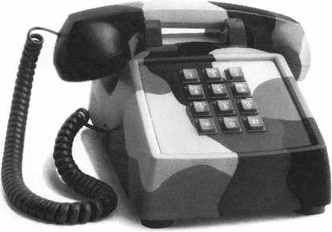

Your link to military intelligence.

Getting information about the military has often been considered a difficult proposition.

But not when W's regardina National Guard and Reserve duty. Botn employers and employ­ees can simply call our ombudsman to find out their rights and obligations under the Uniformed Services Employment and Re-employment Rights Act. Weve got nothing to hide. 1-800-336-4590.



March 1997

Keynotes

51



PRP

Report

Pame^Tatt, CML

Committee Chairman

Catagories that have been changed.

**/PRP Dates**

April 6, 1997

Fort Lauderdale, FL South Florida Chapter of ALOA Contact: Jerry Moeller [305] 944-0469

April 12, 1997

Bellevue, Washington KDL Trade Show Contact: Dean Nickels, CPL [206] 483-1702

April 13, 1997

Anaheim, CA AM LOCK Security Show Contact: Debbie Lussier [909] 371-1088

April 21,1997

Somerset, NJ MLANJ

[201] 267-8884

April 25, 1997

Red Deer, Alberta, Canada P.L.A.A.

Contact: Dave Kennedy [403] 948-9997

April 26, 1997

Eau Claire, Wl

Wisconsin Indianhead Chapter Contact: John Dorsey [715] 832-4207

April 27, 1997

Three Forks, Montana Montana Chapter Contact:Walt Cooney, CML [406] 723-4692

30 Day Application Period on PRP Classes0

J

Keynotes March 1997

Many requests for information about the PRP categories that have been combined have been received as people get ready to sit for the PRP in 1997. To save everyone a few pennies, below is information about the cate­gories that have been combined or split in the last couple of years.

**Changes in the PRP Categories**

1. The combining of C01 & C02 (Basic and Advanced Alarms) into the new category L42 (Alarms):
2. If a candidate has passed wither C01 or C02, he will retain that credit and may take L42 for additional credit, b. If a candidate has passed both, he may not sit for L42.
3. If a candidate has not taken either one or failed both, he may only sit for L42.
4. The splitting of C09 (Cylinder Servicing, Inter-changeable Core) into the new cate­gories L38 (Inter-changeable Core, Best style) and L39 (Inter-changeable Core, other than Best Style):
5. If a candidate has passed C09, he will retain that credit and may take either or both L38 and L39 for additional credit for each one passed.
6. If a candidate has failed C09, he may only take L38 and L39-
7. The combining of 04 (Electro- Mechanical Locks, Basic) and Cl5 (Electro-Mechanical Locks, Advanced,) into the new category L40 (Electro- Mechanical Access Control):
8. If a candidate has passed either Cl4 or Cl3, he will retain that credit and may take L40 for additional credit.
9. If a candidate has passed both, he may not sit for L40.
10. If a candidate has not taken either one or failed both, he may only sit for L40.
11. The combining of C35 (Locks, Detention) and C36 (Remote Door, Detention) into the new category L43 (Detention Locking Systems):
12. If a candidate has passed either C35 or C36, he will retain that credit and may take L43 for additional credit.
13. If a candidate has passed both, he may not sit for L43.
14. If a candidate has not taken either one or failed both, he may only sit for L43.

Remember how important the PRP is to your career. With ample preparation and dedication, you’ll be glad you invested the time to take the exam.

**I PRP History Requests**

There have been a lot of requests for PRP history reports recently as the 1997 PRP sea­son gets underway. If you do not know what your PRP history is, please contact the Chairman by phone at 406-721-9797 or by fax at 406-549-7067. Be sure to have your current ALOA membership number and /or old ALOA membership numbers you might have taken the PRP under when you call or write. PRP history reports will be mailed or faxed to you upon your written request.

**Give the PRP a Try**

For those of you who may have started the PRP some time ago and found that you could not pass the Mandatory, please consid­er giving it a second chance. If you have not attended a sitting in the last two years, the Mandatory—while still being the compre­hensive test it has always been—is now easi­er to pass as it is better written and, there­fore, easier to understand. Please give it a try this year.

**PRP Resource Guides**

As a last note, The PRP Resource Guide, although not the last word on the PRP by any means, is an excellent beginning source to use to find the information you need to prepare for your next sitting. The guides are available from either the PRC Chairman or the ALOA office for only $15, which includes shipping. Call today to get your copy.

About the Chairman: James Watt,

CML, CPS, owns and operates Art and Ray’s  
Lock and Safe in Missoula, MX He has been an  
ALOA member since 1977 and is also serving as  
the Northeast Regional Vice President of ALOA.

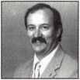

|  |  |  |
| --- | --- | --- |
|  | Tins | |
| JLraae |  |  |
|  | | lony Ramunno, CML, CPS  Department Editor | |

“This is the easiest way I’ve found to do it.”

New Plugs

I have a customer who orders his own Wil­son Bohannon brass padlocks, and he period­ically wants a number of them keyed to an existing key that he supplies. Removing the brass plugs from the top edge of the padlock isn’t one of my favorite things, but this is the easiest way I’ve found to do it.

I first check each pin position to see if any are the same depths as my existing key. If so, I don’t disturb the chambers. To locate the chamber position, you can use a factory key and hold it upside down against the padlock top with the shoulder against the bottom. I take a black felt-tip pen and touch the area under the key at each key cut center. This leaves a black dot on each chapter cap, which I lightly centerpunch. The chamber caps will be recessed enough to see where to drill. I drill through the caps with a 1/16-inch bit, then I switch to a 5/64-inch.

When the larger bits starts into the pilot hole, it will grab, and the cap will usually spin and you can lift the drill and remove the caps easily with a light hand and a cord­less drill. After rekeying, drive in new cap plugs and dress the lock top with a file.

Larry Wright #9558

'^Editor’s Note: Wilson Bohannon makes sub-assem­bled padlocks for custom keying in the field. Also, they will factory key the locks if you send them a key. Hercules Industries can also provide an inden- tial padlock if sent a WB key. Here are the compa­nies’ addresses.

Wilson Bohannon Co.

621 Buckeye Street Marion, OH 43302 (614) 382-3639

Hercules Industries, Inc.

P.O. Box 197 Prospect, OH 43342 (614) 494-2628 (614) 494-2274 (FAX)

The Year of the Vehicle

To determine the model year of an automo­bile or tmck that you are working on, look

to the VIN (vehicle identification number). Since the early eighties, all motor vehicles have a 17-digit VIN. The 10th digit of the VIN represents the model year.

Congratulations to Kenneth W. Cloughley, CRL for sending in January’s winning tip, “91 Caddy.”

About the Department Editor: Tony

Ramunno, CML, CPS, owns and operates Allied  
Locksmiths of Youngstown in Youngstown, OH.  
He has been in the locksmithing business for 23  
years and has been an ALOA member for 23  
years. He also serves as the chairman of the  
Library-Museum Committee for ALOA.

Let It All Hang Out

Got a secret? Know a short cut? If you have  
a tip that would help your fellow lock-  
smiths, send it to Keynotes. We can’t wait to  
see what information you’ve discovered,  
invented or simply stumbled upon. Do it for  
your country. Do it for humanity. For good-  
ness sakes, do it for your health. After all, it’s  
been proven that too much unshared knowl-  
edge can cloud your brain.

March 1997 Keynotes

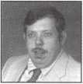

|  |  |  |
| --- | --- | --- |
| 1997 V | 1991 M | 1985 F |
| 1996 T | 1990 L | 1984 E |
| 1995 S | 1989 K | 1983 D |
| 1994 R | 1988 J | 1982 C |
| 1993 P | 1987 H | 1981 B |
| 1992 N | 1986 G | 1980 A |
| *NOTE: Not all letters | are used. |  |

Steve Dudik #20011

**How To Become A**

**trade Tipper**

Each month, the Associated Locksmiths of America (ALOA) holds a “Trade Tips” con­test in Keynotes for ALOA members. In addition to helping other locksmiths by sharing your knowledge, there are three levels of prizes to be awarded:

As a departure from our usual Trade Tips prizes, donated products will be given out to monthly winners for the remainder of the year.

April 1997

Sargent & Greenleaf 6120 electronic safe lock

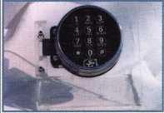

Grand Prize: An expense-paid trip to the ALOA ’97 Security Expo

Each year, the ALOA Publications Commit­tee selects one outstanding tip, the author of which receives a seven-day ALOA con­vention package that includes travel and accommodations.

Authors of any Trade Tip published will still receive $20.

Want to Participate?

Mail your best idea (including photos,

illustrations or parts, if necessary) to

Keynotes

Trade Tips Editor

3003 Live Oak St.

Dallas, TX, 75204-6186.

All entries are sent to the Trade Tips editor with the author’s identity deleted. The tips must be submitted exclusively to Keynotes and become the exclusive property of ALOA. Tips are judged on the basis of accuracy, professionalism, ethical stan­dards and usefulness.

|  |  |
| --- | --- |
| ALOA | l |
| Extra | \ |



Dept)

Scholarship Update

In 1991, ALOA formed a partnership with MBNA MasterCard. This membership affil­iation program allows MBNA to offer their card to members. When our members accept this card and use it, ALOA receives a small portion of MBNA’s profit. Soon after this program began, past president Evelyn Wersonick, CML, recommended that all monies received by ALOA be placed in the Scholarship Foundation. So far, the Founda­tion has received $14,292. The yearly MBNA contribution to the Foundation is now second only to the proceeds of the annual golf tournament, The ALOA Open, sponsored by Yale.

Currently the Foundation has assets of $250,400 and will be able to award a num­ber of scholarships in 1997. These scholar­ships are frequently used by the students attending the ALOA and SAVTA conven­tions, but may be used by students pursu­ing locksmith education from any legiti­mate source. Applications may be found in the July/August and January issue of Keynotes. Applications are also available from the ALOA headquarters. Members and non­members are invited to apply.

Museum Fund Progress

For the past three years, there has been an option on the ALOA dues renewal form to contribute to the ALOA Museum/Library Fund. By way of an update: The ALOA headquarters building in Dallas, built in the late 1950s, has become too small for our operations. In addition to the ALOA staff, this facility also houses the SAVTA staff, education and other storage, the ALOA Library and Museum. One option, which we have been able to avoid so far, is to elim­inate the museum or place the artifacts in storage. However, we feel that these two facilities that maintain the history and tra­dition of locksmithing should remain open and operational. In order to ensure that this is possible, we began collecting money in order to add space to the existing building or purchase additional space elsewhere. Although we will have about $45,000 in

54 | Keynotes March 1997

the fund after the completion of dues collec­tion this year, this still is not enough to build. It is a very good start, though. The fact that members have responded with this much of a contribution leaves us with the clear impression that the Museum and Library are important to you. Accordingly, we will continue our efforts.

Is It Marked?

Have you remembered to mark the new dates for the ALOA convention in Reno? The ALOA Security Expo and Convention will now run July 28 to Aug. 2—don’t for­get!

Don’t Take A Bath

A considerate member from Florida called in after reading the boat locksmithing arti­cles in January 1997 Keynotes. He wanted to remind locksmiths to double-check their insurance coverage if they do marine work—some policies apparently exclude coverage for injury or loss received in that environment and an additional premium may be necessary if that kind of coverage is desired. So if you’re headed out to sea with your toolbox, call your insurance agent and make sure everything is ship-shape.

Keynotes Reprint Policy

Keynotes magazine, the official interna­tional publication of the Associated Lock­smiths of America, Inc., currently extends, as a courtesy, permission to reprint portions of the publication to ALOA members, ALOA chapters and regional locksmith associations. This policy is based on the assumption that the material is being used for informational purposes only and that no direct profit is to be made by the reprinting party. The Keynotes reprint policy carries the following stipulations:

* The party wishing to reprint a portion of Keynotes will inform ALOA, in writing, of what is to be reprinted, where and for what purpose.
* The reprinted information must appear verbatim—i.e., exactly as published— with a notation that the material appears

“courtesy of Keynotes magazine, Associat­ed Locksmiths of America, Inc., [issue date].”

If the party wishing to reprint a pub­lished portion of Keynotes stands to profit directly from re-publishing this material, arrangements must be made with the author/owner of that material. Contact information for authors is available from ALOA. [This is primarily a requirement for any for-profit publications. This does not, for example, apply to an ALOA member who wishes to make photocopies of Keynotes material to educate consumers about profes­sional standards such as the recommended ALOA Positive ID Policy.]

If the party wishing to reprint a pub­lished portion of Keynotes—either on a profit OR nonprofit basis—wishes to use the pho­tography or illustrations from the magazine, arrangements must be made with the artist/owner of that material. Contact infor­mation for artists is available from ALOA. (Note: Art executed by ALOA staff is “work for hire” and does not fall under this provi­sion.)

**Positive ID Policy For Lockout Services**

ALOA would like to remind its members to use the following positive identification pol­icy when servicing lockouts:

Notify Caller. When a call comes in to request lockout services, ask the caller if he/she has identification and authority to open the lock.

Keynotes Advertisers Index

|  |  |  |
| --- | --- | --- |
| RS# | Advertiser | Page |
| 1 | MLANJ | 7 |
| 17 | Locksmith Publishing | 19 |
| 22 | Omaha Wholesale Hardware | 51 |
| 21 | LAB Security | 57 |
| 100 | Jet Hardware Mfg. | BC |

w

Complete Form. Upon arrival at the job site, the locksmith should complete an Authorization Form that asks for the name, address, phone number, identification num­ber and property description from the cus­tomer. ALOA provides a model form.

Verify I.D. Verify the customer’s photo-iden­tification card and compare it to the infor­mation provided by the customer. If no photo-ID card is available, ask for some other reasonable form of ID.

Verify Authority. The locksmith should inquire as to what authority the customer has to open the lock, and request to see any reasonable and appropriate evidence that could verify the authority. This may be impossible in some cases.

Ask for Signature. Ask the customer to sign the Authorization Form, which should contain a statement that (a) the information given by the customer is correct, (b) the customer has the authority to open the lock, and (c) the customer shall identify and hold harmless the locksmith against liability.

The ALOA model form contains this state­ment.

Optional Last Resort. If you have any sus­picions that the customer is giving false information or does not have authority to open the lock, say that you will be happy to open the lock provided a law enforcement officer is present. If the customer agrees, call the police; if not, leave.

File the Form. Keep the Authorization Form on file for a reasonable period of time (at least three years).

Membership Survey

Just a reminder that you’ll be receiving a membership survey in the near future—be sure to participate. This is one of the best opportunities we’ve had in a long time to find out what everybody thinks, what every­body wants—what members like and don’t like so much.

Buyer’s

Guide

Allstate Locksmith Insurance Program

As a retail or  
mobile locksmith,  
you understand  
how important it  
is to rely on a  
solid, reputable  
company to help  
you with your  
business insurance  
needs. If you have  
any questions  
about your insur-  
ance needs in gen-  
eral, an Allstate  
Agent can provide  
you with addition-  
al information. To  
be referred to an

Allstate Agent, please call 1-800-669-6711.

Reader Service #18



Cap with Built-In Light

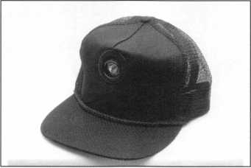

This cap is the perfect solution for hands­free lock and safe work which requires some illumination. The light is build right in and can be adjusted to three different positions. The light turns on when it is pushed down in any of the three angles. Operates on two AAA batteries (included). Made from black cotton mesh, the cap is fully adjustable and very affordable. Contact MBA (mark bates Associates) toll free at (888) 622-5495,

(606) 887-0496, Fax (606) 887-9491 or write: 101 Edgewood Plaza Dr., Nicholasville, KY 40356-1850.

Reader Service #19

0

h.e.s., Inc 7500 Series Strike Passes UL Fire Door Test

The test was a success. The h.e.s. models 7501 and 7505 are now UL listed for fire doors, category 10B, for use on class “A”— three hour or less doors. This is the highest rating an electric strike can obtain from UL.

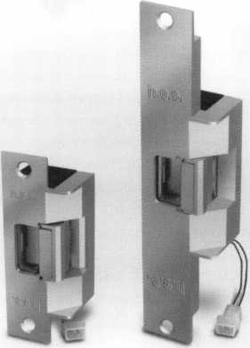

7501 7505

The 7501 and 7505 models are available now for immediate shipment, h.e.s is very excited to offer such a superior electric strike to our customers, and we look forward to a successful partnership in 1997.

Hanchett Entry Systems 2040 W. Quail Avenue Phoenix, AX 85027 *Reader Service #20*

March 1997 Keynotes



It is amazing what you can learn just from the trade shows

Well, by the time you read this, Texas Locksmith Association’s Convention will be history. I am sure that all will have had a great time there and will have received 10 days of ACE classes that were just great. Exciting things are occurring in our indus­try, and if one is to keep abreast of all these new changes and additions to our trade, one must attend association, ACE and manufac­turers’ classes and trade shows. It is amazing what you can learn just from the trade shows and sharing with your fellow lock­smiths. If you have never tried this, I highly recommend you attend the next convention, association or trade class in your area. I guarantee this will be the finest experience of your life and it will help you greatly in your business and trade.

ACE has some exciting new classes at

^Upcoming ACE Classes

Beehive State Locksmith Assoc.

March 15-16, 1997 Salt Lake City, UT Contact: Deloy J. Hamblin, CPL [801) 621-5625 Master Keying Methods Instructor: Jerome Andrews, CML

Grand Canyon Chapter of ALOA

April 5-6, 1997 Phoenix, AZ Contact: John Ilk [520) 474-8879

Combination Lock Manipulation Instructor: Ken Lee, CPL

Master Locksmith Assoc, of New Jersey

April 17-21, 1997 Somerset, NJ Contact (201) 267-8884 19 full-day classes and two evening seminars

ALOA ’97

July 28-Aug. 1, 1997 Reno, NV

Contact: ALOA Meetings Department (214) 827-1701 (800) 532-2562 Approx. 45 full-day classes, 30 half-day classes and six evening seminars More information TBA

J



Keynotes

March 1997

ALOA ’97 Security Expo in Reno, NV from July 28 to Aug. 2, 1997. Just a few of the 45 full-day and 30-half day classes are: Investigative Locksmithing by D. Shiles; Servicing Aluminum Storefront Doors by D. Thielen, CML; High Security Import Auto by R. D’Adamo; Basic Safe Penetration by

1. Stephenson; Basic Computers by B. Neff and many more.

Our next biggest event will be the Master

we can plan them for 1998 in Nashville, TN. All suggestions, criticism and com­ments are welcome.

The list of upcoming classes are shown to the left and I hope you will take the oppor­tunity to attend one or more of these events. I can promise you it will be the best money you ever spent. Until next month, have a great day and learn something new this week!

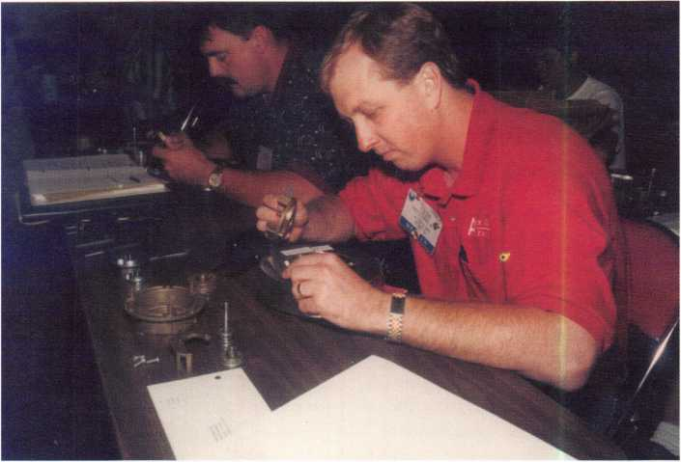

Locksmith Association of New Jersey Convention and Trade Show, which will be April 17 to 21, 1997 in Somerset, NJ. ACE will have 20 ACE classes during this time. One of these will be the Association Officers Training Class for all who would like to improve the management of their chapter or association. This will be a free class to any association officer or prospective officer.

There will be a small fee—refunded upon class completion—to guarantee attendance You can contact MLANJ at (201) 267-8884 for a brochure and full details.

The Education Committee will be meet­ing at the fall board meeting in Dallas, TX, on March 11 to 15, 1997 to begin planning the 1998 classes. If you have any special classes you would like them to consider, you can fax me at (301) 831-5368 and I will bring these before the committee and maybe

J About the Chairman: James

Glazier, CML, #14240, is a retired police officer  
and operates Security Plus in Mount Airy, MD.  
He also serves on the Finance, Convention and  
Personnel Committees of the ALOA Board.



*W'\**

**Premium Quality  
Tumbler Pins**

**^ .003**

**New Standard**

***designed by Robert A. Labbe CEO***

**UNIVERSAL AND ORIGINAL TUMBLER PINS AND PROFESSIONAL PINNING KITS ARE THE ONLY CHOICE OF  
SECURITY PROFESSIONALS, THE FINEST LOCK MANUFACTURERS, ALL THE LEADING LOCK  
WHOLESALE DISTRIBUTORS AND CONTRACT HARDWARE SUPPLIERS WORLDWIDE.**

**700 EMMETT STREET, BRISTOL, CT 06010 • 1-860-589-6037 • 1-800-243-8242 • FAX 1-860-583-7838**

Lrod Inform_ Doarlor Qor\/i/-/a CorrA

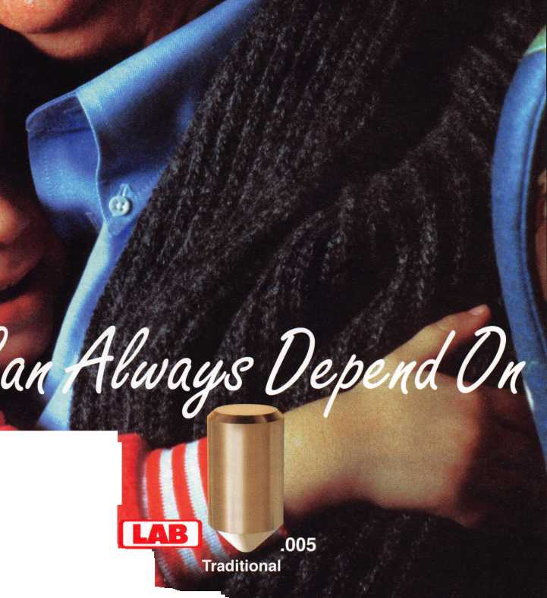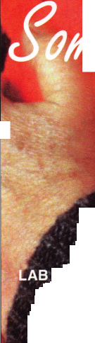

Chapter

Roster



Dept]

**The best way to learn about ALOA’s programs**

**and to network with locksmiths in your area is by  
participating in local ALOA chapter activities. This is  
your opportunity to exchange management and tech-  
nical information, build your professional image, and  
share trade tips with your fellow locksmiths.**

**If you want to start a chapter in your area, please call  
ALOA, (214) 827-1701.**

|  |  |  |  |  |
| --- | --- | --- | --- | --- |
| Alabama | Georgia | Minnesota | Ohio | Wisconsin |
| Alabama Locksmiths | Georgia Chapter | Minnesota Chapter | Ohio North Coast Chap­ | Fox Valley Chapter |
| Association | P.O. Box 48088 | 3M Center | ter | 1425 N. Richmond St. |
| 411 6th St. | Atlanta, GA 30362-1088 | Bldg. 223-BE-04 | #2 Horseshoe Drive | Appleton, WI 54911 |
| Decatur, AL 35601 | (404) 455-6244 | St. Paul, MN 55144-1000 | Monroeville, OH 44847 | (414) 731-5400 |
| (800) 292-5008 | John T. Grist, CML—Chair­ | (612)733-6674 | (419) 465-4153 | e-mail [sageinc@athenet.net](mailto:sageinc@athenet.net) |
| * Larry Warnick, CML | man | ^Douglas Rude, CRL | * Ronald Betschman, | *John F. Engle, CRL |
|  | *M.W. Whitman, Jr. |  | CML—Chairman | Chairman |
| Arizona | Montana | Ohio Valley Chapter | Matt Swoboda—Vice Chair­ |
| Grand Canyon Chapter | Hawaii | Montana Chapter | 144 Julep | man |
| 13016 S. 131st St. | Hawaii Chapter | 1000 S. Main | Cincinnati, OH 45218 | Indianhead Chapter |
| Gilbert, AZ 85233 | 4420 Lawehana St. | Butte, MT 59701 | (513) 825-7528 | 201 N. Barstow St. |
| (602) 786-8182 | Unit 4 | (406) 782-0125 | *James T. Brickler, | Eau Claire, WI 54703-3525 |
| * Larry Schlemmer, CRL | Honolulu, HI 96818 | * Aggie Cooney, CPL | Chairman | (715) 832-4207 |
|  | (808) 623-5914 |  |  | *John Dorsey, CPL |
| California | * Andreas Muenker, CML— | Nebraska | Pennsylvania | Chairman |
| Los Angeles/ | Chairman | Nebraska Chapter | Keystone State Chapter |  |
| Orange Counties Chap­ |  | 343 W. 2nd St. | 3 W 4th St. | Wyoming |
| ter | Indiana | Hastings, NE 68901 | Bridgeport, PA 19405 | Wyoming Chapter |
| P.O. Box 697 | Central Indiana | (402) 463-6661 | (610)272-9292 | 5920 E. Pershing |
| Alhambra, CA 91820-0697 | 1237 Wabash Ave. | *Brad Boden | *Barry Leas, CRL | Cheyenne, WY 82001 |
| (310) 869-2555 | Terre Haute, IN 47807 |  |  | (307) 638-8752 |
| *John H. Cosby, CPL | (812) 234-6249 | Nevada | South Dakota | *Betty Crenshaw, CML |
| San Diego Chapter | * Herbert Dusenberry, CML | Sierra Nevada Chapter | South Dakota Chapter | International Chap­ |
| 1049 Island Ave. | Northern Indiana | C/O Pamela Vankirk | 402 S. Minnesota Ave. |
| San Diego, CA 92101 | 122 N Orchard St. | P.O. Box 115 | Sioux Falls, SD 57102 | ters |
| (619) 234-4829 | Kendallville, IN 46755 | Reno, NV 89504 | (605) 331-6026 | Hong Kong Chapter |
| *Frank Hartung, CML— | (219) 347-1754 | (702) 328-9285 | *Ronald Heidzig—Chair­ | 901 Canton Rd, G/Fl |
| Chairman | *Earl Shanfelt | *Danniel F. Howard, | man | Mong Kok |
|  | Southern Indiana | CMP.—Chairman |  | Hong Kong |
| Colorado | P.O. Box 185 |  | Tennessee | *Timothy Chow—Chairman |
| Colorado Front Range | Bloomington, IN 47402- | New Jersey | Smokey Mountain | Korea Chapter |
| 2603 Pearl St. | 0185 | Garden State Chapter | Chapter | #1250-7 Bi San 7 Dong |
| Boulder, CO 80302 | (812) 334-3737 | 106 Ridgedale Ave. | 2557 Middle Creek Rd. | Seo Gu TaeGu |
| (303) 443-9740 | * Daniel W. Hill, CML | Morristown, NJ 07960 | Pigeon Forge, TN 37863 | Korea |
| John I. Shandy, CML— |  | (201) 538-2737 | (615)453-8344 | (053) 353-0058 |
| Chairman | Kentucky | *Steve Frei, Chairman | *Jessie Swan, RL | *Myeong-rae Cho |
| *John M. Thomas, CRL— | Kyana Chapter |  | West Tennessee |  |
| Vice Chairman | 510 E. Parrish Ave. | New Mexico | 1643 Bartlett Rd. | * Denotes contact person for |
| (303) 666-8980 | Owensboro, KY 42303- | New Mexico Chapter | Memphis, TN 38134 | this chapter. |
| Connecticut | 3125 | 917 2nd St. NW | (901) 372-7464 | All questions regarding chap­ |
| (502) 684-5093 | Albuquerque, NM 87102 | *Richard Pat Walker, | ter activities, meetings and |
| Nutmeg Chapter | *Timothy Morrison, CML— | (505) 242-1380 | CML—Chairman | events should he directed to |
| Phil’s Lock Shop | Secretary | *Evelyn Wersonick, CML |  | this individual. |
| 360 E. Main |  | Marc McGrannahan, Chair­ | Texas |  |
| Meriden, CT 06450-6022 | Maryland | man | Sunbelt Chapter |  |
| (203) 237-4602 | Chesapeake Chapter | Sunbelt Chapter | see New Mexico listing |  |
| Phillip Hobbs, CPL—Chair­ | 700 Rappolla St. | South Central Region |  |  |
| man | Baltimore, MD 21224 | New Mexico State | Washington, D.C. |  |
| Florida | (410) 633-0111 | University | Washington, D.C. Area |  |
| * Bob De Weese, CPL— | Box 30001 Dept. 3545 | 4713 Tallahassee Ave. |  |
| South Florida Chapter | Chairman | Las Cruces, NM | Rockville, MD 20853 |  |
| 1710 NE Miami Gardens |  | 88003-0001 | (202) 722-0900 |  |
| Dr. | Massachusetts | (505) 846-6292 | *Lester Brodsky—Chairman |  |
| Miami, FL 33179 | Massachusetts Chapter | *Don Brazil—Chairman |  |  |
| (305) 944-0469 | 200 Weir Street |  |  |  |
| *Jerri Moeller, CRL Secre­ | Taunton, MA 02780 | North Dakota |  |  |
| tary | (508) 823-4649 | North Dakota Chapter |  |  |
| Paul Renderer, CML— | *Stephen Ehrlich, CML— | Rte. 1 Box 67 |  |  |
| Chairman | Treasurer | Devil’s Lake, ND 58301- |  |  |

3907

(701) 662-5625 *James H. Strong, CRL

Keynotes

March 1997

|  |  |
| --- | --- |
| f21 t . | News |
| trrapter |  |
|  | JT5an^amum, CML  Committee Chairman |

Remember, this is a group effort! No one is ever successful by  
themselves alone.

Greetings again, to all of you. In this issue of Keynotes, I would like to continue our discus­sion on chapter attendance and add some additional ideas for improving it.

I have mentioned before the importance of a well planned and structured meeting schedule. No matter how large or small your chapter is, the basics of setting up and arranging the details of a good chapter meet­ing are the same.

I’ve seen it happen too many times—the entire program schedule is placed upon one individual, and for a while it seems he or she is doing okay. Not for long! Just as it takes more than one person to run your chapter well, it also takes a program committee to keep the interest up, and the program sched­ule active and packed full of exciting coming attractions. Your program committee is one of the most important of the four basic com­mittees your chapter should have. Those committees, of course, are the program com­mittee, the membership and public relations committee, the hospitality committee, and the legislative committee.

The program committee’s function is not only to survey the membership regularly about their interest in new classes and speak­ers, but to review current trends and securi­ty-related subjects. They should look for new security products that might be introduced to members at a meeting or make a good training class. Many companies look forward to sending a rep out to your organization to familiarize you with new products. The committee must realize the importance of advance program planning. Speakers should be scheduled no less than two months in advance. It is not realistic to expect someone to speak at a meeting with only a moment’s notice, and the membership should know well in advance who is coming and what subject matter he/she will be speaking on.

The committee is also charged with preparing a backup plan in the event a scheduled speaker becomes ill or cannot make the appointed meeting. The commit­tee should provide the speaker with any audio/visual aids he/she might require and introduce him/her when it is time for

him/her to speak. A member of the commit­tee should also give written confirmation and a thank you letter to all speakers with a copy going to the chapter secretary. The committee could also schedule special event meetings that could be held every year, such as law enforcement appreciation day, a family picnic or an awards dinner/dance. Some of these things are also handled by hospitality, but the initial scheduling of events should be started by the program committee.

My point here, folks, is that if your chap­ter does not have a well scheduled and publi­cized meeting plan with an organized struc­ture, your chapter could be heading for trou­ble and your attendance may be on a down­hill slide! Remember, this is a group effort! No one is ever successful by themselves alone.

Reminder—make your plans now for ALOA ’97 in Reno, Nevada.

**From The Chapters**

Now On Line

The Wisconsin Valley Chapter now has an e- mail address. Send correspondence to: sagei nc @athenet. net

Spring Fair

The Wisconsin Indianhead Chapter is orga­nizing their Spring Lock Fair ’97. This two- day event will be held the last weekend in April at the Best Western Midway hotel in Eau Claire, WI. There will be two days of classes and a couple of evening seminars, prize drawings and more.

WLA Happenings

At the Wyoming Locksmiths Association’s annual banquet, Gene Ficek was named “Locksmith of the Year.” Betty Crenshaw, CML and Allen McCumber, CPL were installed as president and vice president.

On May 17, 1997, Bill Reed and Steve Young will be putting on a seminar in Casper, WY. For additional information, call Betty Crenshaw at (307) 638-8752 or Fran McCumber at (307) 527-5513.

CFLA Honors

Bill Isaacs has been named the CFLA 1996 Locksmith of the Year. He is appreciated for his work on as a SERLAC board member and treasurer, as well as his contributions to CFLA’s newsletter.

New President

Don DeKuyper has been named president of The Association of Ontario Locksmiths. Congratulations, Don!

Don’t Forget

The news is dues! Be sure to pay yours to your chapter secretary/treasurer at the next meeting.

* Wf
* ..-Vfr ^I About the Chairman: Dana Bamum, CML, #05444, operates South Penn Lock & Safe Co. in Media, PA. He also serves on the ALOA Education, Membership and Bylaws committees, as well as having been on the board of directors of the Greater Philadelphia Locksmiths Association (GPLA). Dana has also sponsored many new ALOA members. Dana can be reached at FAX (610) 565-9902 or e-mail him at dlbamum@aol. com.

March 1997

Keynotes



End

Back

Page

One of the  
many items of  
historic interest  
on display at  
ALOA  
headquarters in  
Dallas is this

combination  
padlock with key.  
The model,

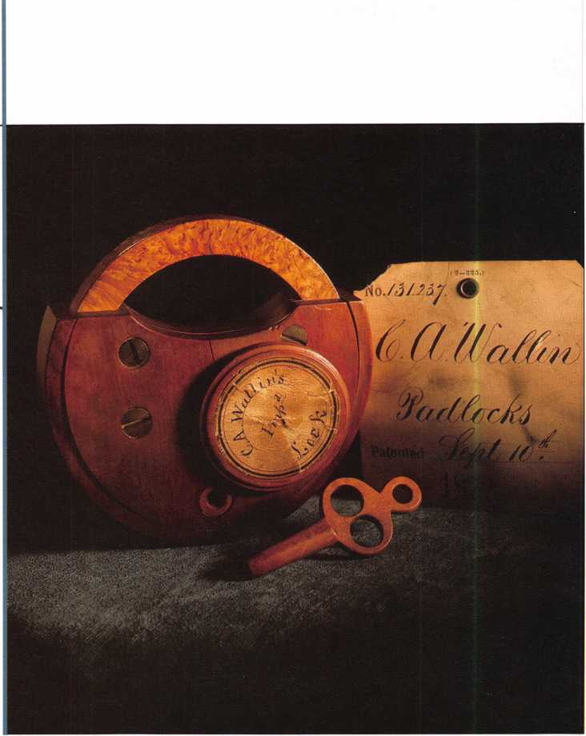

of Pasadena, CA, has been placed in one of the glass display cases in the reception area and, therefore, is often noticed by

visitors of all kinds. One young guest spent a good deal of time staring at this particular artifact and then, looking

up at her adult companion, asked, “What about termites?”



Keynotes

March 1997

Louisville, Kentucky May 5-10 The Galt House

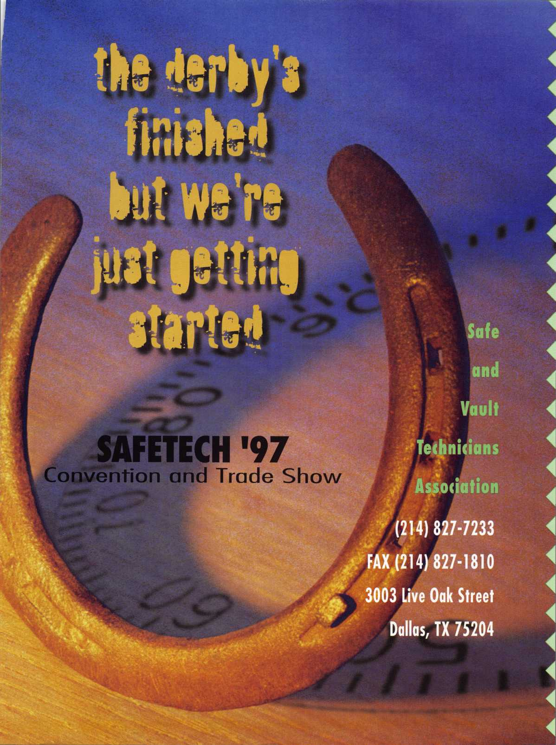

**Jet Soars to a new level of Quality**

**In two short years since its initial introduction by jet, the silver line has become a symbol of quality and a monument to precision in the key manufacturing indus­try. The silver line keys are coined, embossed and designed to look exactly like the originals. Plus the jet pledge guarantees superiority over the originals as well.**

**jet’s silver line Offers regular and sectional keys from...**

**ARROW BEST CORBIN RUSSWIN**

**DIEBOLD FALCON HHM ^ ‘**

**KWlKSET LeFEBURE MEDECO**

**MOSLER SARGENT SARGENT &GREENLEAF**

**SCHLAGE YALE YORK**

**New key blanks are constantly added to the silver line to serve Master Keying and Duplication needs. Recent additions include Corbin Russwin D2-6-NS and 77-6-NS... Another jet symbol of Quality.**

**Another jet symbol of Quality.**

t tr' tl'u')!! it; <? VNl

**JET HARDWARE MANUFACTURING CORP  
800 Hinsdale Street, Brooklyn NY 11207**

**Prfc»P Ihfnrmiitihn - RpprlPr Qprwir'p C'.arri #inn**

